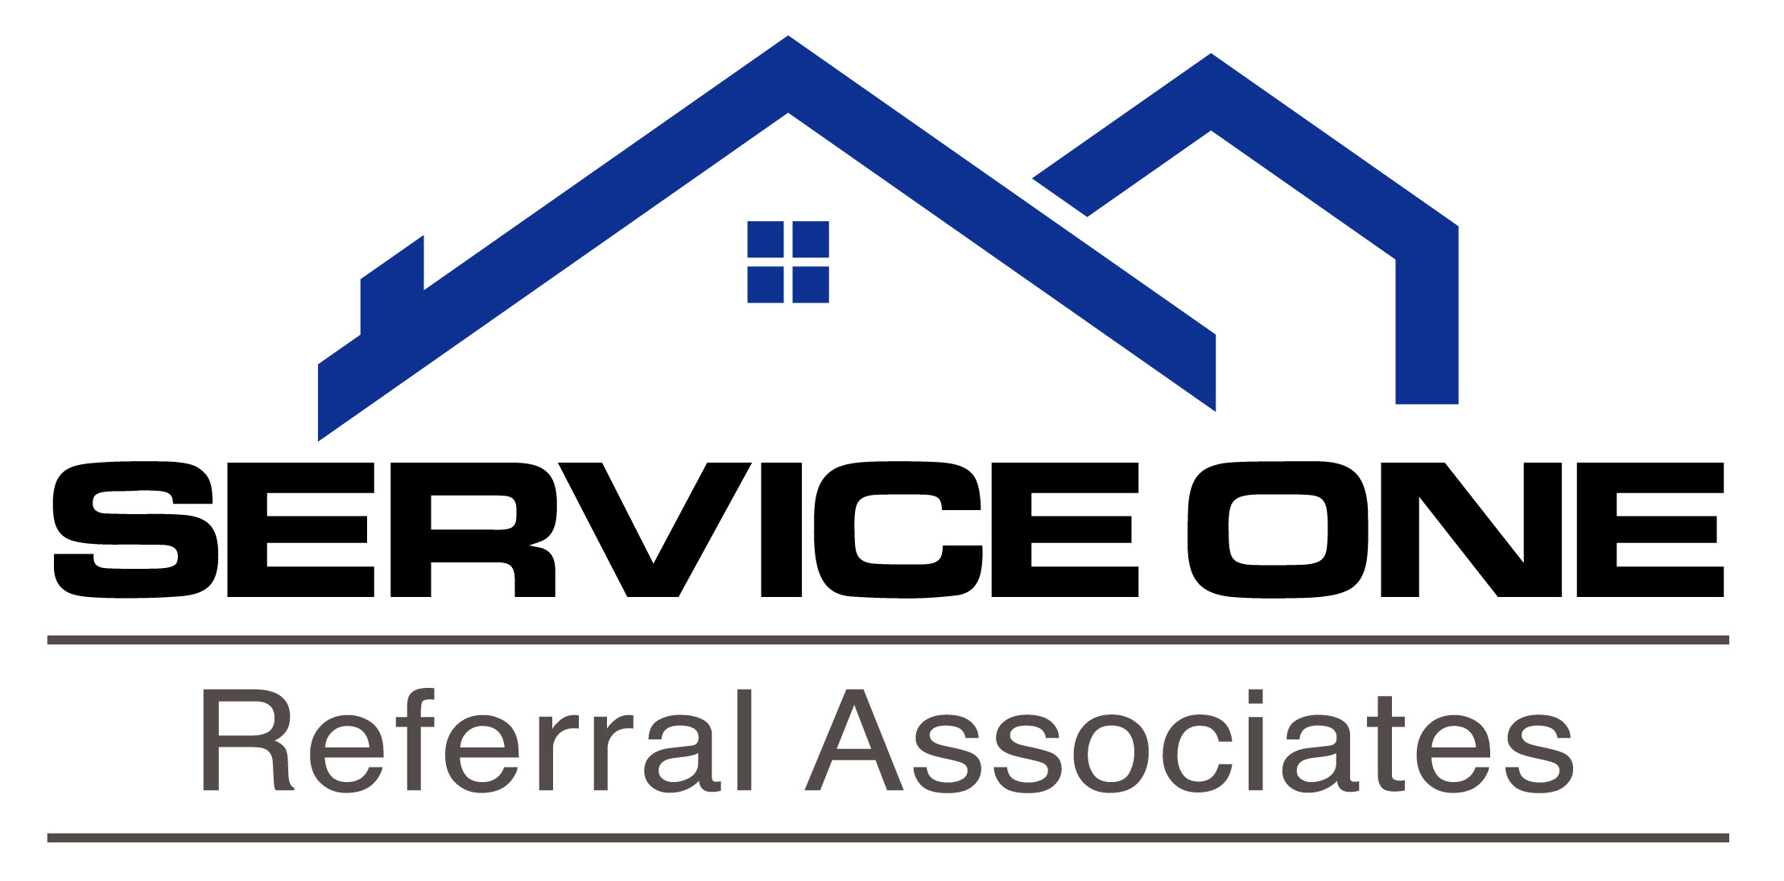
306 Kings Highway South, Cherry Hill, NJ 08034
Phone: (856) 428-1013 Fax: (856) 428-1393

Date

Dear Family and Friends,

I am proud to announce that I recently completed state requirements for my New Jersey real estate salesperson license. Although I am not joining a real estate company at this time, I have joined the Service One Referral Associates, LLC as a salesperson licensed with a Real Estate Referral Company. Service One Referral Associates, LLC is a wonderful service which enables me to provide you with recommendations of highly experienced and caring full time REALTORS®.

Navigating the real estate market is complex, especially in today’s economy. I want you to be completely confident in the REALTOR® you are working with. Real estate investment decisions are far too important to you and your family to choose an unknown agent.

Give me a call at any time. Whether it’s across town or across country, I can quickly connect you with an experienced REALTOR® we can both trust to provide you with the outstanding service you deserve.

I look forward to talking with you soon.

Regards,

Agent name
Direct (cell) number:
Email address

