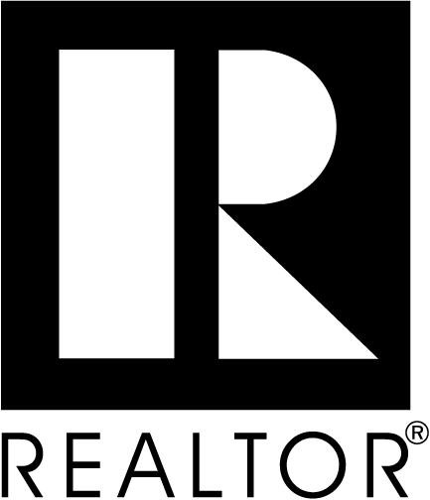

APPLICATION FOR AFFILIATE MEMBERSHIP
GREATER MANCHESTER/NASHUA BOARD OF REALTORS®, INC.
6 Bedford Farms Drive, Bedford, NH 03110

To the Greater Manchester/Nashua Board of REALTORS®, I hereby apply for Affiliate Membership in the above-named Board and am enclosing my check in the amount of $300.00 ($150.00 application fee + $150.00 March 2025 Affiliate Dues) payable to GMNBR*. One-half of my application fee and 2025 dues will be returned to me in the event of non-election. Otherwise, dues are nonrefundable per GMNBR Bylaws Article V, Section 3, b.

*If you would like to join the New Hampshire Association of REALTORS® please add an additional $120.00.

I hereby submit the following information for your consideration:

Company Name: ______________________________________________________
Company Information: Sole Proprietor Partnership Corporation LLC (Limited Liability Company)

Type of Business: _____________________________________________________

Applicant/Contact Person: ______________________________ Title: ____________________________________
Licensed/certified appraiser: [ ] Yes [ ] No Appraisal License #: __________________________

Office Address: _______________________________________________________________________________________
_______________________________________________________________________________________
Phone: _______________________ Fax: __________________________ Cell Phone: _____________________________
E-Mail Address: ____________________________________________________________________________________
Home Address: _______________________________________________________________________________________
_____________________________________________DOB_____________________________________
Home Phone: _______________________________ Cell Phone_______________________________________________

Preferred Mailing: Home [ ] Office [ ] Preferred Phone: Home [ ] Office [ ] Cell Phone [ ]
May the Association, as well as the State and National Associations, communicate with you via text message? ___Yes No
Are you presently a member of any other Association(s) of REALTORS®? [ ] Yes [ ] No

If yes, name of Association and type of membership held: _____________________________________________________
____________________________________________________________________________________________________

I hereby certify that the foregoing information furnished by me is true and correct, and I agree that failure to provide complete and accurate information as requested, or any misstatement of fact, shall be grounds for revocation of my membership if granted. I further agree that, if accepted for membership in the Board, I shall pay the fees and dues as from time to time established. NOTE: Payments to the Greater Manchester/Nashua Board of REALTORS® are not deductible as charitable contributions. Such payments may, however, be deductible as an ordinary and necessary business expense. No refunds.

By signing below, I consent that the REALTOR® Associations (local, state, national) and their subsidiaries, if any (e.g., MLS, Foundation) may contact me at the specified address, telephone numbers, fax numbers, email address or other means of communication available. This consent applies to changes in contact information that may be provided by me to the Association(s) in the future. This consent recognizes that certain state and federal laws may place limits on communications that I am waiving to receive all communications as part of my membership.

Dated: Signature:

