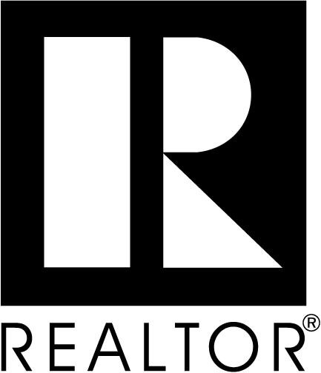

APPLICATION FOR REALTOR® MEMBERSHIP
___New Application ___Transfer Application ___ Re-Application ___Secondary Application
___New Office Application

GREATER MANCHESTER/NASHUA BOARD OF REALTORS®, INC.

6 Bedford Farms Drive, Bedford, NH 03110
www.gmnbr.org – Email: info@gmnbr.org

To the Greater Manchester/Nashua Board of REALTORS®, I hereby apply for REALTOR® Membership in the above-named Board and am enclosing my payment in the amount of:

- For New REALTOR® Members - $367.91 = (Application Fee = $250.00 + December 2024 prorated dues = $92.91** + $25 Voluntary RPAC*** Contribution) payable to GMNBR.
- For New Members Transferring in from another Board In-State: $115.33 = (Transfer application fee $75 + December prorated local dues $15.33*+ voluntary RPAC*** contribution $25) payable to GMNBR.
- For New Members Transferring in from another Board out of State: $134.91 = (Transfer fee $75 + December Prorated local dues $15.33* + December Prorated State dues $19.58* + Voluntary RPAC contribution $25***) payable to GMNBR
- For Secondary Membership with Primary In state Board – Prorated December Local dues $15.33* payable to GMNBR
- For Secondary Membership with Primary Out of state Board: $34.91 = (prorated December local dues $15.33* + optional prorated December NH State dues $19.58*) payable to GMNBR
- For new members transferring in from another Board, in or out of State, for Primary Membership starting in January: $648 = (2025 GMNBR, NHAR & NAR dues=$623+$25 Voluntary RPAC***) TRANSFER FEE WAIVED DURING MONTH OF DECEMBER

My 2024 dues will be returned to me in the event of non-election. One-half Application Fee is nonrefundable. I will attend orientation within 120 days of Association’s confirmation of provisional membership. Failure to meet this requirement may result in having my membership terminated. In the event of my election, I agree to abide by the Code of Ethics of the National Association of REALTORS®, which includes the duty to arbitrate, and the Constitution, Bylaws and Rules and Regulations of the above-named Board, the State Association, and the National Association, and if required, I further agree to satisfactorily complete a reasonable and non-discriminatory written examination on such Code, Constitutions, Bylaws and Rules and Regulations. I understand membership brings certain privileges and obligations that require compliance. Membership is final only upon approval by the Board of Directors and may be revoked should completion of requirements, such as orientation, not be completed within timeframe established in the Board’s bylaws. I understand that I will be required to complete periodic Code of Ethics training as specified in the Board’s bylaws as a continued condition of membership.

*REALTOR® annual membership dues are nonrefundable, per GMNBR Bylaws Article V, Section 3, b
**Prorated dues include dues for NAR, NAR Image, NHAR and GMNBR.
*** RPAC (REALTORS® Political Action Committee)
**** Includes NAR, NAR Image, NHAR, GMNBR and RPAC

NOTE: Applicant acknowledges that if accepted as a member and he/she subsequently resigns from the Board or otherwise causes membership to terminate with an ethics complaint pending, the Board of Directors may condition renewal of membership upon applicant’s certification that he/she will submit to the pending ethics proceeding and will abide by the decision of the hearing panel. If applicant resigns or otherwise causes membership to terminate, the duty to submit to arbitration continues in effect even after membership lapses or is terminated, provided the dispute arose while applicant was a REALTOR®.

I hereby submit the following information for your consideration:
Name: _______________________________________________________________________________________________
Real Estate License #: ______________________________DOB_________________________________________________
Licensed/certified appraiser: [__] Yes [__] No Appraisal License #: __________________________________
Office Name: __________________________________________________________________________________________
Office Address: ______________________________________Designated REALTOR_______________________________
Phone: _______________Fax: ___________________ E-Mail: _________________________________________________
Website: _____________________________________
Home Address: _________________________________________________________________________________________
Phone: _________________Cell: _________________Email: ___________________________________________________
Preferred Mailing: [__] Home [__] Office Preferred Phone: [___] Home [___] Office [___] Cell
May the Association, as well as the State and National Associations, communicate with you via text message? ___Yes ___No
Are you presently a member of any other Association of REALTORS®? [__] Yes [__] No
If yes, name of Association and type of membership held: _______________________________________________________
Have you previously held membership in any Board/Association of REALTORS® (including GMNBR [___] Yes [___] No
If yes, name of Association and type of membership held: _______________________________________________________
Have you been found in violation of the Code of Ethics or other membership duties in any Association of REALTORS® in the past three (3) years or are there any such complaints pending? [___] Yes [___] No (If yes, provide details as an attachment.)

If you are now or have ever been a REALTOR, indicate your NAR membership (NRDS) #: _________________________ and last date (year) of completion of NAR’s Code of Ethics training requirement: __________.
Are you a principal, partner, corporate officer, or branch office manager? [___] Yes [___] No If yes, you must also
complete 3rd page of this application.

I hereby certify that the foregoing information furnished by me is true and correct, and I agree that failure to provide complete and accurate information as requested, or any misstatement of fact, shall be grounds for revocation of my membership if granted. I further agree that, if accepted for membership in the Board, I shall pay the fees and dues as from time to time established. NOTE: Payments to the Greater Manchester/Nashua Board of REALTORS® are not deductible as charitable contributions. Such payments may, however, be deductible as an ordinary and necessary business expense. No refunds.

By signing below, I consent that the REALTOR® Associations (local, state, national) and their subsidiaries, if any (e.g., MLS, Foundation) may contact me at the specified address, telephone numbers, fax numbers, email address or other means of communication available. This consent applies to changes in contact information that may be provided by me to the Association(s) in the future. This consent recognizes that certain state and federal laws may place limits on communications that I am waiving to receive all communications as part of my membership.

Dated: Signature:

Signature of Principal: _________________________________________________

OPTIONAL INFORMATION:

Name of previous real estate firm (if applicable): ______________________________________________________________
Number of years engaged in the real estate business: _________________________________
Prior vocation(s): _______________________________________________________________________________________
Special Skills: __________________________________________________________________________________________
______________________________________________________________________________________________________

REALTOR® APPLICATION: PAGE 3 FOR DESIGNATED BROKERS/BRANCH MANAGERS

If this is a new office applying to GMNBR, there is an additional $399.00 new office fee.

Company information: ___Sole Proprietor ___ Partnership ___ Corporation ___ LLC (Limited Liability Company)

Your position: ___Principal ___ Partner ___ Corporate Officer ___ Branch Office Manager

Names of other Partners/Officers/ of your firm: _______________________________________________________________
______________________________________________________________________________________________________

Have you ever been refused membership in any other Association of REALTORS®? [___] Yes [___] No

If yes, state the basis for each such refusal and detail the circumstances related thereto: ________________________________
______________________________________________________________________________________________________

Is the Office Address, as stated, your principal place of business? [___] Yes [___] No

If not, or if you have any branch offices, please indicate and give address: __________________________________________
______________________________________________________________________________________________________

Do you hold, or have you ever held, a real estate license in any other state? [___] Yes [___] No

If so, where: ___________________________________________________________________________________________

Have you or your firm been found in violation of state real estate licensing regulations within the last three years? If yes, provide details: _________________________________________________________________________________________
______________________________________________________________________________________________________

Have you or you firm been convicted, adjudged, or otherwise recorded as guilty by a final judgment of any court of competent jurisdiction of a felony or other crime. If yes, provide details: ___________________________________________________
______________________________________________________________________________________________________

I hereby certify that the foregoing information furnished by me is true and correct, and I agree that failure to provide complete and accurate information as requested, or any misstatement of fact, shall be grounds for revocation of my membership if granted. I further agree that, if accepted for membership in the Board, I shall pay the fees and dues as from time to time established. NOTE: Payments to the Greater Manchester/Nashua Board of REALTORS® are not deductible as charitable contributions. Such payments may, however, be deductible as an ordinary and necessary business expense. No refunds.

By signing below, I consent that the REALTOR® Associations (local, state, national) and their subsidiaries, if any (e.g., MLS, Foundation) may contact me at the specified address, telephone numbers, fax numbers, email address or other means of communication available. This consent applies to changes in contact information that may be provided by me to the Association(s) in the future. This consent recognizes that certain state and federal laws may place limits on communications that I am waiving to receive all communications as part of my membership.

Dated: Signature:

(Form approved 12/21/17)

Your Best Investment in Real Estate 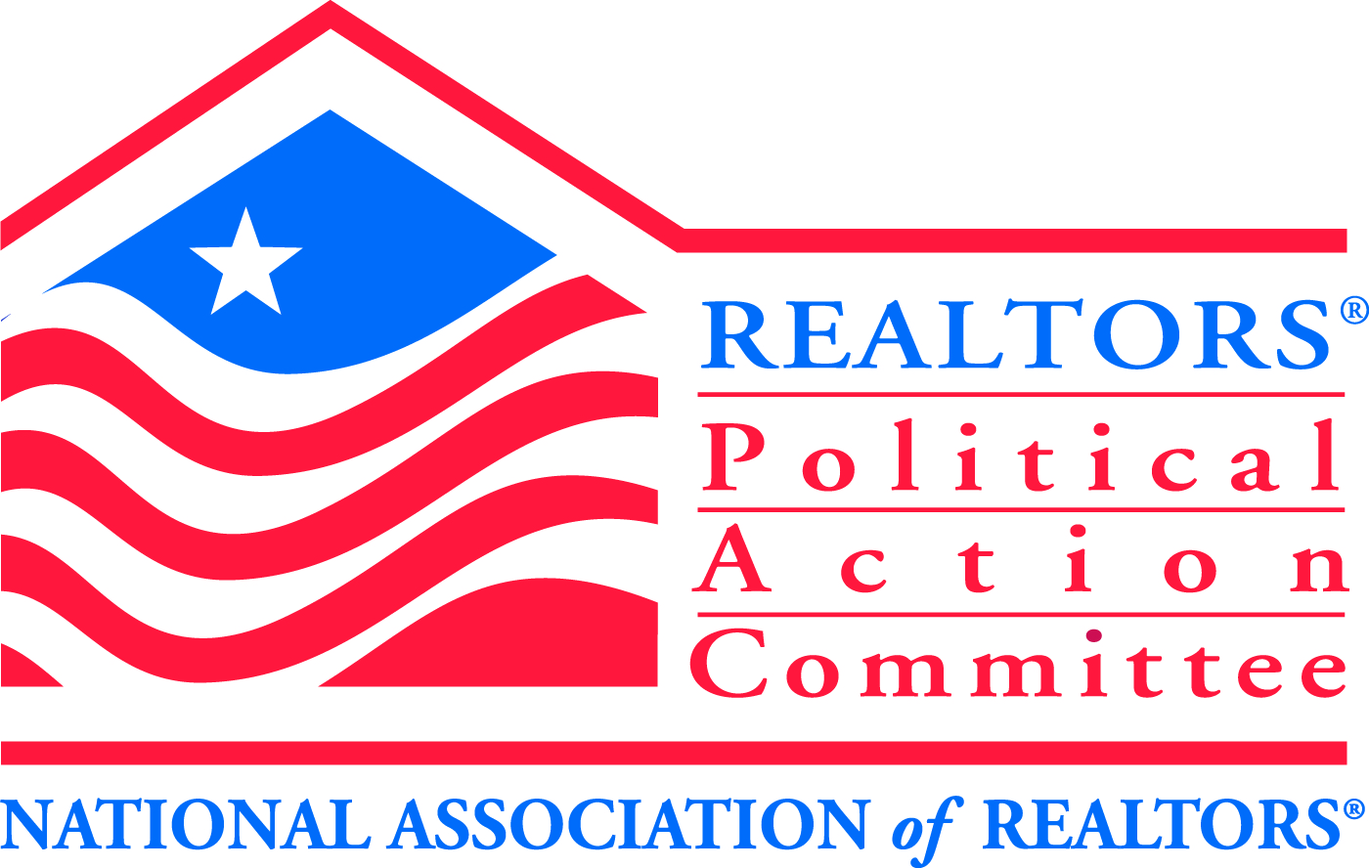
REALTOR® Political Action Committee (RPAC)

Welcome to RPAC, the voice of REALTORS® on Capitol Hill. Since 1969 RPAC has been promoting the election of pro-REALTOR® candidates across the United States. As a leading force in our nation’s public policy debates RPAC is the only investment dedicated to furthering the interests of real estate professionals in our nation’s capital, state legislatures and city halls.

Whether it is on a national, state, or local level, RPAC gives money to candidates who both understand and support REALTOR® issues. RPAC looks to build the future by putting RPAC dollars in places that will help advance the interests of Real Estate professionals. When you donate to RPAC, you give to a bipartisan organization that supports pro-REALTOR®
candidates. RPAC is the only political group in the country organized for REALTORS®, run by REALTORS® and exists solely to further issues important to REALTORS®.

Think of your RPAC contribution as an investment. The best investment you’ll ever make in your business and yourself. RPAC is your best insurance against poorly designed small business and commercial real estate profession, your business and yourself.

Are you concerned with the following issues?
- Thwarting efforts to expand the real estate transfer tax to include mortgage refinancing
- Opposing statewide sprinkler system mandates
- Preventing the State of New Hampshire from mandating expansive testing of private well water at point of sale
- Sponsoring legislation to reverse retroactive taxation of certain 1031 Real Estate Exchanges
- Supporting efforts to expand affordable housing opportunities
- Working to Protect Private Property Rights Under the Shoreland Protection Act
- Stopping town assessors from mandating commercial owners to turn over private financial data

If so, you should know the RPAC aggressively pursues the election and re-election of candidates for local, state, and federal office who stand up for and support real estate professionals on key issues like these, as well as a long list of other issues critical to our future. RPAC is the only political action committee in the country dedicated to furthering these goals. If you don’t get involved, you may face the prospect of bad legislation or a new set of crippling regulations.

Getting Involved is Simple ∙ Get involved by joining your colleagues nationwide who agree that RPAC is the best investment you can make to influence your profession’s long-term growth and the stability of the real estate industry. Whether you are a brand-new member or a seasoned veteran, RPAC offers a variety of giving levels so every REALTOR® can become involved in the political process.

Protect Your Profession ∙ RPAC not only speaks with a unified voice, but continues to provide an influential political presence. Please consider making a contribution to RPAC/IMF with your application. By doing so you are ensuring the RPAC/IMF dollars with continue to fight for REALTOR® concerns. Please send contributions to GMNBR, 6 Bedford Farms Drive, Bedford, NH 03220

REALTORS® POLITICAL ACTION COMMITTEE CONTRIBUTION CARD
YES, I want to support the real estate industry by contributing to RPAC

Name(s): ________________________________________________________________________
Address: _________________________________________________________________________
City __________________________________ State: ______________________ Zip: ___________
Company Name: ___________________________________________________________________
I am a: ____ Member ____ Association Staff Local Board: ____________________
Please indicate contribution amount: (Check One)
___ $20 ___ Sterling “R” $1,000.00 Credit Card #: ___________________
___ $99 Club $99 ___ $Crystal “R” $2,500 Signature: _______________________
___ Granite Club $250 ___ $Golden “R” $5,000 Personal Check Payable to: NHAR RPAC
___ Capitol Club $500 ___ Other (Please Specify) $___ Corporate Check Payable to: NHAR IMF

Contributions are not deductible for income tax purposes. Contributions to RPAC are voluntary and are used for political purpose. You may refuse to contribute without reprisal and the National Association of REALTORS® or any of its state associations or local boards will not favor or disfavor any member because of the amount contributed. 70% of each contribution is used by your state RPAC to support state and local political candidates. Until your state PAC reaches its RPAC goal, 30% is sent to the National RPAC to support federal candidates and is charged against your limits under 2 U.S.C. 441a: after the state PAC reaches its RPAC goal it may elect to retain your entire contribution for use in supporting state and local candidates.

