Your Best Investment in Real Estate 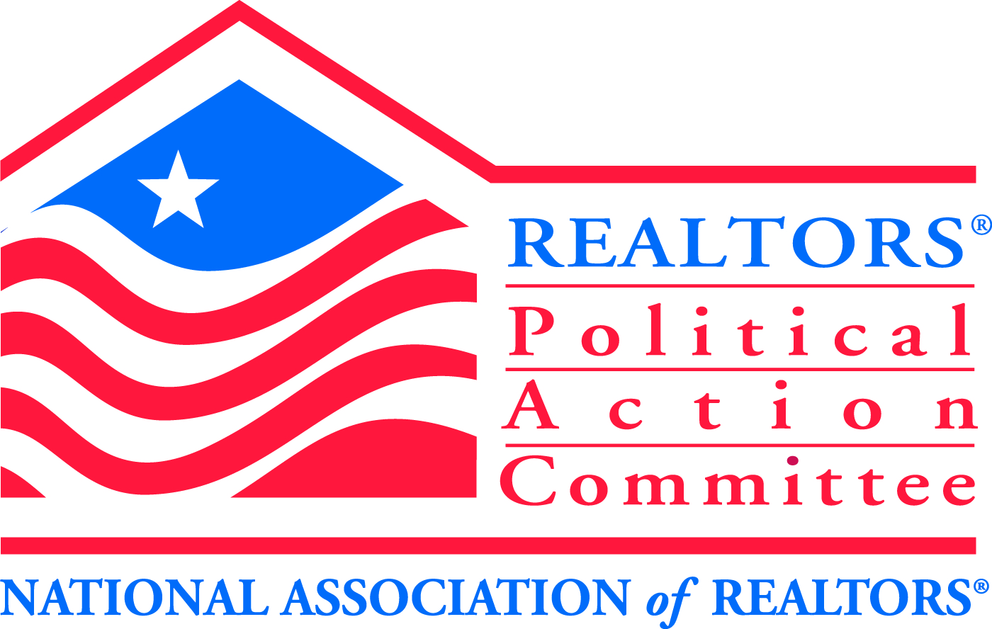
REALTOR® Political Action Committee (RPAC)

Welcome to RPAC, the voice of REALTORS® on Capitol Hill. Since 1969 RPAC has been promoting the election of pro-REALTOR® candidates across the United States. As a leading force in our nation’s public policy debates RPAC is the only investment dedicated to furthering the interests of real estate professionals in our nation’s capital, state legislatures and city halls.

Whether it is on a national, state, or local level, RPAC gives money to candidates who both understand and support REALTOR® issues. RPAC looks to build the future by putting RPAC dollars in places that will help advance the interests of Real Estate professionals. When you donate to RPAC, you give to a bipartisan organization that supports pro-REALTOR®
candidates. RPAC is the only political group in the country organized for REALTORS®, run by REALTORS® and exists solely to further issues important to REALTORS®.

Think of your RPAC contribution as an investment. The best investment you’ll ever make in your business and yourself. RPAC is your best insurance against poorly designed small business and commercial real estate profession, your business and yourself.

Are you concerned with the following issues?
- Thwarting efforts to expand the real estate transfer tax to include mortgage refinancing
- Opposing statewide sprinkler system mandates
- Preventing the State of New Hampshire from mandating expansive testing of private well water at point of sale
- Sponsoring legislation to reverse retroactive taxation of certain 1031 Real Estate Exchanges
- Supporting efforts to expand affordable housing opportunities
- Working to Protect Private Property Rights Under the Shoreland Protection Act
- Stopping town assessors from mandating commercial owners to turn over private financial data

If so, you should know the RPAC aggressively pursues the election and re-election of candidates for local, state, and federal office who stand up for and support real estate professionals on key issues like these, as well as a long list of other issues critical to our future. RPAC is the only political action committee in the country dedicated to furthering these goals. If you don’t get involved, you may face the prospect of bad legislation or a new set of crippling regulations.

Getting Involved is Simple ∙ Get involved by joining your colleagues nationwide who agree that RPAC is the best investment you can make to influence your profession’s long-term growth and the stability of the real estate industry. Whether you are a brand-new member or a seasoned veteran, RPAC offers a variety of giving levels so every REALTOR® can become involved in the political process.

Protect Your Profession ∙ RPAC not only speaks with a unified voice, but continues to provide an influential political presence. Please consider making a contribution to RPAC/IMF with your application. By doing so you are ensuring the RPAC/IMF dollars with continue to fight for REALTOR® concerns. Please send contributions to GMNBR, 6 Bedford Farms Drive, Bedford, NH 03220

REALTORS® POLITICAL ACTION COMMITTEE CONTRIBUTION CARD
YES, I want to support the real estate industry by contributing to RPAC

Name(s): ________________________________________________________________________
Address: _________________________________________________________________________
City __________________________________ State: ______________________ Zip: ___________
Company Name: ___________________________________________________________________
I am a: ____ Member ____ Association Staff Local Board: ____________________
Please indicate contribution amount: (Check One)
___ $20 ___ Sterling “R” $1,000.00 Credit Card #: ___________________
___ $99 Club $99 ___ $Crystal “R” $2,500 Signature: _______________________
___ Granite Club $250 ___ $Golden “R” $5,000 Personal Check Payable to: NHAR RPAC
___ Capitol Club $500 ___ Other (Please Specify) $___ Corporate Check Payable to: NHAR IMF

Contributions are not deductible for income tax purposes. Contributions to RPAC are voluntary and are used for political purpose. You may refuse to contribute without reprisal and the National Association of REALTORS® or any of its state associations or local boards will not favor or disfavor any member because of the amount contributed. 70% of each contribution is used by your state RPAC to support state and local political candidates. Until your state PAC reaches its RPAC goal, 30% is sent to the National RPAC to support federal candidates and is charged against your limits under 2 U.S.C. 441a: after the state PAC reaches its RPAC goal it may elect to retain your entire contribution for use in supporting state and local candidates.

