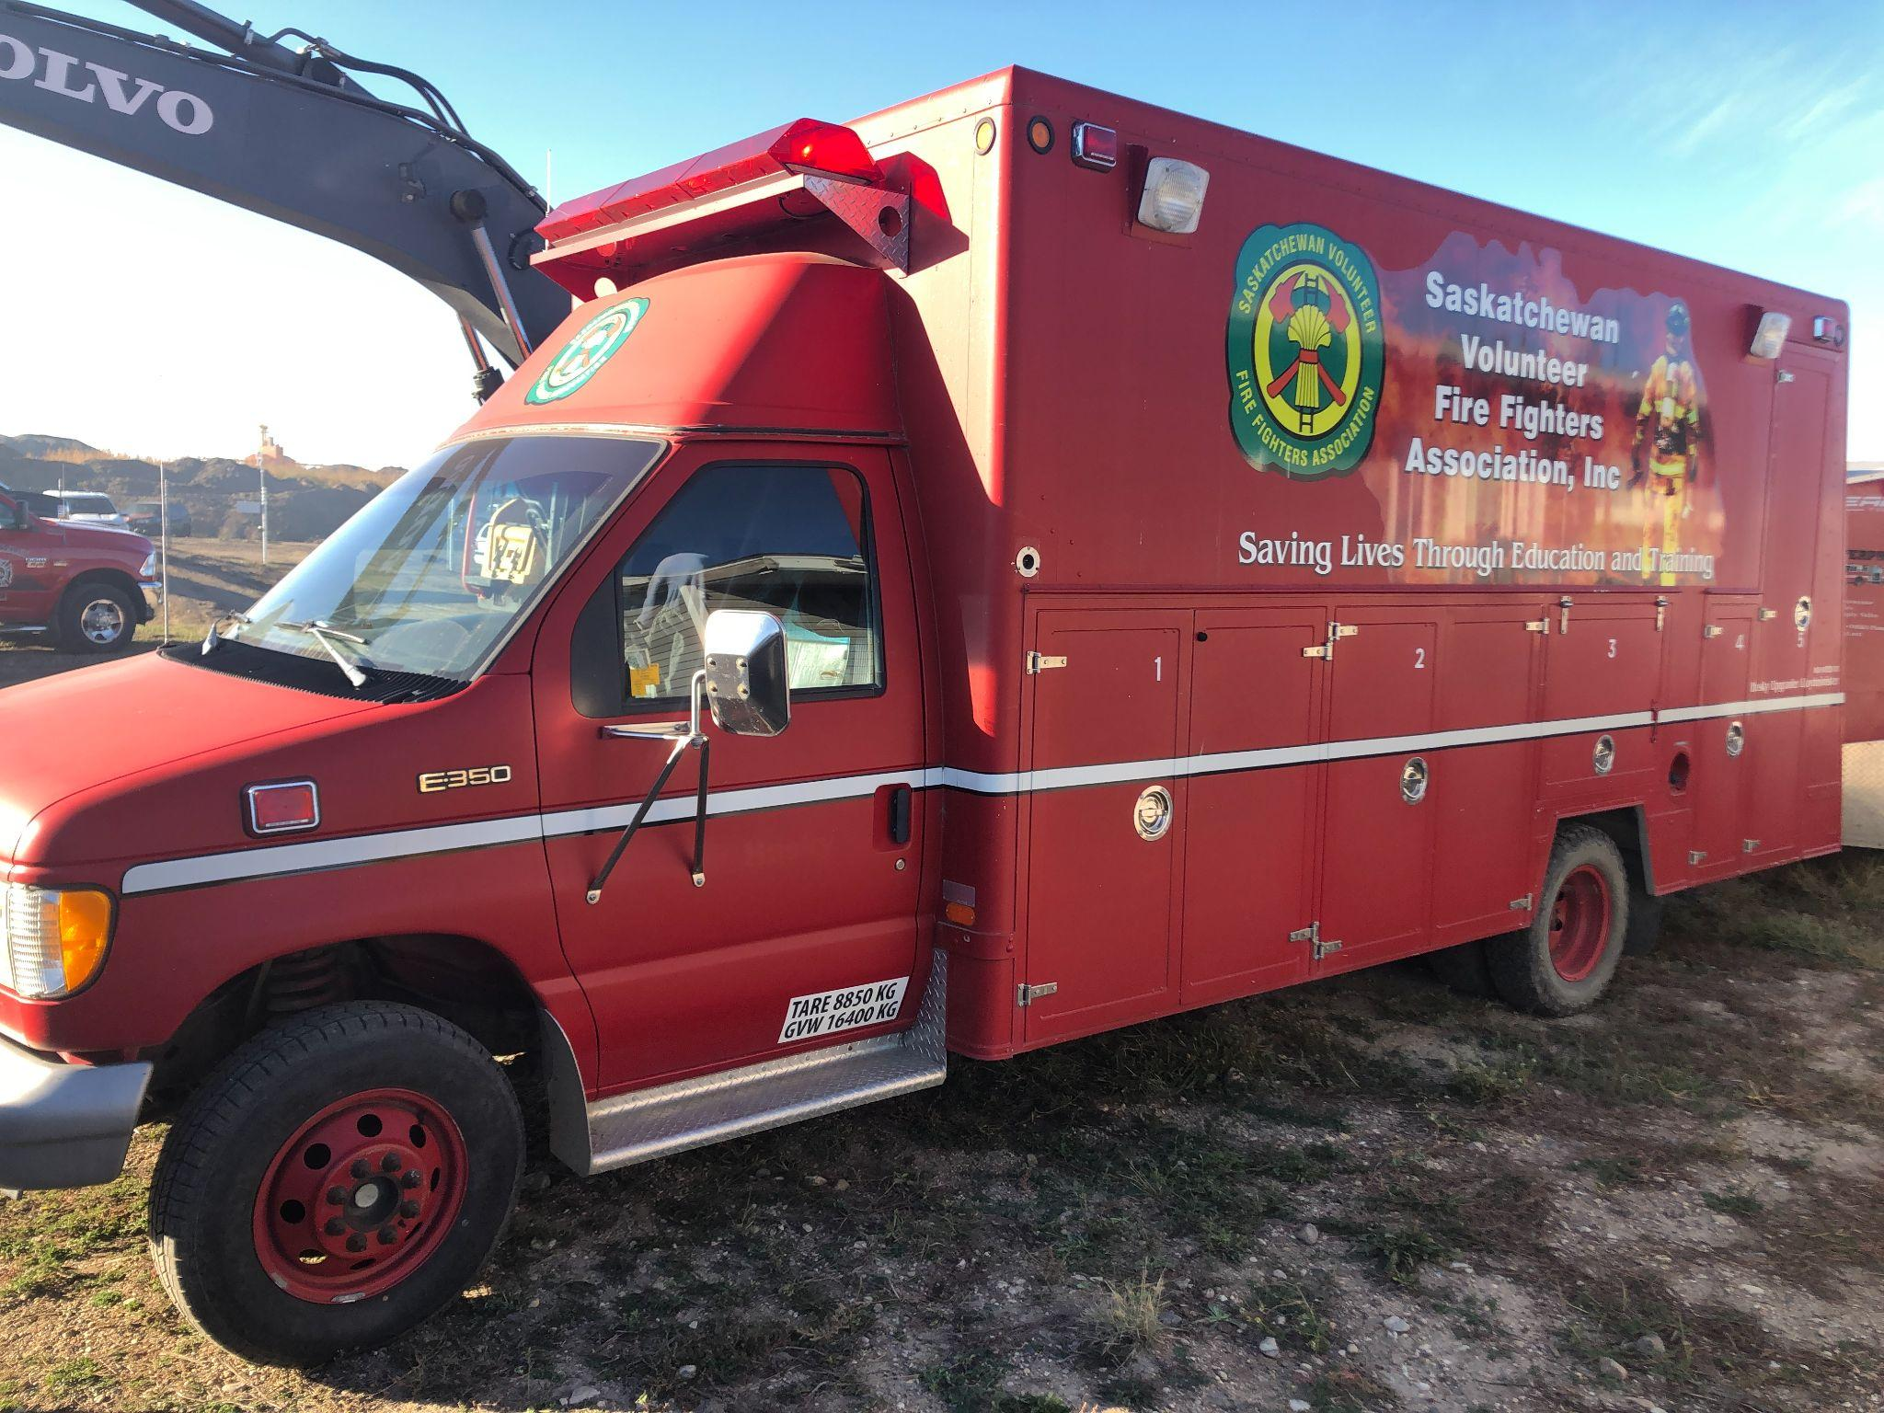**Advertisement for Tender: Used Rescue/Command Truck for Sale**

**Tender Notice**We are inviting bids for the sale of a **Used Fire Truck**. This well-maintained vehicle is available for immediate purchase through a competitive tender process.

### **Key Specifications:**

* **Make/Model**: Ford Club Wagon E-350
* **Year of Manufacture**: 1993
* **Mileage**: 10,XXX kms
* **Engine Type**: 7.3L Ford V8 PowerStroke Turbo Diesel
* **Condition**: Regularly serviced, all components in good working order, tires 80%

### **Features:**

* Fully operational emergency lighting and sirens.
* Spacious cabin with multiple storage compartments.
* Ideal for emergency response teams, rescue, or command unit.
* Vehicle only - no contents or equipment are included in this tender.

### 

### **Vehicle Inspection:**

Interested bidders are encouraged to inspect the fire truck by scheduling a visit. Please contact us at [executivedirector@svffa.ca](mailto:executivedirector@svffa.ca) or call 306-520-3278 to arrange an inspection.

### **Submission Details:**

* **Deadline for Bids**: July 31st, 2025
* **Submission Address**:

SVFFA - Executive Director

Attn: Rescue Tender

Box 26067 RPO Northgate

Regina SK S4R 8R7

* **Tender Documents**: Available upon request via email at executivedirector@svffa.ca or phone at 306-520-3278.

### **Terms & Conditions:**

* The vehicle is sold **as-is** with no warranties provided.
* The highest or any tender may not necessarily be accepted.
* Payment must be completed within 30 days after the acceptance of the bid.

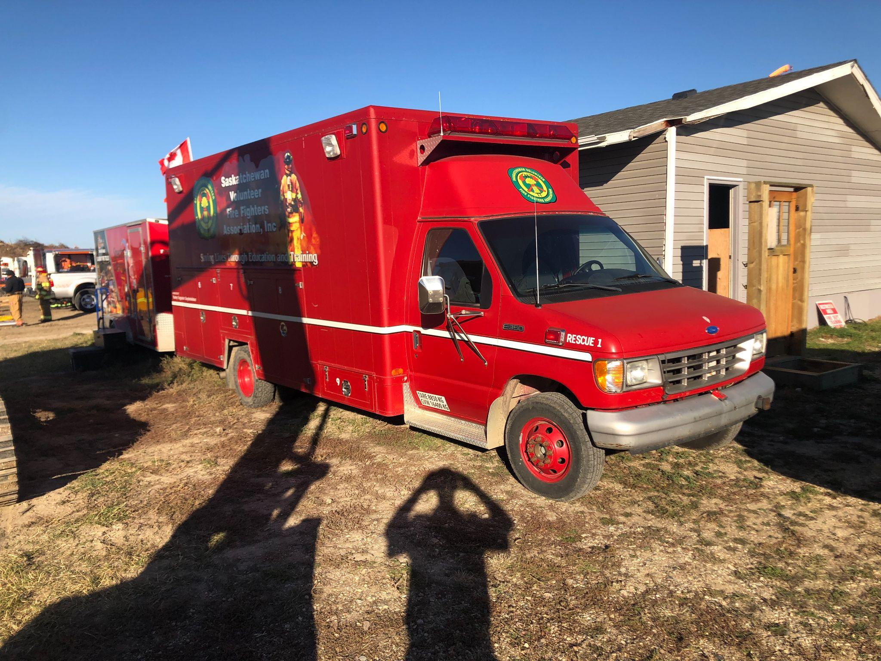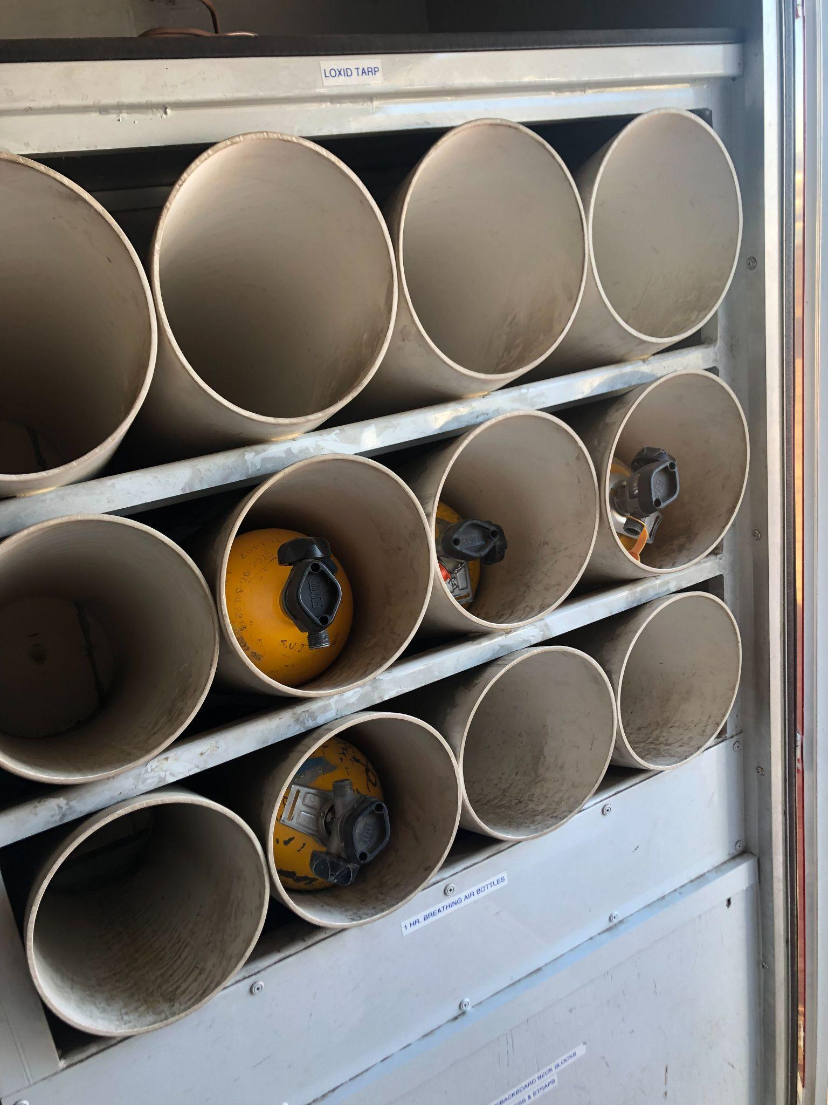 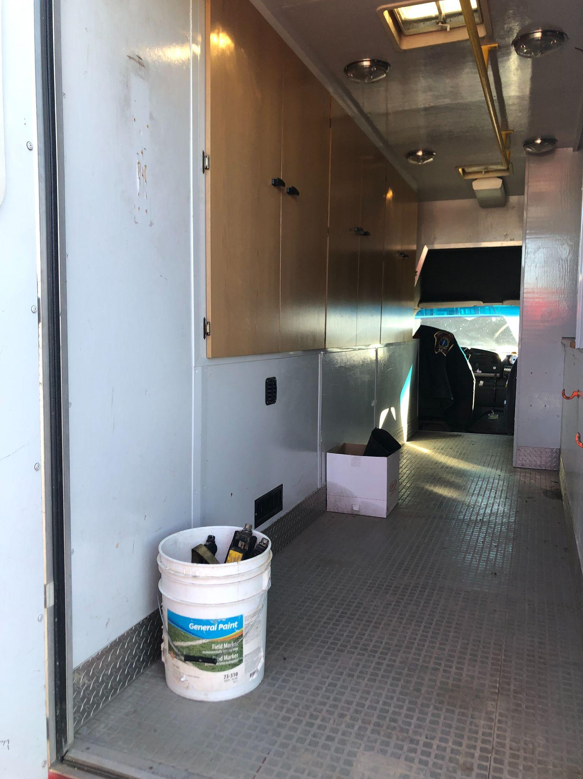

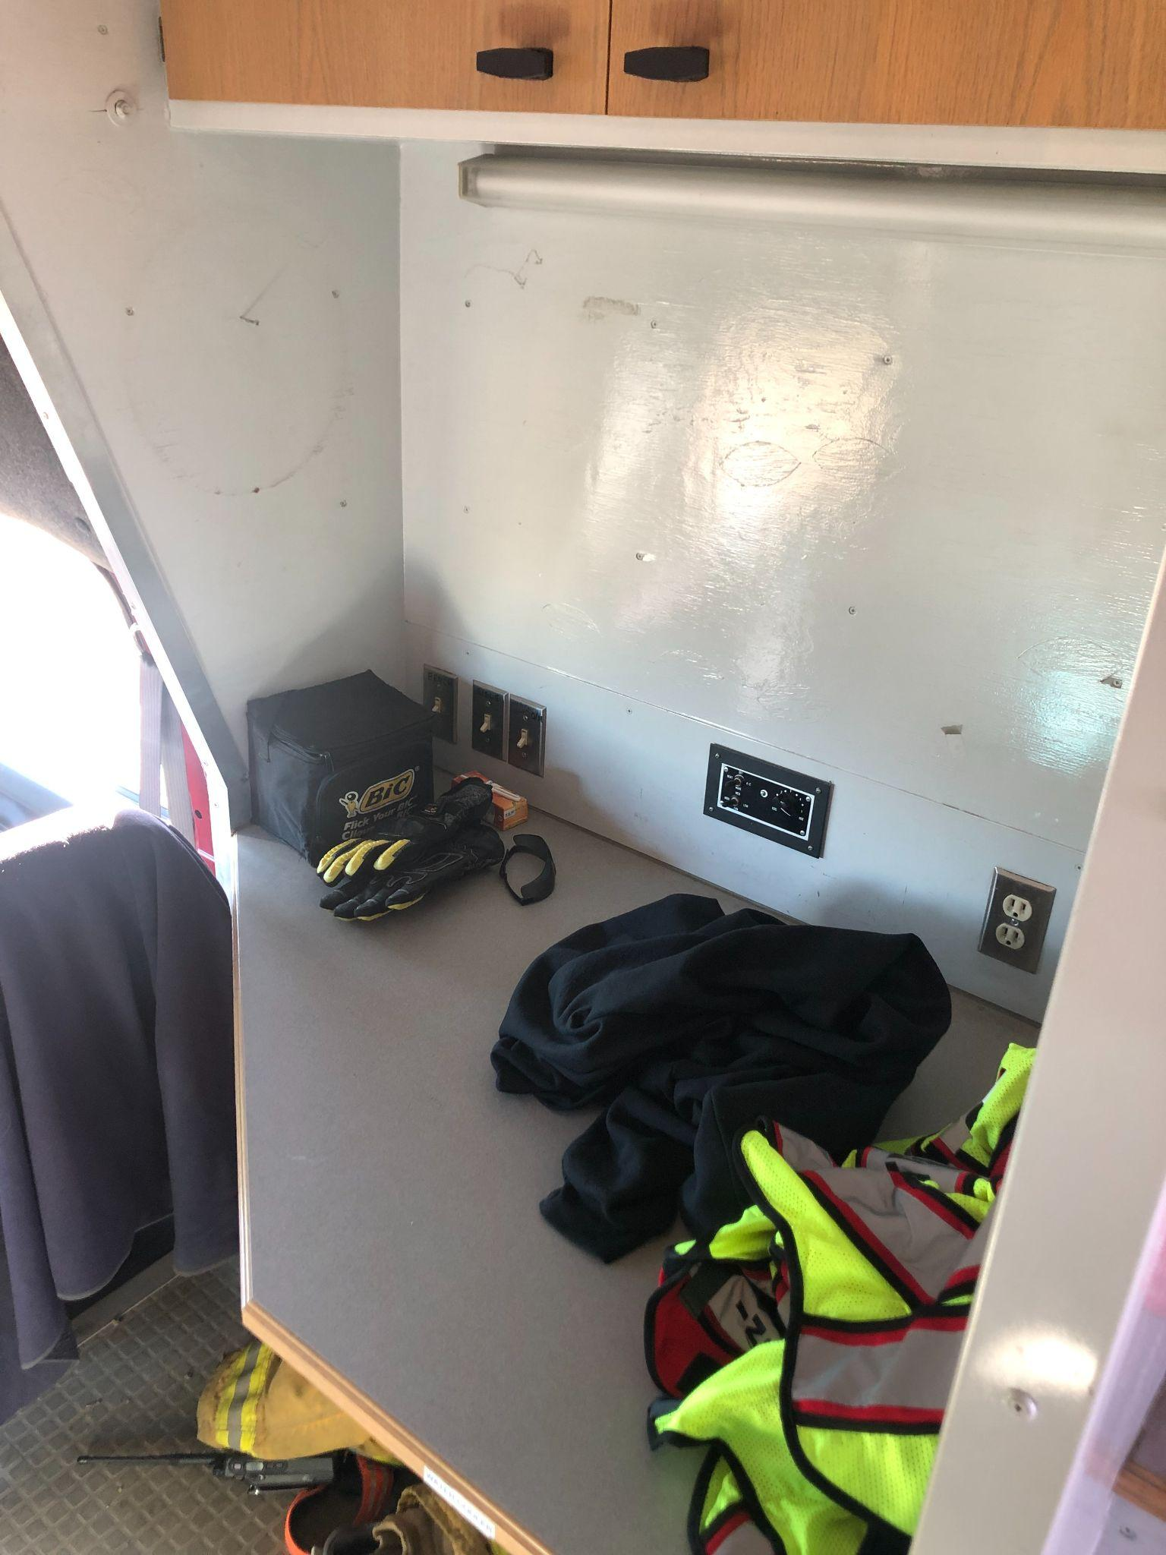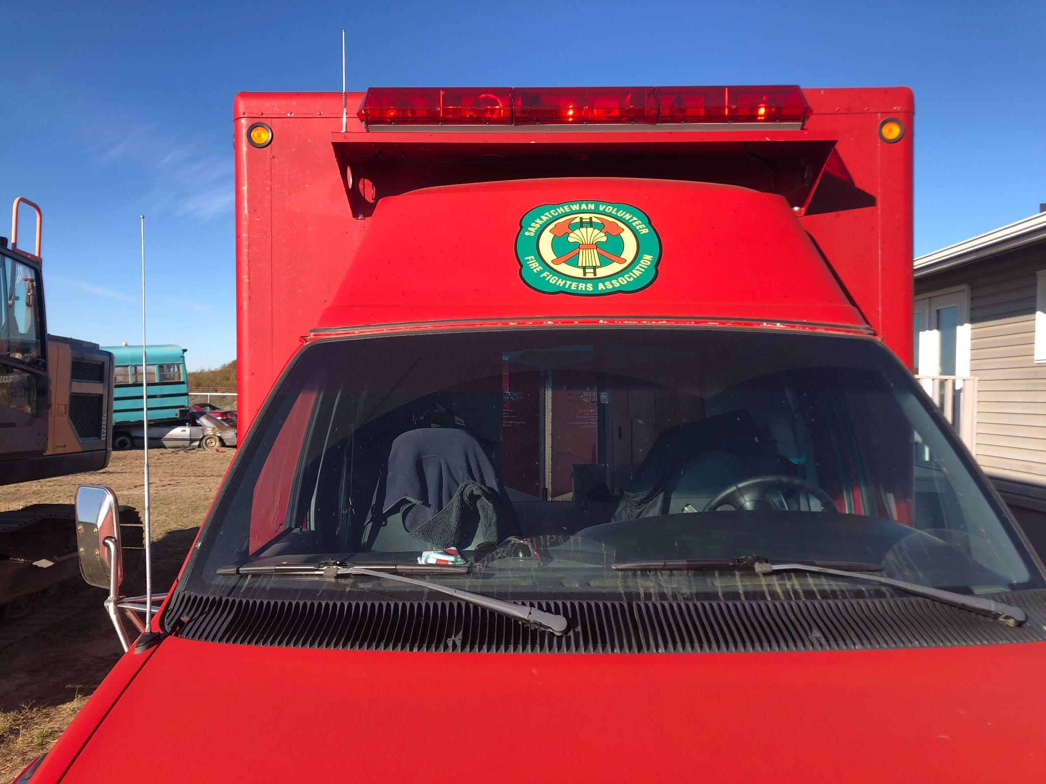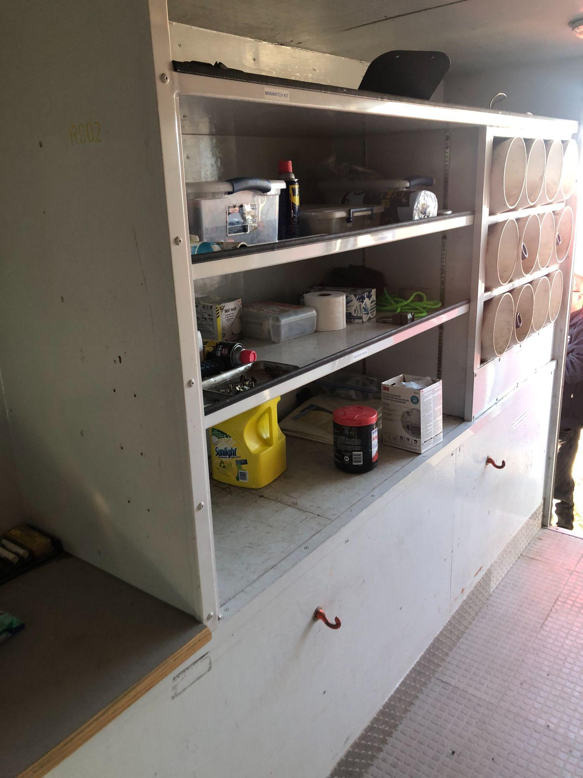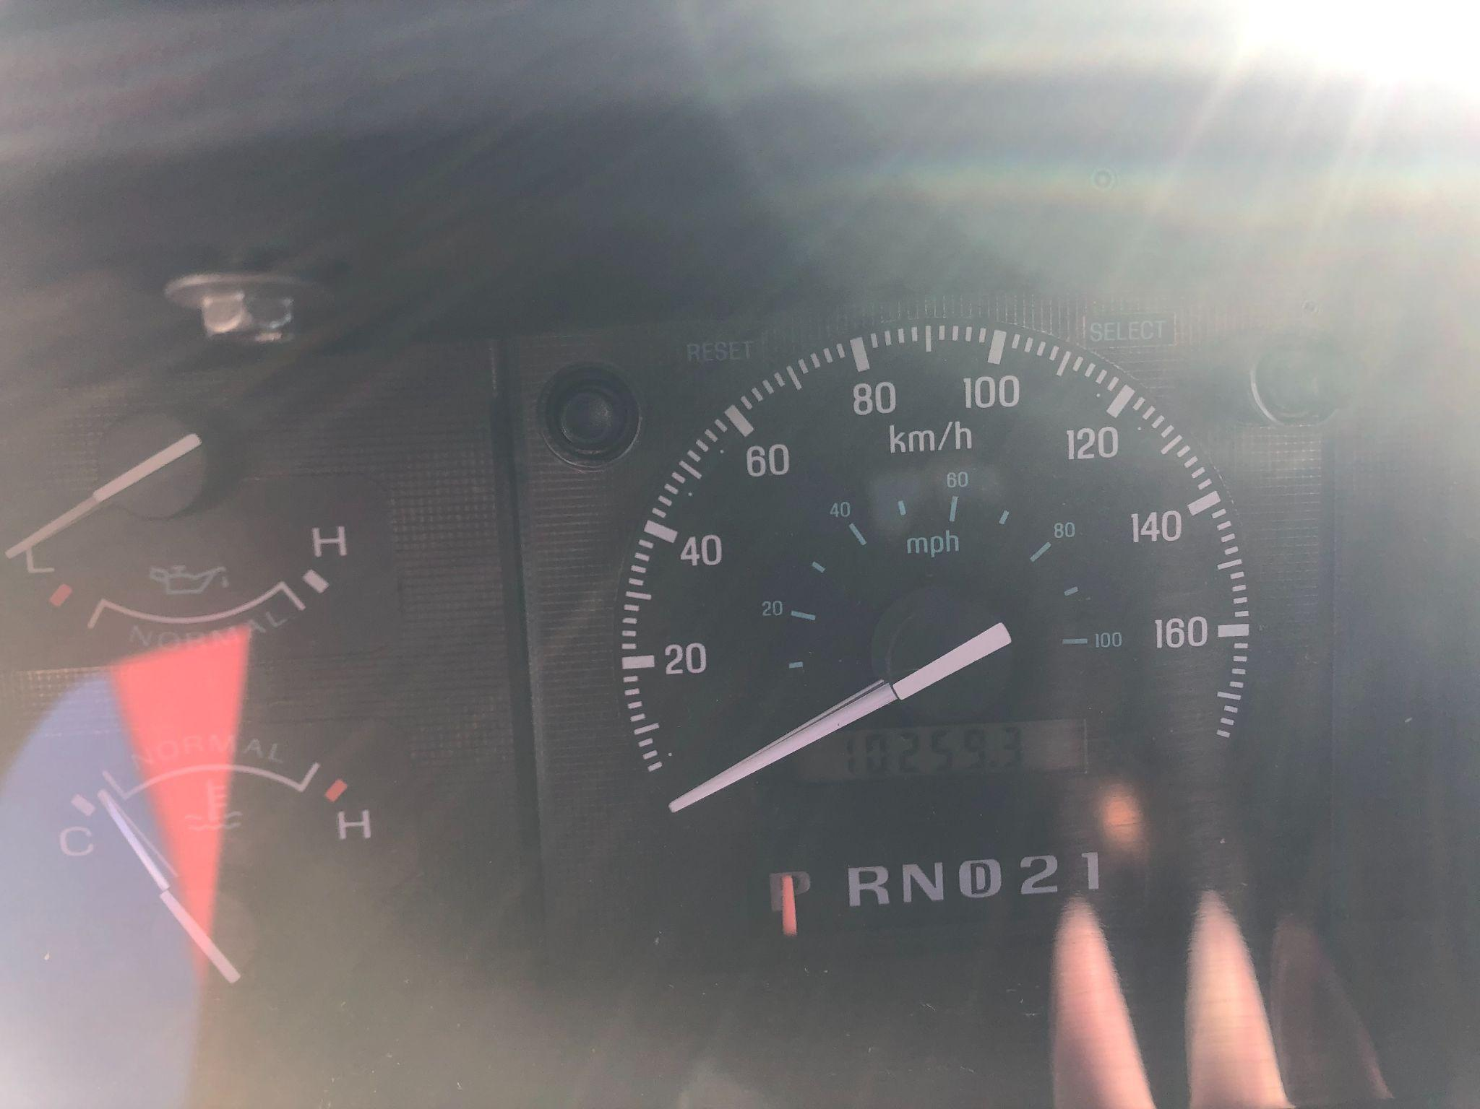

**Tender Submission Document for Purchase of Used Fire Truck**

Date:

**Part 1: Bidder Information**

1. Bidder's Full Name/Company Name:
2. Address:
3. Phone Number:
4. Email Address:
5. Contact Person:

### 

### **Part 2: Bid Details**

1. Fire Truck Details:  
   Bidder acknowledges the details of the fire truck, including the following:
   * Mode**l**: Ford Club Wagon E-350
   * Engine: 7.3L Ford V8 PowerStroke Turbo Diesel
   * Mileage: 10,XXX kms
   * Year of Manufacture: 1993
   * Condition: Sold as-is, with no warranties
2. Bid Offer (Canadian Dollars):  
   **We hereby submit our bid for the purchase of the used fire truck in the amount of:**

### **Part 3: Terms & Conditions**

1. Acknowledgment of Inspection:  
   We confirm that we have inspected the fire truck and are satisfied with its current condition.  
   [ ] Yes  
   [ ] No  
   If no, explain: [Insert Explanation]
2. Payment Terms:  
   We agree to make the full payment of the bid amount within 30 days upon acceptance of the tender.
3. Validity of Offer:  
   Our offer remains valid for 30 days from the submission deadline.
4. Acknowledgment of Terms:  
   We acknowledge that the vehicle is sold as-is, and that the seller reserves the right to accept or reject any or all tenders.

### 

### **Part 4: Declaration**

I/we, the undersigned, declare that the information provided in this tender submission is true and correct. We understand that any false information may result in disqualification from the tender process.

Name:

Title:

Authorised Signature: ________________________

Date: