**Advertisement for Tender: Used Rescue/Command Truck for Sale**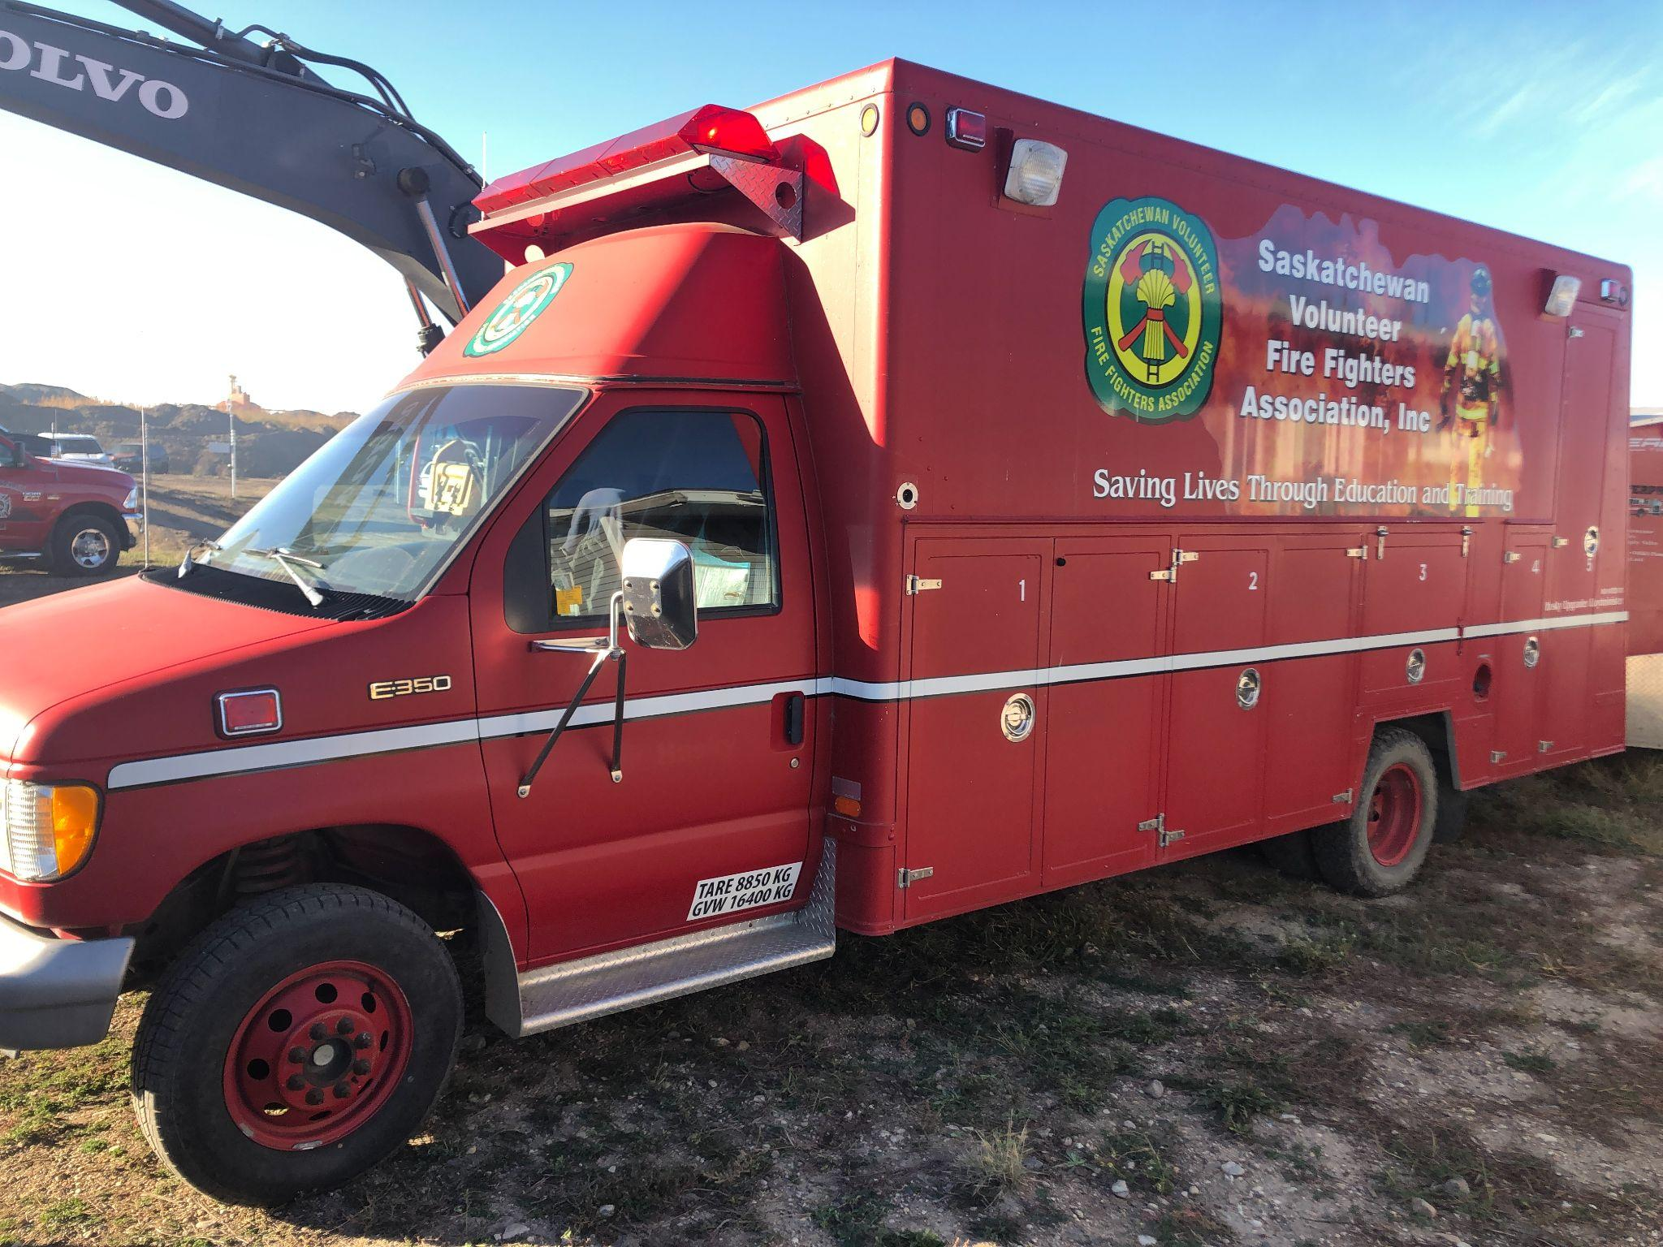

**Tender Notice**We are inviting bids for the sale of a **Used Fire Truck**. This well-maintained vehicle is available for immediate purchase through a competitive tender process.

### **Key Specifications:**

* **Make/Model**: Ford Club Wagon E-350
* **Year of Manufacture**: 1993
* **Mileage**: 10,XXX kms
* **Engine Type**: 7.3L Ford V8 PowerStroke Turbo Diesel
* **Condition**: Regularly serviced, all components in good working order, tires 80%

### **Features:**

* Fully operational emergency lighting and sirens.
* Spacious cabin with multiple storage compartments.
* Ideal for emergency response teams, rescue, or command unit.
* Vehicle only - no contents or equipment are included in this tender.

### 

### **Vehicle Inspection:**

Interested bidders are encouraged to inspect the fire truck by scheduling a visit. Please contact us at [executivedirector@svffa.ca](mailto:executivedirector@svffa.ca) or call 306-520-3278 to arrange an inspection.

### **Submission Details:**

* **Deadline for Bids**: January 10th, 2025
* **Submission Address**:

SVFFA - Executive Director

Attn: Rescue Tender

Box 26067 RPO Northgate

Regina SK S4R 8R7

* **Tender Documents**: Available upon request via email at executivedirector@svffa.ca or phone at 306-520-3278.

### **Terms & Conditions:**

* The vehicle is sold **as-is** with no warranties provided.
* The highest or any tender may not necessarily be accepted.
* Payment must be completed within 30 days after the acceptance of the bid.

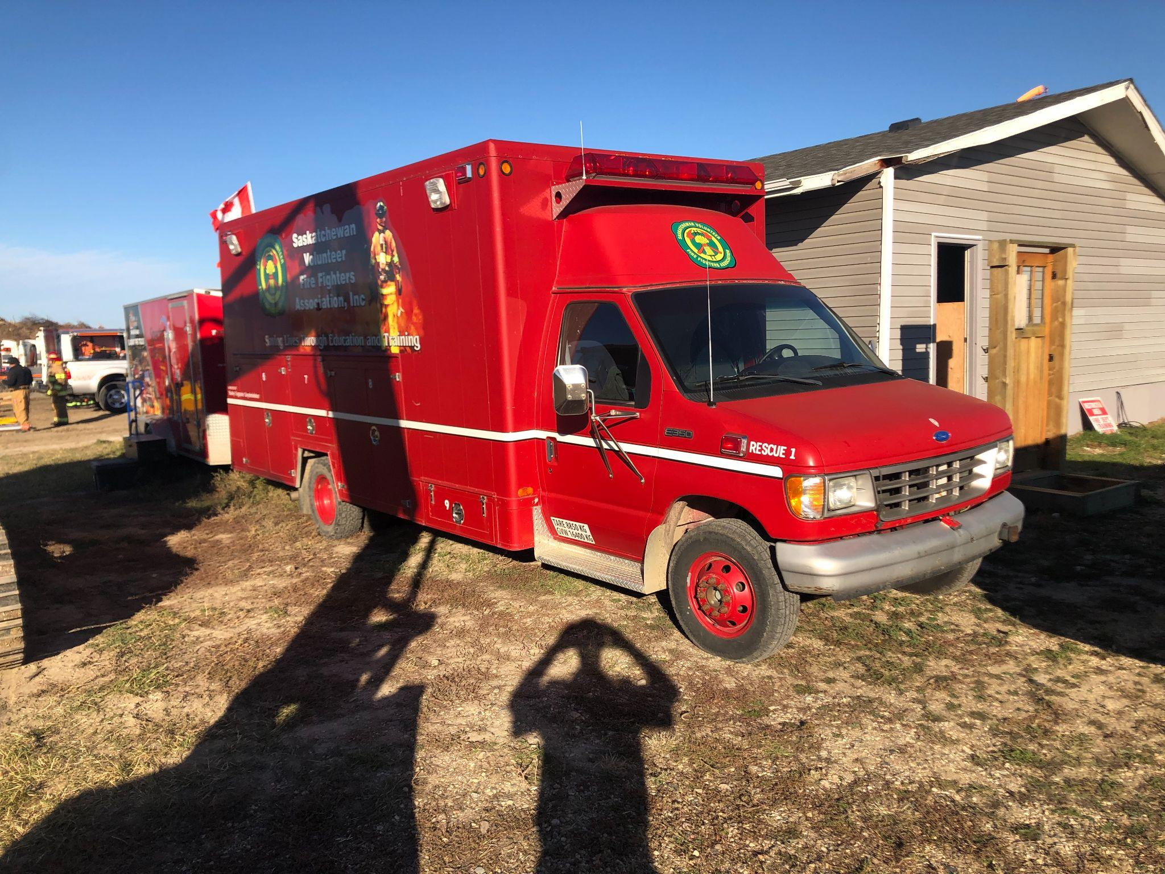

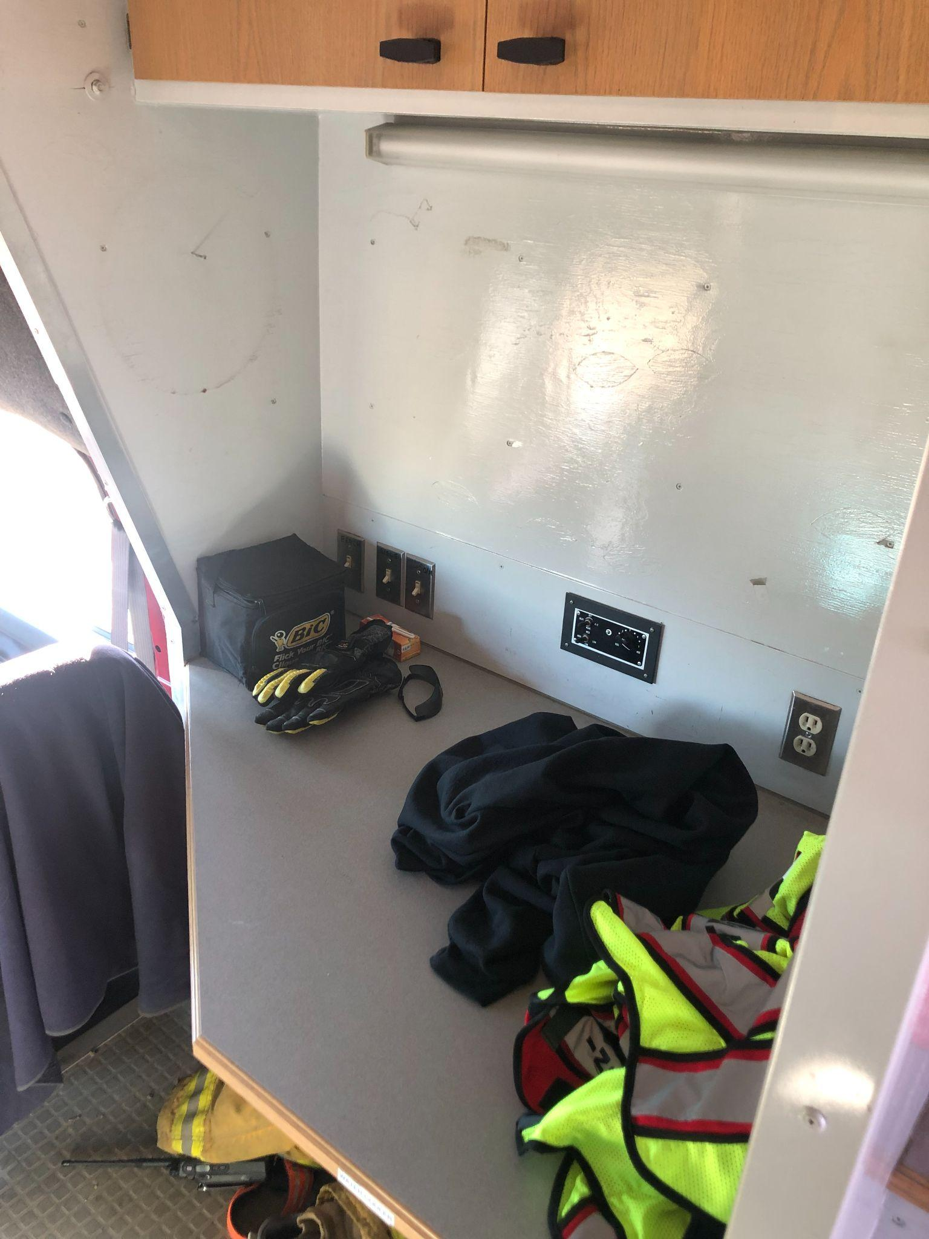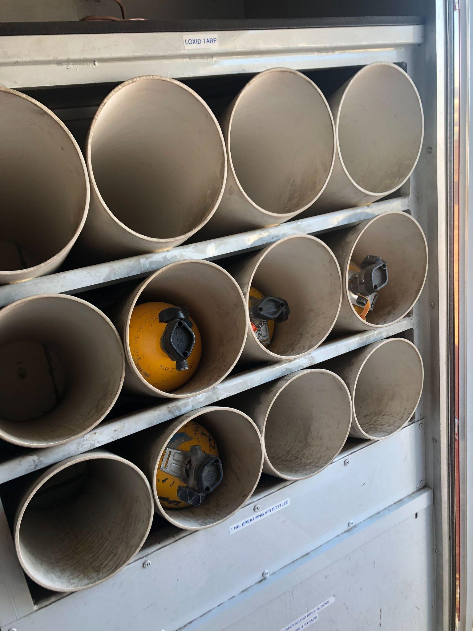 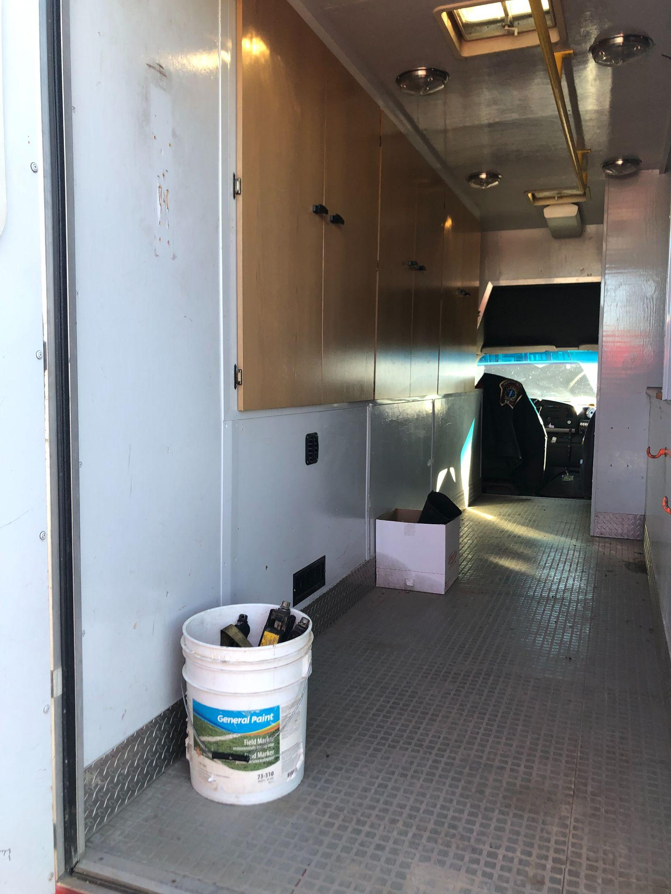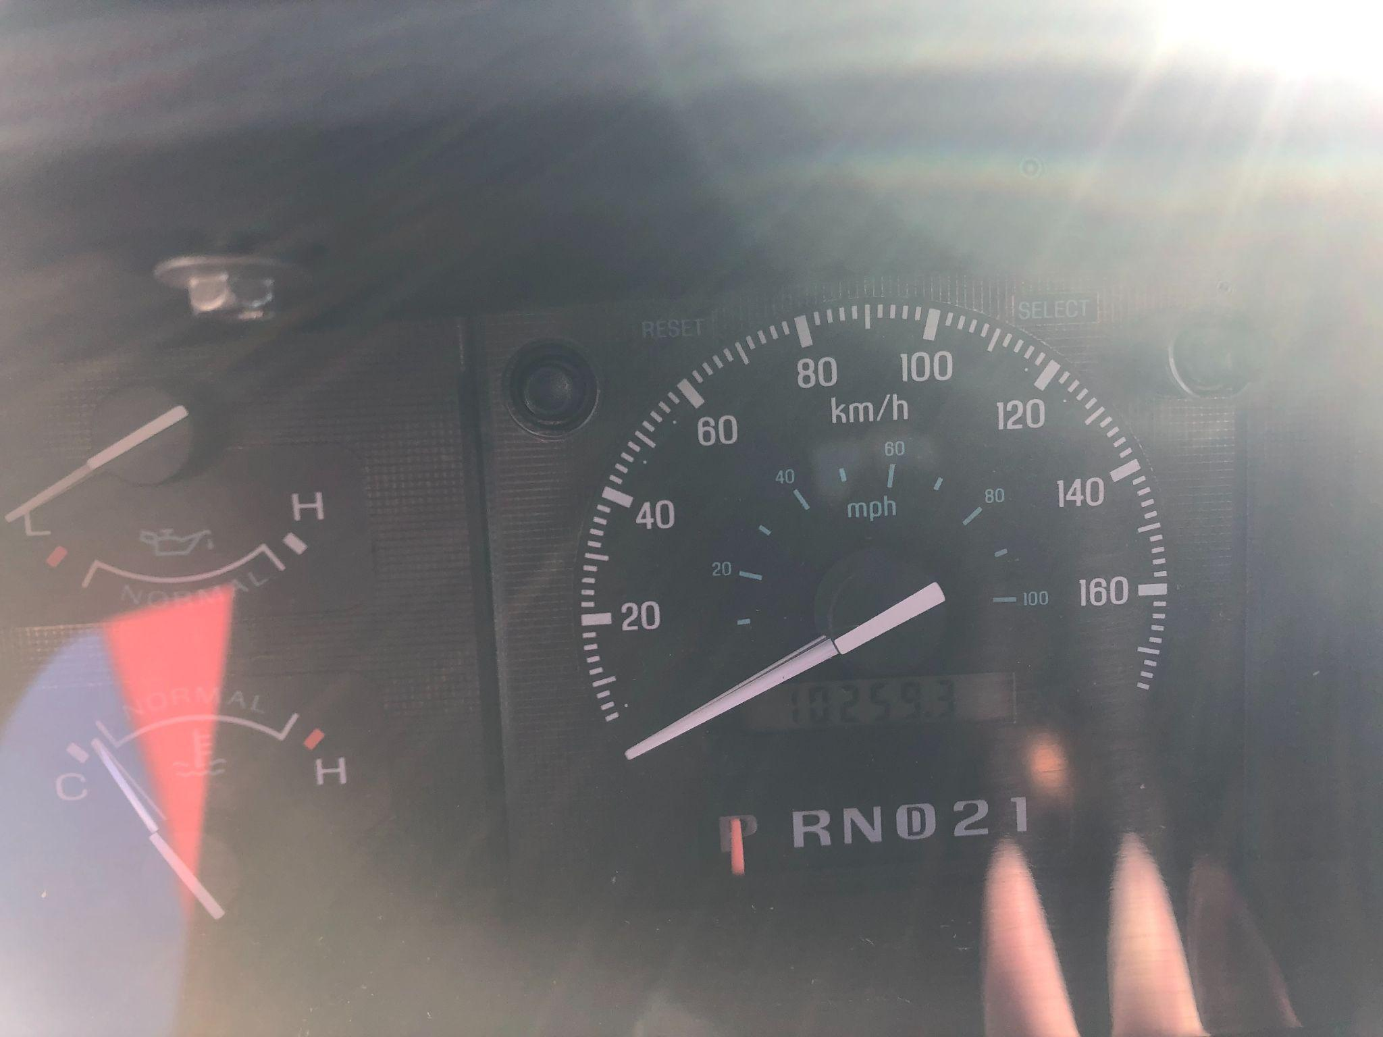

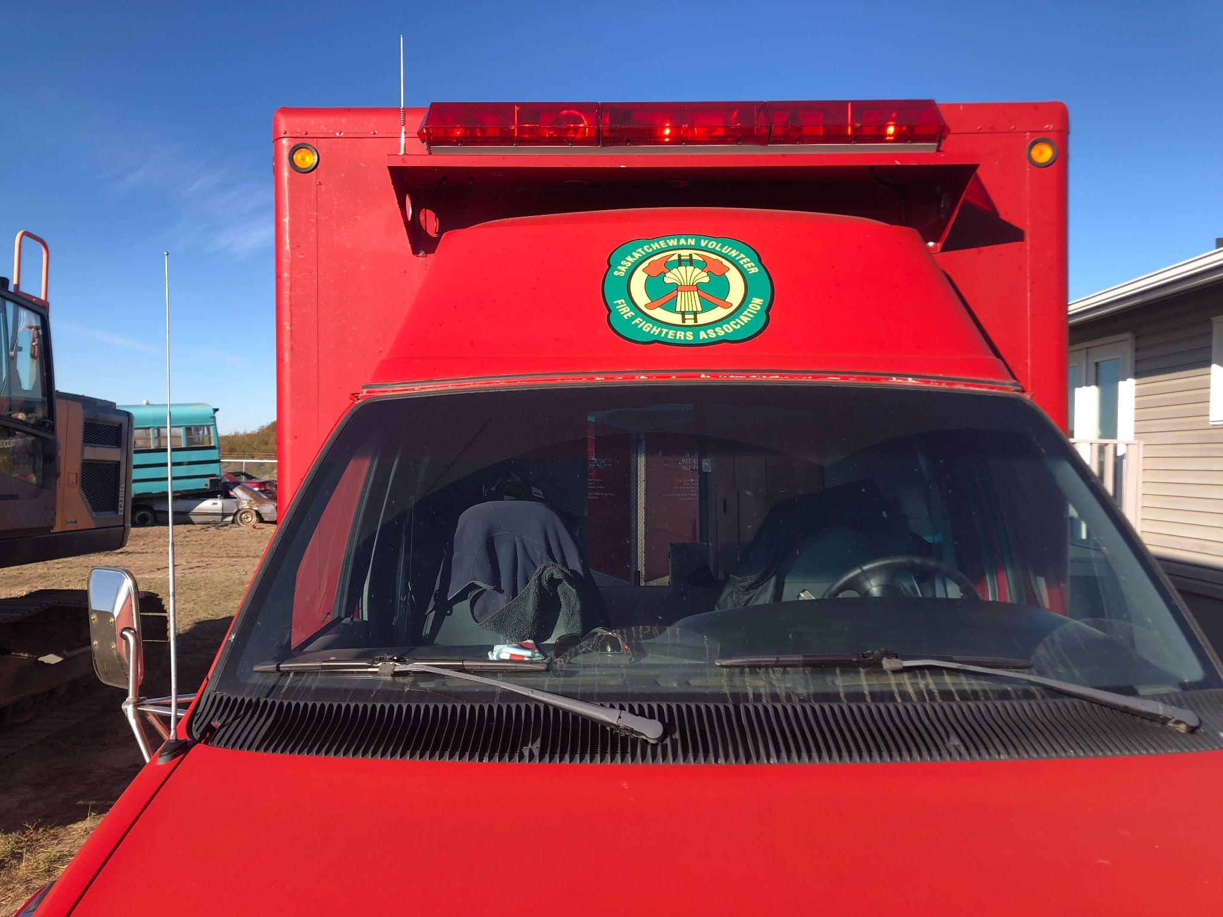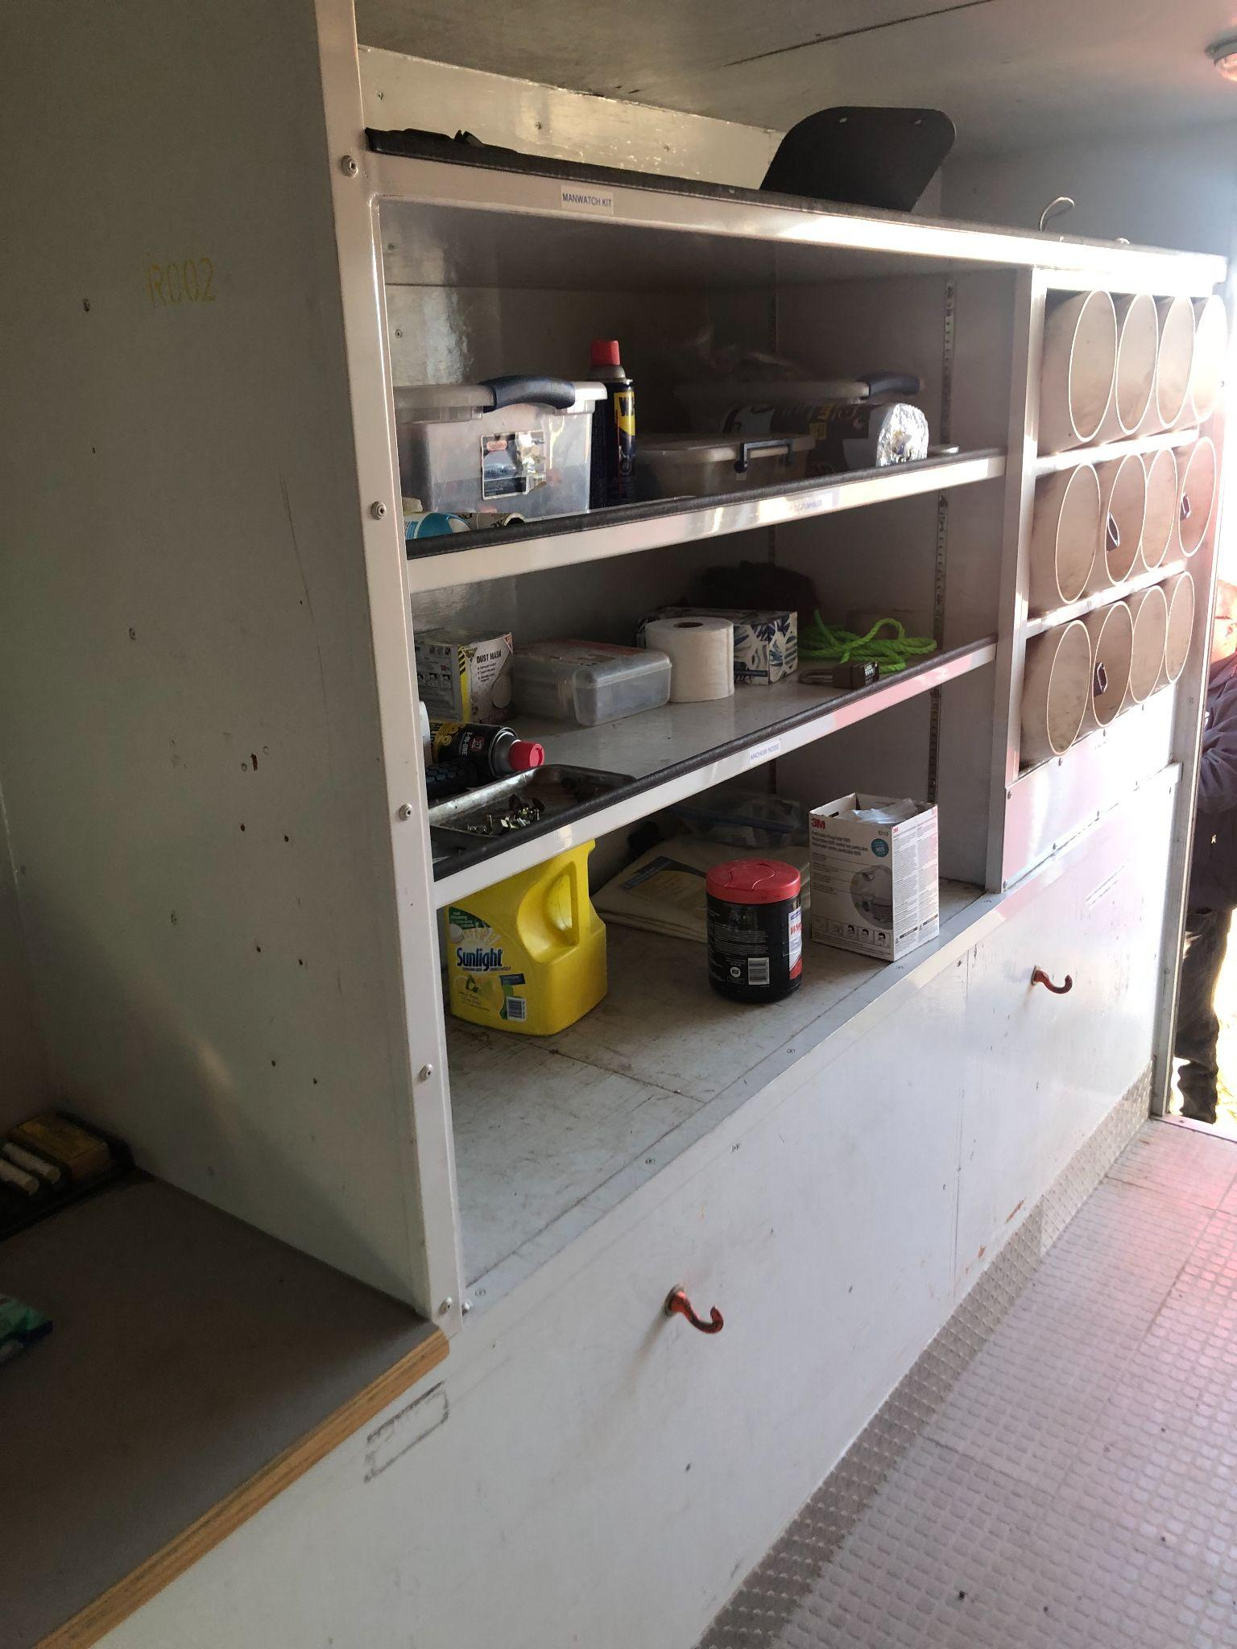

**ALL SVFFA DECALS WILL BE REMOVED**