SAMPLE STATE REQUEST FOR PROCLAMATION

WHEREAS: One of the basic rights of children, as set forth in the Universal Declaration of Human Rights by Eleanor Roosevelt in 1948, is their right to basic nutrition. Caring for the children must be our nation’s first priority; and

WHEREAS: Since the inception of the Child and Adult Care Food Program (CACFP) in 1968, it has granted our children the best possible foundation in life and benefited many adults, which is vital to our state’s long-term health; and

WHEREAS: The two fundamental goals of the CACFP are that children serviced by this program will be well nourished during their crucial early years, while concurrently learning healthy eating behaviors that will last their lifetime. Nutritious diets are foundational for emotional, mental, and physical health; and

WHEREAS: We acknowledge the child and adult care providers, nutrition educators, program specialists and staff, state and federal professionals and parents who contribute to the success of this outstanding program; and

WHEREAS: The CACFP community will continue its commitment to the benefits of nutritious eating for children and adults in care. Together, as Americans, we can make a difference in the lives of our youngest and most vulnerable citizens.

Now therefore, I, [Name], Governor of the State of [your State], do hereby proclaim the week of March 15-21, 2026, to be NATIONAL CHILD AND ADULT CARE FOOD PROGRAM WEEK. I urge our citizens and all agencies and organizations to unite on that week in observance of the necessity of the Child and Adult Care Food Program to provide food security to children, individuals with disabilities and older adults in our community.

______________________________________ ________
Governor’s Signature Date

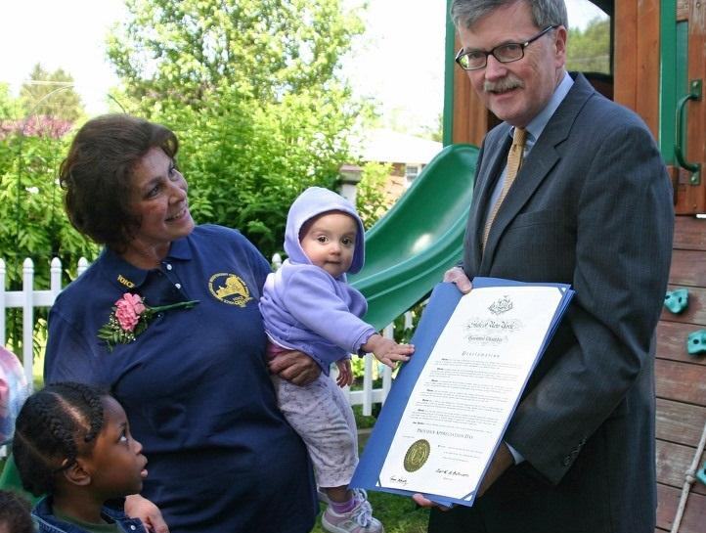

Ask Your Governor to Issue a State Proclamation
Share these outreach materials with your state governor’s office now, and together with other sponsors and providers from across the state, petition for a state proclamation to coincide with National CACFP Week. It’s a grassroots effort that, when fulfilled, will serve to raise awareness in your state government as well as community members across your state.

