PRESS RELEASE
“This program provides over
1.7 billion meals and snacks to over 4.6 million children and adults daily.”

DATE: Date
TO: Local Newspaper
FROM: Your Organization Name
Address
FOR: IMMEDIATE RELEASE
SUBJECT: National Child & Adult Care Food Program Week: March 15-21, 2026
The primary goal of the Child and Adult Care Food Program (CACFP) is to serve nutritious meals to children in family child care homes, child care centers, and afterschool programs. The CACFP also serves children under the age of 18 in emergency shelters and adults in day care. The food program also contributes to the establishment of positive eating habits at the earliest stages of development, reduction of future health care and education costs due to lack of proper early development and training and support for local child care personnel.
During National CACFP Week, (Your Organization Name) joins with all other organizations nationwide working in the CACFP in acknowledging the many ways our community benefits from the program.
Children and adults who are cared for by providers participating in the CACFP benefit from nutritious meals that ensure proper development. Children in CACFP care settings receive meals that are nutritionally superior to those served to children in comparable child care settings not participating in the CACFP. These children also benefit from early nutrition education that helps them establish positive eating habits that will enrich the quality of their diet throughout their lives. Research shows that CACFP reduces food insecurity and plays a vital, clear role in supporting long-term positive health outcomes.
Parents of children in child care are assured that their child(ren) receive high-quality meals. With proper nutrition, the child is less likely to experience illness and fatigue and will develop at a normal physical and intellectual pace. Good nutrition is the recipe for an all-around happier child. By expanding access and strengthening CACFP, working families can ensure that their children are well cared for and receive the nutrient-rich diet and tools they need to be healthy.
Providers receive nutrition education and support services from their CACFP sponsor that help them serve nutritious meals and create a positive eating environment for children. Reimbursement for CACFP participation supports providers in purchasing healthy foods to serve to those in their care. As a result, CACFP providers serve more fruits, vegetables, whole grains and milk and less saturated fats and added sugars than non-CACFP child care providers. Research shows that the CACFP is an indicator of an overall higher quality of child care.
This program provides over 1.7 billion meals and snacks to over 4.6 million children daily in child care centers, family day care homes, after-school programs, and emergency shelters, and over 117,000 adults in adult day care. Over 80,000 child care centers and 68,000 family child care providers work with 500 sponsors to use CACFP to provide children with high quality nutrition and learning experiences.
Please join us in honoring all CACFP providers for their invaluable work done on behalf of (Your State) children.
CONTACT: (Your Name, Phone, Email Address)
MORE INFO: www.cacfp.org

CHILD AND ADULT CARE FOOD PROGRAM: AVERAGE DAILY ATTENDANCE
Data from FY 2024
State/Territory | Number of Children and Adults Served |  | State/Territory | Number of Children and Adults Served
Alabama | 43,282 |  | Montana | 10,516
Alaska | 6,223 |  | Nebraska | 31,735
Arizona | 54,840 |  | Nevada | 18,962
Arkansas | 55,803 |  | New Hampshire | 7,882
California | 672,992 |  | New Jersey | 99,588
Colorado | 34,298 |  | New Mexico | 37,791
Connecticut | 27,805 |  | New York | 256,032
Delaware | 39,464 |  | North Carolina | 118,144
District of Columbia | 20,851 |  | North Dakota | 13,693
Florida | 296,909 |  | Ohio | 96,682
Georgia | 130,174 |  | Oklahoma | 57,643
Guam | 653 |  | Oregon | 32,563
Hawaii | 7,859 |  | Pennsylvania | 120,249
Idaho | 8,315 |  | Puerto Rico | 16,236
Illinois | 127,287 |  | Rhode Island | 8,729
Indiana | 80,807 |  | South Carolina | 41,279
Iowa | 34,310 |  | South Dakota | 9,644
Kansas | 38,623 |  | Tennessee | 69,810
Kentucky | 66,479 |  | Texas | 1,046,764
Louisiana | 83,559 |  | Utah | 29,738
Maine | 9,390 |  | Vermont | 8,958
Maryland | 74,503 |  | Virginia | 92,595
Massachusetts | 72,015 |  | Virgin Islands | 549
Michigan | 59,079 |  | Washington | 55,018
Minnesota | 85,642 |  | West Virginia | 22,906
Mississippi | 39,341 |  | Wisconsin | 41,970
Missouri | 200,192 |  | Wyoming | 6,188
 |  |  | TOTAL | 4,722,552
Source: USDA Food and Nutrition Service
Data are subject to revision.

LETTER TO CONGRESS
(Date)
Senator (First and Last Name)
(Address)
(City, State Zip)
Dear Senator (Last Name):
March 15-21, 2026 is National Child & Adult Care Food Program (CACFP) Week. The CACFP is a federal program that provides reimbursements for nutritious meals and snacks to participating child care centers, afterschool programs, family child care homes, emergency shelters, and adult day care centers. The CACFP has been cited both in academic studies and in government reports for the contributions it makes to the well-being of children being cared for in our child care system. This program provides over 1.8 billion meals and snacks to over 4.5 million children and adults and is an indicator of quality child care.
Because this program is so important to the constituents in your state, I would love you to join me in celebrating the goals of the program and am requesting your support during National CACFP Week.
The primary goal of the CACFP is to serve nutritious meals that contribute to the wellness, healthy growth, and development of young children, especially those in low-income areas, and the health and wellness of older adults and individuals with disabilities. The CACFP also aims to promote the establishment of lifelong, positive eating habits; reduce future health care and education costs due to lack of proper early development; and train and support local child care personnel. The CACFP benefits our state in the following ways:
FOR THE CHILD
Proper nutrition during the early years of childhood ensures appropriate development and reduces physical and educational challenges later in life. Eating patterns and habits established during these years are vital to positive health outcomes. Children participating in the CACFP enjoy meals that meet the evidence-based USDA nutrition requirements that help combat hunger and improve food security.
FOR THE PARENT
Parents are assured that their children receive high quality, well-balanced meals. A well-nourished child is less likely to experience fatigue and illness, which would require parents to be absent from work. Children are more likely to be healthy, happy and develop at a normal physical and intellectual pace. Resources sent home with the children, like easy and highly nutritious recipes that they can make at home, contribute to the health of the entire household.
FOR THE PROVIDER
Providers receive valuable nutrition education that helps them identify the proper foods and proportions necessary to provide nutrient-rich meals and snacks to the children and adults in their care. They obtain help in understanding how to encourage positive, lifelong eating habits. The financial reimbursement helps them to afford to serve meals that are nutritionally superior to those served to children in comparable child care settings not participating in CACFP.
FOR THE COMMUNITY
Within our state, approximately (enter number) children and adults directly benefit from the food program. The CACFP in our state meets the nutritional needs of children, individuals with disabilities and older adults while they are in care, resulting in significant enrichment and improvement of the quality of child care provided in our community.
We must all work together to continue to strengthen and provide access to the CACFP.
Sincerely,

(Your Name)
(Your Organization)
SAMPLE STATE REQUEST FOR PROCLAMATION

WHEREAS: One of the basic rights of children, as set forth in the Universal Declaration of Human Rights by Eleanor Roosevelt in 1948, is their right to basic nutrition. Caring for the children must be our nation’s first priority; and

WHEREAS: Since the inception of the Child and Adult Care Food Program (CACFP) in 1968, it has granted our children the best possible foundation in life and benefited many adults, which is vital to our state’s long-term health; and

WHEREAS: The two fundamental goals of the CACFP are that children serviced by this program will be well nourished during their crucial early years, while concurrently learning healthy eating behaviors that will last their lifetime. Nutritious diets are foundational for emotional, mental, and physical health; and

WHEREAS: We acknowledge the child and adult care providers, nutrition educators, program specialists and staff, state and federal professionals and parents who contribute to the success of this outstanding program; and

WHEREAS: The CACFP community will continue its commitment to the benefits of nutritious eating for children and adults in care. Together, as Americans, we can make a difference in the lives of our youngest and most vulnerable citizens.

Now therefore, I, [Name], Governor of the State of [your State], do hereby proclaim the week of March 15-21, 2026, to be NATIONAL CHILD AND ADULT CARE FOOD PROGRAM WEEK. I urge our citizens and all agencies and organizations to unite on that week in observance of the necessity of the Child and Adult Care Food Program to provide food security to children, individuals with disabilities and older adults in our community.

______________________________________ ________
Governor’s Signature Date

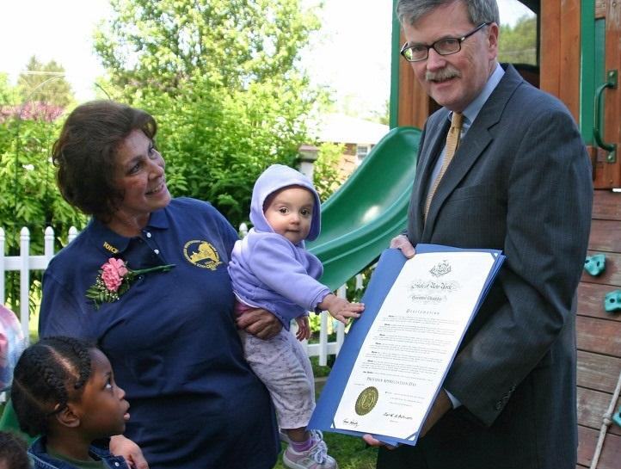

Ask Your Governor to Issue a State Proclamation
Share these outreach materials with your state governor’s office now, and together with other sponsors and providers from across the state, petition for a state proclamation to coincide with National CACFP Week. It’s a grassroots effort that, when fulfilled, will serve to raise awareness in your state government as well as community members across your state.

SAMPLE LOCAL REQUEST FOR PROCLAMATION

WHEREAS: One of the basic rights of children, as set forth in the Universal Declaration of Human Rights by Eleanor Roosevelt in 1948, is their right to basic nutrition. Caring for the children must be our nation’s first priority; and

WHEREAS: Since the inception of the Child and Adult Care Food Program (CACFP) in 1968, it has granted our children the best possible foundation in life and benefited many adults, which is vital to our state’s long-term health; and

WHEREAS: The two fundamental goals of the CACFP are that children serviced by this program will be well nourished during their crucial early years, while concurrently learning healthy eating behaviors that will last their lifetime. Nutritious diets are foundational for emotional, mental, and physical health; and

WHEREAS: We acknowledge the child and adult care providers, nutrition educators, program specialists and staff, state and federal professionals and parents who contribute to the success of this outstanding program; and

WHEREAS: The CACFP community will continue its commitment to the benefits of nutritious eating for children and adults. Together, as Americans, we can make a difference in the lives of our youngest and most vulnerable citizens.

Now therefore, I, [Name], [Elected Official Title], do hereby proclaim the week of March 15-21, 2026, to be NATIONAL CHILD AND ADULT CARE FOOD PROGRAM WEEK. I urge our citizens and all agencies and organizations to unite on that week in observance of the necessity of the Child and Adult Care Food Program to provide food security to children, individuals with disabilities and older adults in our community.

______________________________________ ________
(Insert Elected Official’s Title) Signature Date
Ask Your Local Elected Official to Issue a City Proclamation
Share these outreach materials with your local elected official’s office now, and together with other sponsors and providers from across the city, petition for a city proclamation to coincide with National CACFP Week. It’s a grassroots effort that, when fulfilled, will serve to raise awareness in your city government as well as community members across your city.

