
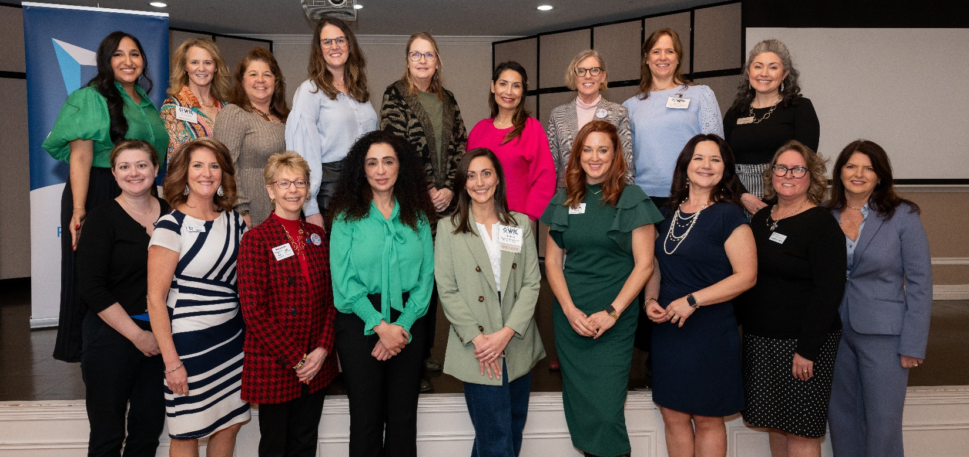
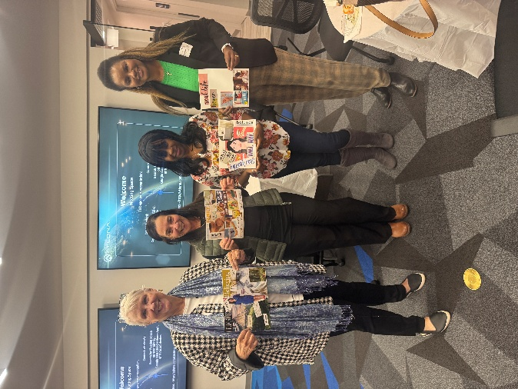
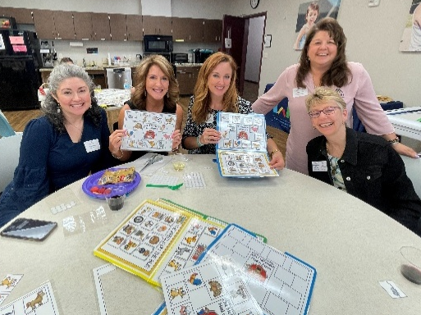

Richardson Chamber Women in Leadership
Committee Member Guidebook
INTRODUCTION
2026 Chamber Event Calendar at a Glance
Welcome to Women in Leadership
Program of Work
Committee Information Packet & Commitment Form
Committee Engagement Process
Sponsorship Packet

COMMITTEE ROSTER AND SUBCOMMITTEES
Committee Roster
Women in Leadership Subcommittees

LUNCHEONS
Luncheon Timelines
Luncheon Run of Show & Example Script

MEETING DOCUMENTS
Agendas (Not included)
Minutes (Not included)
2026 Chamber Event Calendar at a Glance
(Check Event Calendar online for updates)
January | February | March
1/13 – Monthly Luncheon) Small Business Committee)  1/22 – Monthly Social (Women in Leadership Committee) | 2/3 – Monthly Luncheon  2/12 – Monthly Social (Small Business Committee)  2/19 – Chamber Annual Meeting | 3/3 – Monthly Luncheon (Small Business Committee)  3/12 – Monthly Social (Leaders After Hours Committee)  3/25 – Member Orientation
April | May | June
4/7 – Monthly Luncheon (Women in Leadership Committee)  4/16 – Monthly Social (Small Business Committee)  4/21-4/23 – DC Fly-In | 5/5 – Monthly Luncheon (Small Business Committee)  5/12 – Monthly Social (Women in Leadership Committee) | 6/2 – Monthly Luncheon (Women in Leadership Committee)  6/11 – Monthly Social (Small Business Committee)  6/26 – Chamber Bowling Tournament
July | August | September
7/7 – Monthly Luncheon (Small Business Committee)  7/16 – Monthly Social (Leaders After Hours Committee) | 8/4 – Monthly Luncheon (Workforce Development Committee)  8/13 – Monthly Social (Small Business Committee) | 9/1 – Monthly Luncheon (Small Business Committee)  9/10 – Monthly Social (Women in Leadership Committee)  9/26 – Chamber Golf Classic
October | November | December
10/6 – Monthly Luncheon (Women in Leadership Committee)  10/15 – Monthly Social (Small Business Committee) | 11/5 – Chamber EDGE Awards  11/10 – Monthly Luncheon (Workforce Development Committee)  11/12 – Monthly Social (Leaders After Hours Committee) | 12/8 – Monthly Luncheon (Women in Leadership Committee)  12/10 – Chamber Member Holiday Party

Welcome to Women in Leadership!
Our mission
The mission of Women in Leadership is to inspire, influence and champion women as they grow into their roles as business leaders in the community.

2026 Chamber theme
Leading Today, Shaping Tomorrow

Meeting information
The Women in Leadership monthly meetings take place on the 4th Thursday of each month at 8:30 am. We highly encourage attending in person. The meetings will be held at the Richardson Chamber office:
411 Belle Grove Dr.
Richardson, TX 75080
Zoom options may be available. A Zoom link if needed will be sent out with individual monthly meeting invitations.

Website
Richardson Chamber website: richardsonchamber.com
Women in Leadership Chamber website: richardsonchamber.com/women-in-leadership
Chamber Instagram: @richardsonchamber
Facebook: facebook.com/RichardsonChamber
LinkedIn: linkedin.com/company/the-richardson-chamber-of-commerce/
2026 Program of Work
Committee Name: | Women in Leadership
Staff Lead: | Mallory Crumb
Exec. Committee: | Teresa DuVall
Tri-chairs: | 1st Jeanie Jones, 2nd Amanda Pritchard, 3rd Maria Harris
Purpose/Mission: | The mission of the Women in Leadership Committee is to inspire, influence and champion women as they grow into their roles as business leaders in their community.
 | 2026 Goals
- Expand Professional Development Opportunities
Offer high-quality programs, workshops, and speaker events that equip women with leadership, communication, and business-growth skills relevant to Chamber members and local employers.
- Strengthen Member Engagement & Networking
Create more intentional opportunities for members to build relationships — through networking mixers, and cross-program collaborations within the Chamber.
- Grow & Diversify Participation in WIL Programs
Broadly promote WIL events to attract a wider range of industries, career stages, and demographics; increase event attendance; and ensure programming is inclusive and reflective of the Chamber’s broader membership.
 | Action Plans
- Host three high-value Women in Leadership luncheons featuring dynamic, relevant speakers, and conduct full research, planning, and logistics for launching a structured signature program—such as a half-day Women’s Leadership Series—either later this year or in 2027.
- Create energetic, high-attendance mixers designed to attract members across the entire Chamber, foster cross-collaboration, and intentionally engage younger professionals to build the next generation of Women in Leadership participants.
- Transition WIL Socials into the Chamber’s overall social portfolios to increase reach and participation, supported by the WIL Marketing team through consistent cross-promotion, tagging, sharing, and social engagement to strengthen awareness and attendance.
 | Metrics
- Strengthen sponsor partnerships by renewing commitments from Methodist and Texas Bank and Trust, while securing at least one additional new sponsor to expand program support.
- Achieve a minimum of 100 attendees at each Women in Leadership luncheon, ensuring robust engagement and strong community participation.
- Meet or exceed the budgeted net revenue target for WIL programs through strategic sponsorships, high-value programming, and effective event marketing.
 |  | Tools to Succeed
- Engaged Committee – need all members to cover their tasks and attend meetings
- Connections – need connections to valuable speakers that will draw attendance
- Network – need new attendees and members/sponsors to widen our reach
 |  | Board or Executive Committee Assistance
- Support with sponsor dollars
- Support with engagement by attending events
 |  | Staff Assistance
- Support committee meetings with calendar invites, agendas and minutes
- Support events with registration and website management, as well as coordinating contracts, venues and F&B
- Support communication/marketing with Chamber social media, email marketing, event programs and podium guides

Committee Information Packet
Thank you for your interest in serving on a committee with the Richardson Chamber of Commerce! Our committees are essential extensions of the Chamber, helping support the strategic priorities set by our Board of Directors. They play a key role in advancing the Chamber’s mission to develop, promote and foster a continually growing, diverse and vibrant business community and civic climate in Richardson and the surrounding area.
This packet provides an overview of the expectations, responsibilities, and benefits of committee service. Please review carefully and reach out with any questions.
1. Purpose of Chamber Committees
Chamber committees are formed to align with and implement key initiatives that support the Chamber’s mission and strategic goals. They provide a platform for member engagement, foster collaboration, and help create programming that addresses the needs of our members.
2. Committee Member Requirements and Responsibilities
  - Must be a Chamber member in good standing
  - Attend meetings regularly and participate actively
  - Contribute ideas and feedback on programs and initiatives
  - Complete assignments and support event planning tasks
  - Serve as an ambassador for the Chamber within the community
  - Uphold the Chamber’s mission, values, and policies
3. Committee Leadership
Each committee is led by Tri-Chairs and managed by a Chamber Staff Lead. Committee leaders:
  - Help set the meeting agenda
  - Facilitate committee meetings
  - Ensure progress toward goals
  - Mentor new committee members
  - Attend Chamber organized tri-chair meetings for further communication and collaboration

4. Meeting Expectations
  - Meetings are typically held monthly
  - Meetings are preferred to be held in person (virtual or hybrid options may be available); however, no recordings of meetings are allowed
  - Agendas are sent prior to meetings, and minutes are provided
  - A typical commitment is 2–4 hours/month, including meetings, events and tasks
5. Committee Contributions to Events
Committees often plan and execute key Chamber programs and events. Committee members may:
  - Help identify topics and speakers
  - Secure sponsors and promote the event
  - Serve as greeters, moderators, or ambassadors
  - Participate in event evaluations and planning sessions
6. Offboarding & Continuation of Service
Committee members may be subject to review and offboarding may occur due to:
  - Personal resignation
  - Inactivity or non-participation
  - Conflict of interest or violations of policy
7. Why Get Involved?
Committee service provides personal and professional rewards:
  - Build leadership and communication skills
  - Expand your business network
  - Increase visibility within the community
  - Contribute to meaningful work that supports local businesses
8. Ready to Join?
  - Attend a committee meeting
  - Complete a Committee Commitment Form
  - Be added to the official committee roster

Committee Member Commitment Form

I, ________________________________, understand the mission, structure, and responsibilities of serving on a Richardson Chamber of Commerce committee.
By signing this form, I commit to:
  - Remaining a Chamber member in good standing
  - Attending meetings regularly
  - Participating actively in committee discussions and planning
  - Supporting events and initiatives through assigned tasks
  - Representing the Chamber positively and ethically in the community
  - Communicating with the Committee Tri-Chairs and Chamber Staff Lead if I am unable to continue my service
Conflict of Interest Statement:
As a committee member, I recognize that I have an obligation to avoid actual or perceived conflicts of interest that could interfere with the impartial performance of my duties on behalf of the Chamber.
I agree to disclose any personal, financial, or professional interests that may influence my actions or decisions in the context of committee service. I further agree to abstain from decision-making in any situation where a conflict exists or may appear to exist.
Should a potential conflict arise, I will promptly notify the Committee Tri-Chairs and Chamber Staff Lead to determine the appropriate course of action.
Member Code of Conduct:
Respectful Engagement:
Refrain from publicly disparaging the business practices of fellow members and avoid endorsing or participating in misrepresentation or unethical conduct. Be professional and treat others with respect. Refrain from any malicious, inflammatory, abusive or threatening messages in any form.
Professional Integrity:
Conduct business and professional activities with integrity, reflecting positively on both the business community and fellow Chamber members.
Chamber Representation:
Uphold and honor the reputation, profile, and status of the Richardson Chamber of Commerce, serve as ambassadors of the organization and participate in functions and activities whenever feasible.
Ethical Excellence:
Adhere to the highest ethical standards in rendering services and offering products and abide by all applicable laws.
Chamber Staff Respect:
Acknowledge and respect the vital role of the Chamber staff and their overall contributions to the success of the Chamber and its members.

Printed Name:
__________________________________________

Signature:
__________________________________________

Date:
__________________________________________

Company (if applicable):
__________________________________________

Email:
__________________________________________

Phone:
__________________________________________

Committee Engagement Process
After new committee members have attended their first meeting, signed their commitment form, and been added to the committee roster they will be connected to the Engagement Subcommittee of the Women in Leadership Committee to continue their onboarding and determine a subcommittee or engagement opportunity to join.
After attending at least three committee meetings and one event, this guidebook will be presented to the member along with an opportunity to engage in further aspects of the committee.
If a member misses more than three consecutive meetings, the Engagement Committee will follow up to check in and offer support, including discussing potential offboarding if needed.

Options for engagement:
Engagement Subcommittee
This committee focuses on keeping members connected, supported, and actively engaged. They complete the onboarding process for new members, pair them with another member, monitor attendance, check in with inactive members, and help create meaningful connections.
Meets Quarterly with Staff Lead outside of monthly committee meetings.

Socials Subcommittee
This committee plans the WIL assigned Chamber Monthly Socials with Chamber Member companies that will provide networking opportunities for Chamber members and non-members. Sometimes they may plan additional events that align with the Chamber and WIL missions.
Meets Quarterly with Staff Lead outside of monthly committee meetings.

Conference Subcommittee
This committee will begin developing a comprehensive plan for the Chamber’s first Women’s Conference, including programming concepts, networking opportunities, and resource planning, to present as a formal proposal to the Board of Directors.
Meets Quarterly with Staff Lead outside of monthly committee meetings.

Luncheon Host
Luncheon Hosts coordinate the WIL assigned Chamber Monthly Luncheons, focusing on business-related topics that educate, inspire, and support our members. Hosts work closely with the Staff Lead to confirm the topic, secure speakers, and coordinate event logistics.
Meets with Staff Lead and speaker as needed to prepare for presentation.

Sponsor
Sponsorship of the Women in Leadership committee and its events helps offset program costs while providing valuable brand visibility to the large and engaged audience that WIL attracts.

Greeter
Greeters support event-day operations by arriving early to help set out programs, welcome guests, distribute name tags, collect business cards for raffles, gather raffle prizes and record donor information, and assist with clean-up at the conclusion of the event.

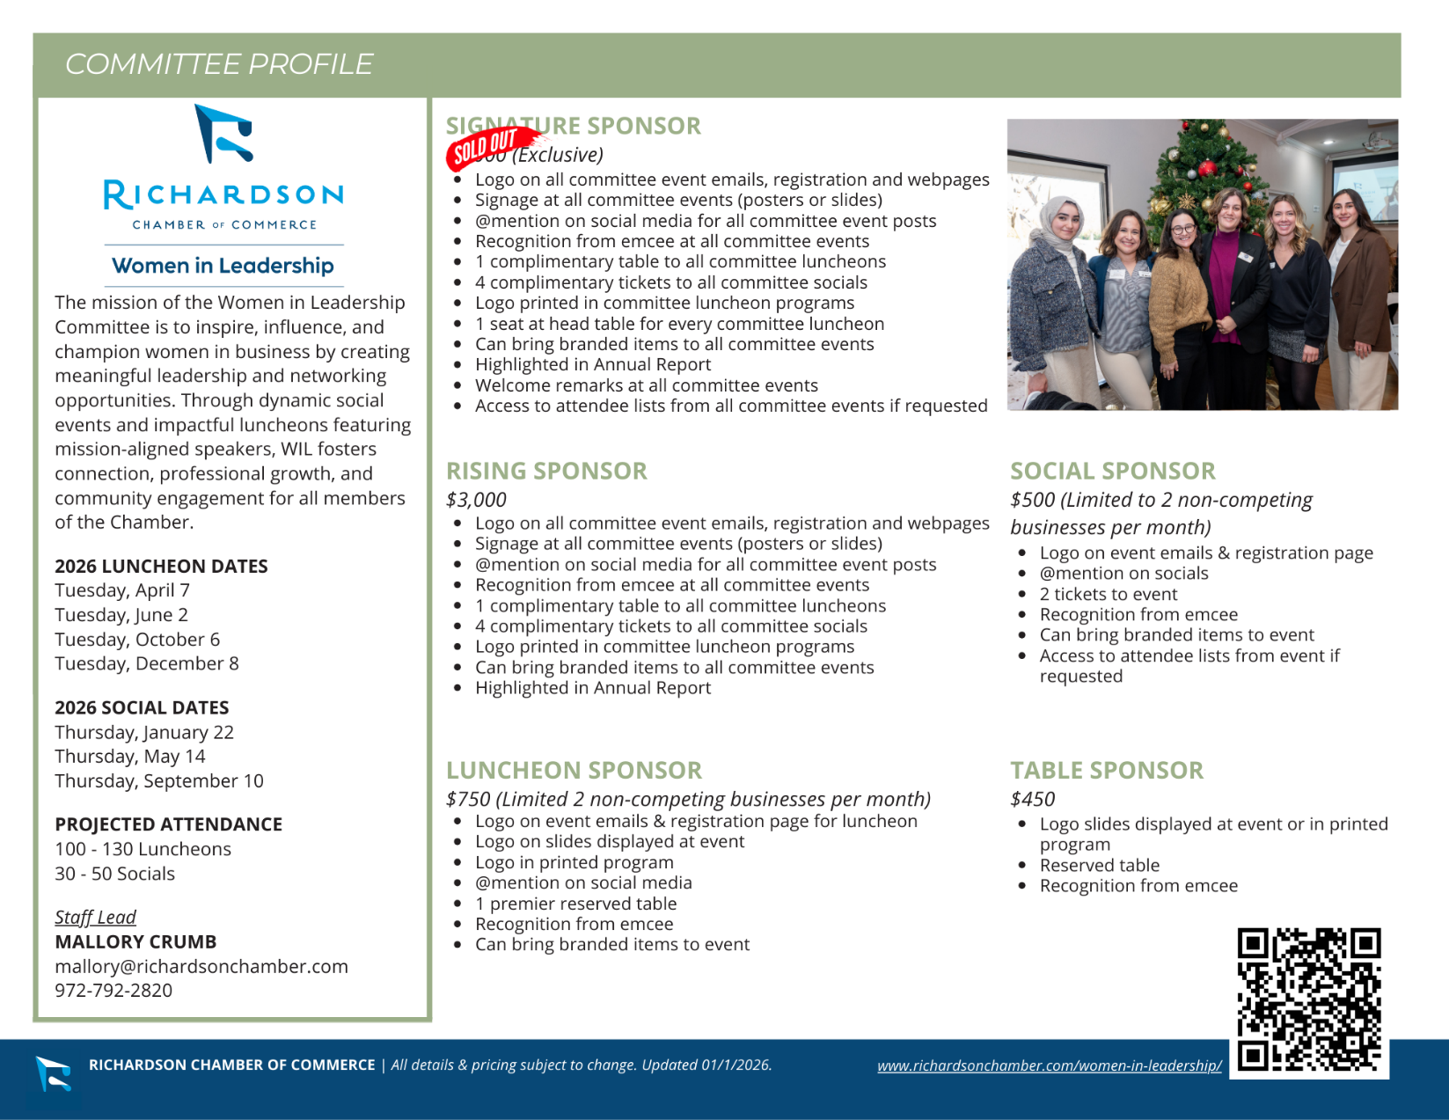

2026 Richardson Chamber Women in Leadership Committee
X | NAME | COMPANY | EMAIL | PHONE | SUB
 | Amanda Pritchard (Tri-Chair) | The University of Texas at Dallas | AmandaP@utdallas.edu | 972-883-6580
 | Amiee Nemer | City of Richardson | aimee.nemer@cor.gov | 214-729-9376
 | Amy Spawn | The Warren Center | amy.spawn@thewarrencenter.org | 469-328-0596 | CONF
 | Angela McCants | Dave Perry Miller Real Estate | Angela@daveperrymiller.com | 214-207-4218
 | Anh Nguyen | Missing Pieces Support Group | anh@mpsgcares.org | 713-540-0117
 | Ann Banks | Richardson Adult Literacy Center | director@ralc.org | 309-221-2953
 | Arica Koster | Nothing Bundt Cakes | Akoster44@gmail.com | 352-346-3820
 | Arwa Deeb | Hancock Whitney | arwadeeb@hotmail.com | 469-688-0733 | SOCIAL
 | Ashley Hust | RE/MAX Four Corners | AshleyHustHomes@gmail.com | 214-226-9801
 | Beril Berk | Dialogue Institute Dallas | Harikaberk16@gmail.com | 972-362-2441
 | Brenna Nix | West Coast University | bNix@westcoastuniversity.edu | 214-453-4297
 | Brittany Lewis | Bell Nunnally | blewis@bellnunnally.com | 949-294-9855
 | Cindi Jackson | Texas Bank and Trust | cjackson@texasbankandtrust.com | 972-470-1562
 | Cris Haest | Richardson Adult Literacy Center | cris@brightsocialagency.com | 817-422-2257 | SOCIAL
 | Cynthia Roldan | Toyota Financial Savings Bank | cynthian.roldan@gmail.com | 646-696-8158
 | Gabi Pate | The University of Texas at Dallas | gabriella.pate@utdallas.edu | 214-868-7037
 | Hannah Sweitzer | Royal Catering | hannah@RoyalCateringDFW.com | 972-437-1466 | SOCIAL
 | Heather Hurd | Frost Bank | Heather.hurd@frostbank.com | 214-515-4962 | CONF
 | Irene Zucker | VerbaCom | izucker@verbacom.com | 972-386-8372 | CONF
 | Janelle Teng | Jeng Chi Foods Corporation | Janelle@JengChiRestaurant.com | 214-325-2316 | ENGAG
 | Jeanie Jones  (Tri-Chair) | SilverXis | jeanie.jones@silverxis.com | 214-356-8777 | CONF
 | Kelley Barringer | USI Southwest, Inc | Kelley.Barringer@usi.com | 469-951-6167
 | Lakeesha Browne | LV Browne CPA | keesha@lvbrownecpa.com | 214-538-3154
 | Laura Konz | Reliant, an NRG Company | Laura.konz@nrg.com | 972-213-4169 | SOCIAL
 | Lisa Wall | NCLAb | lisa@nclab.com | 972-330-6516 | ENGAG
 | Maria Harris  (Tri-Chair) | BRYJO Roofing and Remodeling | maria@bryjo.com | 972-669-7807 | CONF
 | Mary Bedosky | Richardson East Rotary Club | maryrbedosky@gmail.com | 972-768-0226 | ENGAG
 | Melissa Flynn | Melissa Flynn PR & Marketing | melissa@melissaflynnpr.com | 843-817-7653 | ENGAG
 | Melody Terry | Sunflower Bank | melody.terry@sunflowerbank.com |  | ENGAG
 | Stacy Baker | Glacis Technologies | sbaker@glacistech.com | 214-417-2158 | ENGAG
 | Susan Kassen | Keller Williams | susan.kassen@gmail.com | 214-957-1175 | SOCIAL
 | Tawnya Broome | Blue Cross Blue Shield of Texas | tawnya_broome@bcbstx.com | 713-446-0078 | SOCIAL
 | Teresa DuVall (Vice Chair) | Bland Garvey, CPAs & Wealth Advisors | tduvall@blandgarvey.com | 972-231-2503
 | Mallory Crumb (Staff Liaison) | Richardson Chamber | mallory@richardsonchamber.com | 972-792-2820

Women in Leadership Subcommittees
ENGAGEMENT
Objective:
Connect members to engagement opportunities that increase participation, retention, and activity.

Goals:
- Increase subcommittee size to 10
- Create personalized onboarding experience for new committee members
- Offboard committee members as needed

Members:
- Janelle Teng, Chair
- Lisa Wall
- Mary Bedosky
- Melody Terry
- Stacy Baker
- Melissa Flynn

SOCIALS
Objective:
To create welcoming and engaging social experiences that encourage authentic connections and strengthen professional networks.

Goals:
- Provide evening networking opportunities for Chamber members on Jan 22, May 12 and Sep 10
- Host event outside of the happy hour time slot for those that can’t make an after-work event
- Have an event where people are invited to participate in a volunteer project in the community

Members:
- Susan Kassen, Chair
- Arwa Deeb
- Hannah Sweitzer
- Laura Konz
- Cris Haest
- Tawnya Broome

CONFERENCE

Objective:
To plan and develop a dynamic Women’s Conference that delivers high-impact programming, meaningful networking opportunities, and resources that inspire professional growth, leadership development, and community connection.

Goals:
- Identify the purpose, goals, and target audience for the Women’s Conference
- Outline the event format, session types, and potential speaker topics
- Create a financial plan that includes projected expenses, revenue, and sponsorship opportunities

Members:
- Cynthia Roldan, Chair
- Irene Zucker
- Jeanie Jones
- Amy Spawn
- Heather Hurd
- Maria Harris
Women in Leadership Luncheons Timeline

2026 Luncheons are scheduled for Tuesday, April 7, Tuesday, June 2, Tuesday, October 6, Tuesday, December 8. All luncheons will be held at the Richardson Woman’s Club. Hosts will volunteer to produce each luncheon. Typically like to have a group of 2 – 3 with a mixture of some that have hosted a luncheon before and some who have not.

Please make sure to discuss the plans for your topic and speaker with Mallory prior to commitment!

60–90 Days Out
- Determine topic and confirm with Staff Lead that it is not being duplicated with another committee event
- Brainstorm speaker ideas and share recommendations with committee and Staff Lead
- Finalize speaker and hold speaker meeting with Staff Lead

45–60 Days Out
- Confirm presentation and format
- Determine speaker AV needs and additional event logistics
- Finalize event title and description
- Identify and contact potential sponsors
- Staff Lead opens registration and launches marketing

30 Days Out
- Continue promotion and with networks
- Confirm committee roles for event day
- Secure door prizes and assign greeters
- Determine if speaker and/or raffle items are needed
- Staff Lead manages logistics, catering, and AV

14 Days Out
- Review speakers’ presentation (if applicable) with Staff Lead

7 Days Out
- Finalize agenda/podium guide with Staff Lead
- Coordinate any updates to programs, surveys or tabletop items with Staff Lead
- Staff Lead finalizes materials and speaker coordination

Event Day
- Serve as greeters, hosts, or ambassadors
- Welcome attendees and support engagement
- Collect door prizes and fill out forms for the emcees
- Post event photos to social networks and tag the Chamber
- Staff Lead manages registration and event flow

Post-Event
- Share feedback and observations
- Participate in debrief if scheduled
- Staff Lead handles reporting and follow-up

Speaker Guide and Run of Show
(Created by Staff Lead for each event)

11:15 – 12:00 PM | Check-In, Networking & Lunch

12:00 – 12:15 PM | Welcome & Introductions
Speaker: WIL Host
Opening Remarks:
- Welcome attendees:
Good afternoon and welcome to the Richardson Chamber of Commerce Women in Leadership Luncheon…..
- Overview of the Women in Leadership program and mission
- Thank and recognize event sponsors
- Signature Sponsor – Methodist Richardson Medical Center – ask to come to podium for a few words
- Rising Sponsors – Texas Bank and Trust
- Additional/Table Sponsors
- President’s Club Members
- Recognize dignitaries and special guests
- Chamber Board Members
- Elected officials and community partners (if applicable)
- Acknowledge fellow committee members/hosts in attendance
- Thank Royal
- Introduce today’s speaker/moderator/bio summary overview of discussion

12:15 – 12:45 PM | Presentation
Speaker:
Moderator:
Topic:
12:45 – 12:55 PM | Q&A
- Audience questions (have 1 or 2 ready to go)
- Time cues provided by Host Committee/Staff Lead if needed

12:55 PM | Announcements & Closing
Speaker: WIL Host
- Brief introduction:
Hello, my name is...
- Thank speaker for presentation and present speaker gift
- Upcoming Chamber Events (included in program)
- TBD
- TBD
- Encourage attendees to complete the event feedback survey (QR code in program)
- Door prizes - collect business cards and hand out prizes
- Closing remarks and final thank you to speaker, sponsors and attendees

Richardson Chamber of Commerce
Women in Leadership Quarterly Luncheon
- EXAMPLE SCRIPT -

Legend:
Items in black are to be read aloud
Items in blue are instructions to the emcees
Items in orange are changed to fit each luncheon

11:45 Emcee asks everyone to be seated for lunch and we will begin in at Noon

12:02 pm: Emcee approaches the lectern

Before you begin speaking, if the slide show needs to be switched from the sponsor slides to the speaker’s slides, do so at this time.

Ladies and gentlemen, welcome to the Richardson Chamber of Commerce Monthly Luncheon with Women in Leadership. My name is…

your name and I am with/the owner of your company

and I’m a member of the Women in Leadership committee.

The purpose of WIL is to inspire, influence and champion women as they grow into their roles as business leaders in the community.

We are happy that so many of you have joined us today. We are looking forward to hearing from today’s guest speaker and insert comment related to their presentation.

We could not have these programs without our sponsors:

Introduce Signature Sponsor, and invite representative up to speak if instructed to do so.

If Signature Sponsor spoke, thank them and lead the applause.

Introduce Rising Sponsor(s). DO NOT ask them to come to the lectern to speak.

Thank table sponsor(s) if there are any.

Thank you all for sponsoring our event today. We are deeply grateful for your support.

Recognize any dignitaries if instructed to do so.

Recognize your co-hosts by name and company.

Insert any pertinent information necessary to provide before the presentation, for example, a Q&A app to be used or asking not to take photos, that sort of thing. This will differ by event.

And now to introduce our speaker!

Read abbreviated version of speaker’s bio, preferably in your own words.

As the bio is being read, the speaker should rise from their seat at the table and stand to the side of the room. You will need to tell the speaker these instructions before you begin the program. As the applause begins, they should approach the lectern.

Women in Leadership, sponsors and guests, please help me welcome speaker’s first name!

Stay at the podium until speaker gets up there, then shake their hand when they arrive, then smile and return to your seat.

Speaker takes the stage and presents

Approximately 12:45 pm: Speaker concludes presentation.

Emcee leads the applause as you approach the lectern and give a brief commentary on the presentation.

Now it’s time for some questions from our audience.

Take questions from live audience and/or online app.

After the last question, comment:

Great questions and responses!

Adlib more if you like.

Turn to speaker who is still at the lectern, and say

Speaker’s name, we have a gift that we’d like to present to you to show our appreciation for sharing your knowledge and experience with us (or adlib this part).

Thank you so much for speaking to our audience!

Lead round of applause as speaker goes back to their seat.

If a second Emcee is doing this part of the presentation, they should introduce themselves here. If it is the same person, there is no need to introduce themselves again.

My name is

Your name

and I am with/the owner of

Your company

and I am a member of the Women in Leadership committee.

I hope you got some good takeaways from this very informative, insightful and inspiring presentation (or make up a better sentence if you want!).

In just a moment we will draw for raffle prizes. If you have not put your business card in the bowl, please raise your hand and someone will come collect a card from you.

Greeters walk around the room collecting business cards.

The Chamber has some upcoming events I would like to invite you to.

Insert list of upcoming events here

Please see our program for a list of these events as well as a QR code that will lead you to a survey of today’s event. We would appreciate any feedback and suggestions for future programming.

Now it’s time for door prizes!

This is the cue for a greeter to provide you with a list and hand you the prizes and the fishbowl.

Congratulations to all the drawing winners!

Lead a round of applause for the drawing winners

Thank you for attending today’s luncheon. This concludes our program. Have a great day!

