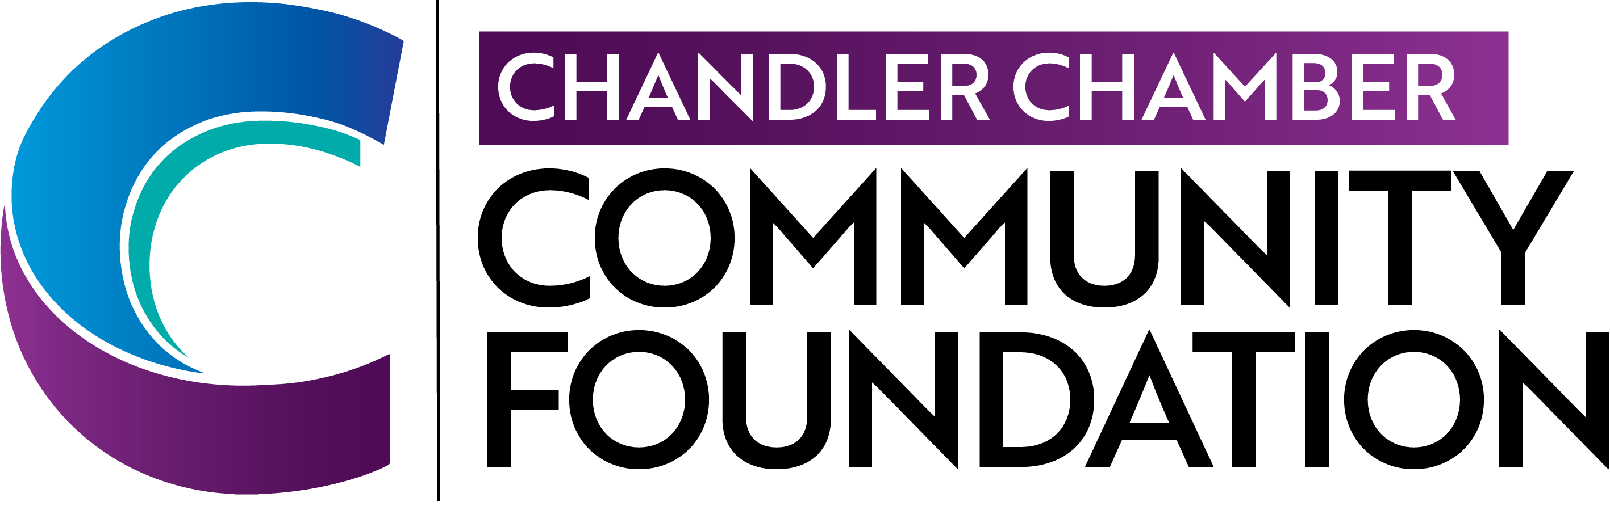
Chandler Chamber Community Foundation

2025-2026
Scholarship Application for students attending

Chandler-Gilbert Community College

The mission of the Chandler Chamber Community Foundation is to enhance the business community and develop future business leaders through educational events, programs, and scholarships. Chandler Chamber Community Foundation and Air Products and Chemicals will award up to three (3) scholarships in the value of $2,000 each to students who enroll in at least a part-time in a business-related course of study at Chandler-Gilbert Community College.

Scholarship Eligibility:
- Must live or work in Chandler, Arizona. Or be a current student at any high school servicing Chandler or attend Chandler-Gilbert Community College.
- Must be a legal resident of the United States
- Applicants must be actively enrolled at Chandler-Gilbert Community College for the 2024-2025 academic year with a minimum of 6 credit hours per semester
- Field of Study must be business-related
- Must submit one letter of recommendation
- Must attach high school or college transcript to application
- If chosen to receive the scholarship, must attend an award ceremony in order to receive the scholarship. At this award ceremony, recipients will be asked to say a few words.
Thursday, May 29th
5:30 pm
Gila River Resorts & Casinos – Wild Horse Pass

Process
All applications will be considered by a panel of judges comprised of members from the Chandler Chamber Community Foundation representing Chandler-based businesses and a representative from Chandler-Gilbert Community College. Applications will be evaluated on academic achievement, letter of recommendation, and video essay submission

Completed applications and corresponding materials should be submitted by May 1,2025. Late applications will not be considered. All decisions made will be final.

Return completed applications to: info@chandlerchamber.com

Application deadline date is May 1, 2025

Chandler Chamber Community Foundation

2025-2026
Scholarship Application for students attending
Chandler-Gilbert Community College
Applicant Information:

Name: ______________________________________________________________________
First Middle Last

Address: _____________________________________________________________________
Street & Apt. # City State Zip

Telephone Number: _____________________________ Date of Birth: __________________
(00/00/0000)

E-mail: ______________________________________________________________________

Check all that apply:
Chandler Resident □ Work in Chandler □ Attend School in Chandler □
(Any school that services Chandler)
U.S. Legal Resident: Yes □ No □

Extracurricular Activities and/or Volunteer Experience: ________________________________

_____________________________________________________________________________

_____________________________________________________________________________

College/University/Trade School Information:

My academic major/program of study is ___________________________________________

Degree Sought: Bachelor □ Associates □ Certificate □ Other □

My cumulative high school or college GPA is: __________________
I am an adult re-entering college: Yes □ No □

Application Checklist:

_____ Student Application

_____ Video Submission

_____ Letter of Recommendation

_____ Transcript

I acknowledge that the information included in this application is complete and accurate to the best of my knowledge.

Applicant’s Signature: _________________________________________ Date: _____________

Chandler Chamber Community Foundation

2025-2026
Scholarship Application for a student attending
Chandler-Gilbert Community College

Please create a 2-4 minute long video OR complete an essay, in which you will address the following questions. The format in which the questions are addressed is up to you- please feel free to be creative.

Please upload your video to YouTube and include the URL to your video here or attach your essay to your application:

____________________________________________________________________

Video/Essay Questions:

Question 1: How will your studies contribute to the local business community?

Question 2: What are your career goals, and how will earning a college degree or certificate from Chandler-Gilbert Community College help you achieve those goals?

Question 3: From a financial standpoint, what impact would this scholarship have on your education?

Certification:
I certify that the information included with this application is accurate and correct to the best of my knowledge and I authorize the CGCC Financial Aid Office to release my academic, financial, or other necessary information required by a donor. In addition, I agree that Chandler-Gilbert Community College shall have the right to use and release my name if I am awarded a scholarship at CGCC in order to publicize or to otherwise promote the college to any local or national media or in any college publications and at any college events.
Only those with a lawful presence in the US may qualify for MCCCD scholarships or federal financial aid. Any information you provide about your legal status when you apply for financial aid or scholarships may be subject to mandatory reporting to federal immigration authorities under AZ law. This does not apply to applications for the private scholarship funds held in and distributed by the Maricopa Community Colleges Foundation.
By signing this application, I swear under penalty of perjury that the document(s) that I have submitted to demonstrate lawful presence in the United States are true.
Student’s signature: _______________________________________ Date: _____________

IF APPLICANT DEFERS ENTRANCE INTO Chandler-Gilbert Community College
THE SCHOLARSHIP WILL REVERT BACK TO THE
Chandler Chamber Community Foundation SCHOLARSHIP FUND

