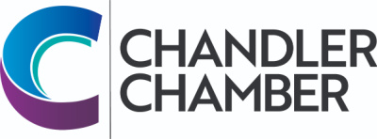
2025 COMMUNITY AWARDS NOMINATION FORM FOR
Red Apple Award

______________________________________ ______________________________________
Name of Nominee Location

Nomination procedure: Colleagues, administrators, principals, parents, students, etc may submit nominations. Please submit up two pages of narrative (max), which can be complemented with up to five supporting materials (letters of recommendation, newspaper clips, etc.) Along with any letters of recommendation, please include names, addresses, and phone numbers. Stories and incidents, which support the criteria, will help the committee make a fair decision. We encourage you to include letters of support from colleagues, parents and students. Note that a recipient cannot have received a Chandler Chamber Community Award in the past 3 years.

CRITERIA

1.Manage and administrate effectively
2.Demonstrate and encourage creativity and innovation
3.Foster cooperation between the school, business and the community
4.Encourage a continuing partnership among students and parents as well as faculty and staff
5.Keep abreast of developments in the field of education
6.Encourage team spirit
7.Demonstrate leadership and exemplify commitment
8.Continue to play an active role in the classroom

____________________________________ ___________________________________
Name of person submitting application Street Address

____________________________________ ___________________________________
City/State/Zip Telephone

This award is open to all certified employees in the Chandler Unified School District and is subject to approval of the Education Committee of the Chandler Chamber of Commerce. Please return completed Nomination Form by March 7,2025 to the Chandler Chamber of Commerce, 101 W Commonwealth Ave, Chandler, AZ 85225. Nominations and supporting information can also be sent via e-mail to: info@chandlerchamber.com.

