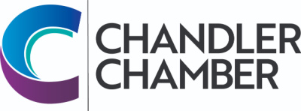

2025 COMMUNITY AWARDS NOMINATION FORM FOR
CUSD EDUCATOR OF THE YEAR AWARD

______________________________________ ______________________________________
Name of Nominee Location

Nomination procedure: Colleagues, administrators, principals, parents, students, etc may submit nominations. Please submit up two pages of narrative (max), which can be complemented with up to five supporting materials (letters of recommendation, newspaper clips, etc.) Along with any letters of recommendation, please include names, addresses, and phone numbers. Stories and incidents, which support the criteria, will help the committee make a fair decision. We encourage you to include letters of support from colleagues, parents and students. Note that a recipient cannot have received an award in the past 3 years. (Education Award recipients are selected through the Chandler Unified School District)

CRITERIA

- Display a genuine concern for students

- Encourage parent involvement in the educational process

- Participate in extra-curricular activities involving students, business and the community

- Participate in community events and organizations

- Cause significant educational growth and build a positive self-image in students

- Maintain a high standard of professionalism

- Demonstrate initiative and creativity to improve instruction

- Strive for personal and professional growth

____________________________________ ___________________________________
Name of person submitting application Street Address

____________________________________ ___________________________________
City/State/Zip Telephone

The object of this award is to select a “TLC” Certified Employee of the Year. If you know of a certified employee whose performance goes above and beyond what is expected of a “good employee.” This award is open to all certified employees in the Chandler Unified School District and is subject to approval of the Education Committee of the Chandler Chamber of Commerce. Please return completed Nomination Form by March 7,2025 to the Chandler Chamber of Commerce, 101 W Commonwealth Ave, Chandler, AZ 85225. Nominations and supporting information can also be sent via e-mail to: info@chandlerchamber.com.

