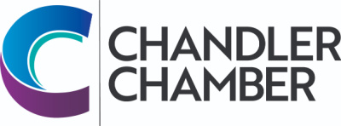
2025 COMMUNITY AWARDS NOMINATION FORM FOR
CUSD ADMINISTRATOR OF THE YEAR

_________________________________________ ________________________________________
Name of Nominee Location

Nomination procedure: Please submit up two pages of narrative (max), which can be complemented with up to five supporting materials (letters of recommendation, newspaper clips, etc.). Note that a recipient cannot have received an award in the past 3 years. (Education Award recipients are selected through the Chandler Unified School District)

CRITERIA

- Manage and administrate effectively

- Demonstrate and encourage creativity and innovation

- Foster cooperation between the school, business and the community

- Encourage a continuing partnership among students and parents as well as faculty and staff

- Keep abreast of developments in the field of education

- Encourage team spirit

- Demonstrate leadership and exemplify commitment

- Continue to play an active role in the classroom

NOTE: Colleagues, administrators, principals, parents, students, etc may submit nominations. The more specific your nomination is, the better chance the nominee has of receiving the award. Stories and incidents, which support the criteria, will help the committee make a fair decision. We encourage you to include letters of support from colleagues, parents and students. A maximum of two statements of support is required along with the names, addresses and phone numbers.

______________________________________ ______________________________________
Name of person submitting application Street Address

______________________________________ ______________________________________
City/State/Zip Telephone

The object of this award is to select a “TLC” Certified Employee of the Year. If you know of a certified employee whose performance goes above and beyond what is expected of a “good employee.” This award is open to all certified employees in the Chandler Unified School District and is subject to approval of the Education Committee of the Chandler Chamber of Commerce. Please return completed Nomination Form by March 7,2025 to the Chandler Chamber of Commerce, 101 W Commonwealth Ave, Chandler, AZ 85225. Nominations and supporting information can also be sent via e-mail to: info@chandlerchamber.com.

