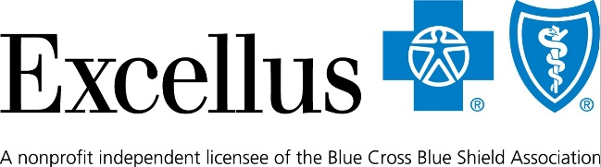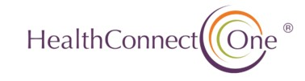
For Immediate Release: June 26, 2026
Contact: Lynn Wesley Burton, Regional Communications Manager, Excellus BlueCross BlueShield - (585) 469-2995 and Amaya Woodley, Community Engagement and Events Manager HealthConnect One, - (980) 253-8434.
Doulas Complete Training Program to Address Maternal Health Inequities in Rochester
Rochester, NY – Rochester continues to experience significant maternal and infant health disparities, with Black mothers facing higher rates of complications and mortality and Black infants less likely to reach their first birthday. In response to these inequities, a new cohort of trained doulas are prepared to help advance more equitable care for families.
The Rochester Initiative for a Skilled and Equitable or (RISE) Doula Workforce Pilot, led by Excellus BlueCross BlueShield and HealthConnect One, is a program that prepares individuals to become certified doulas, expand access to community-based care, and improve maternal and infant health outcomes.
“My mission is to protect black women by any means,” said Irie Williams, RISE Doula Workforce graduate. “With the wisdom from Phyllis, LaKeisha, Excellus, Healthy Baby Network, my community-based doula village & others, I have the tools and the means to provide a helping hand to my folk. I love my people.”
The program comes as Rochester faces some of the most serious maternal health disparities in New York. In the Finger Lakes region, maternal mortality rates are about 60% higher than the state average.
Excellus BCBS data highlights the urgency for action. For example, analysis of nearly 20,000 deliveries since January 2025 shows preeclampsia, a serious pregnancy complication characterized by high blood pressure, affects 13.3% of pregnancies, making it the most common severe maternal complication. Among Black members, the rate rises to 21.2%—nearly 60% higher than the overall average.
These cases are concentrated in Rochester neighborhoods, including 14621, 14609, 14624, and 14616.
“The disparities we see are unacceptable—instead they are not inevitable,” said Dr. Simone Edwards, vice president, health outcomes & community impact at Excellus BCBS. “That’s why doulas are such an important part of the solution to help close gaps in care, strengthen trust, and drive better outcomes for families who need it most.”
While doulas do not provide medical care, they work alongside clinical teams to offer emotional, physical, and informational support to birthing people and their families.
If you are a New York State Medicaid Member, you are eligible to receive doula services with each pregnancy including:
- Up to 8 doula visits before and after pregnancy, plus support during childbirth—regardless of how the pregnancy ends.
- Receiving doula services up to 12 months after your pregnancy ends.
Participants completed a 20-week training program rooted in lived experience, cultural knowledge, and evidence-based care and are now preparing to become certified doulas.
“As an OB-GYN who has practiced in this community, I have seen where our system falls short,” said Dr. Kathleen Robischon, vice president of medical affairs at Excellus BCBS. “This program is preparing a new generation of doulas who will help ensure more families receive respectful, high-quality care when it matters most.”
“Our work centers community voices and builds on their strengths,” said Dr. Twylla Dillion, president and chief executive officer of HealthConnect One. “This program demonstrates what happens when we invest in people and work together to advance birth equity.”
Together, Excellus BCBS and HealthConnect One are building a stronger pipeline of community-based doulas and laying the groundwork for a more equitable maternal health system in Rochester.
# # #
Excellus BlueCross BlueShield, an independent licensee of the Blue Cross Blue Shield Association, is a nonprofit health plan with 1.5 million upstate New York members. The company's mission is to help people live healthier and more secure lives through access to high-quality, affordable health care. Its products and services include cost-saving prescription drug discounts, wellness tracking tools, and access to telemedicine. With more than 4,200 employees, the company is committed to attracting and retaining a diverse workforce to foster innovation and better serve its members. It also encourages employees to engage in their communities by providing paid volunteer time off as one of many benefits. To learn more, visit ExcellusBCBS.com.
About HealthConnect One
For more than 40 years, HealthConnect One has been a national leader in advancing birth equity by strengthening community-based care. The nonprofit partners with communities across the country to train and support doulas, community health workers, and advocates, using approaches rooted in lived experience and cultural knowledge. Through training, technical assistance, and collaboration, HealthConnect One helps build systems where birthing families are supported with dignity, respect, and connection. Learn more at healthconnectone.org.

