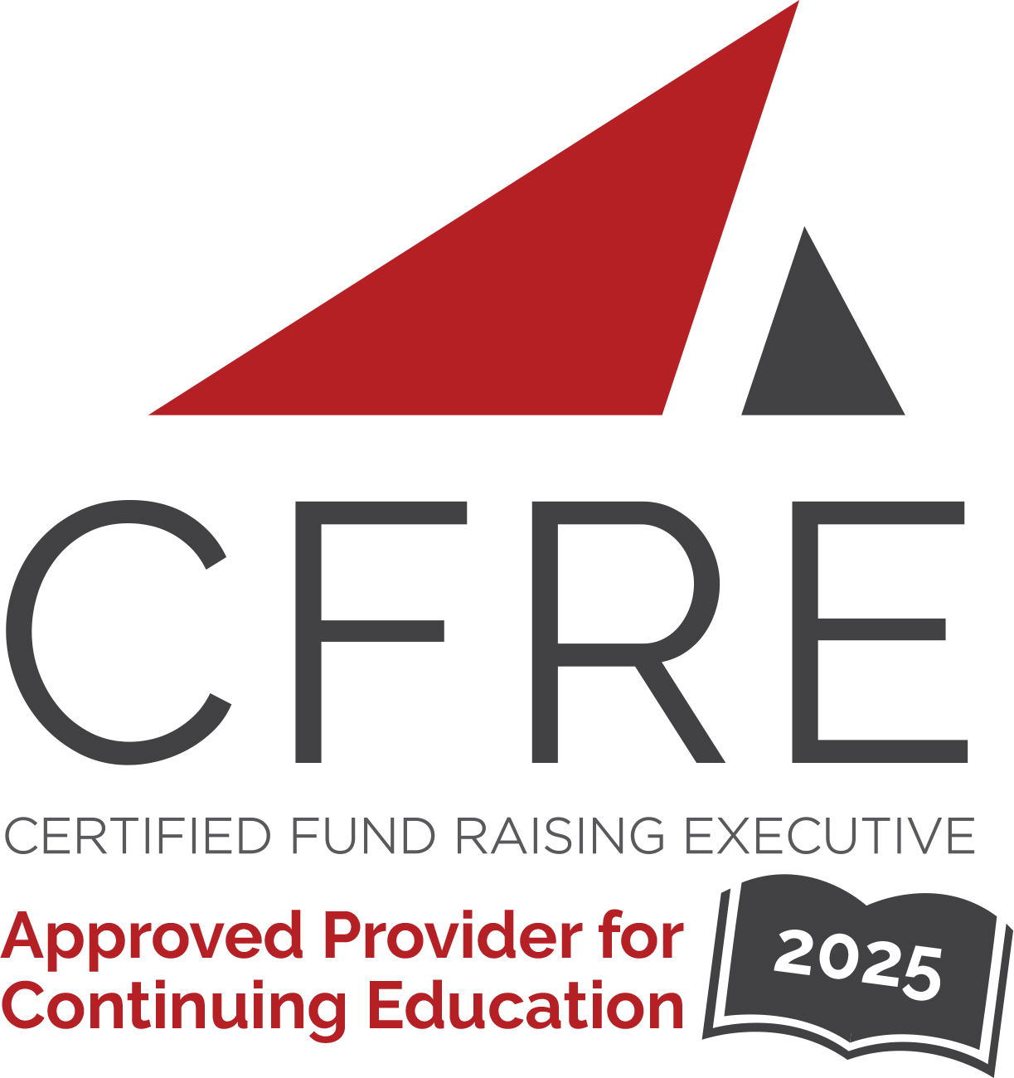  CFRE International has developed this form as a way for you to quickly track (and keep in your files!) the continuing education sessions you have attended. Simply check the boxes next to the sessions you attended. At the end of the conference, add up the total number of hours. Keep this sheet and you will be ready to complete your application form. All of the session slots listed are eligible for continuing education points on your CFRE application for initial certification and/or recertification. Sessions not listed here are not eligible for points. |  | CONTINUING EDUCATION POINTS TRACKER

Activity Organizer: - Direct Marketing Association of Washington
Title of Activity: - 2025 Nonprofit Fundraisers Symposium
Names of Presenter(s): - Various
Dates and Location: - 12-14 March, 2025 – Washington D.C., USA

Date: 13 March, 2025
Session 1: 9:15am – 10:30am (1.25 pts)
- Opening Keynote: Brand Loyalty

Date: 13 March, 2025
Session 2: 10:45am – 12:00pm (1.25 pts)
- Data & AI: How Nonprofits Are Already Leveraging AI & Machine Learning to Improve Fundraising Results
- Building a Bridge to Mid-Level Giving
- Better Testing Meets Better Results: The Science of Neuro-Funding
- Transformative Leadership: Harnessing Executive Coaching and Behavior Science for Fundraising Success

Date: 13 March, 2025
Session 3: 1:30pm – 2:45pm (1.25 pts)
- Making the Case for Investment: A Conversation with CDMO and a CFO
- The Only Constant is Change: How Can You Adapt
- Model Data Bias: The “Inconvenient Truth” About How Its Impacting Donor Files and What It Means for the Future of Fundraising
- Audience Vs. Channel: A New Paradigm for Your Fundraising Team
- Now is the Time for Purpose-Driven Influencer Marketing

Date: 13 March, 2025
Session 4: 3:00pm – 4:15pm (1.25 pts)
- The Leader’s Role in Building Donor-Centric Programs Across Departments
- How Games Can Help Social Impact Organizations Find New Supporters, Deepen Their Relationships, and Expand Their Brand
- Leveraging the New Charity Navigator Rating Systems
- Upskilling vs. Outsourcing? Strategic Talent Decisions for Nonprofit Growth

Date: 13 March, 2025
Session 5: 4:30pm – 5:30pm (1 pt)
- Changing Demographics

Date: 14 March, 2025
Session 6: 9:00am – 10:15am (1.25 pts)
- Beyond the Mailbox: Embracing New Channels to Combat the Challenging Acquisition Environment
- Biggest Bang for the $1MM
- Changing/Evolving Your Brand
- Ensuring “AI For Good” in Your Fundraising: Seven Questions You Need to Ask
- Fundraising in Affiliated Organizations

Date: 14 March, 2025
Session 7: 10:40am – 11:45am (1 pt)
- Closing Keynote: The Lighthouse Effect

Total number of points attained: __________

