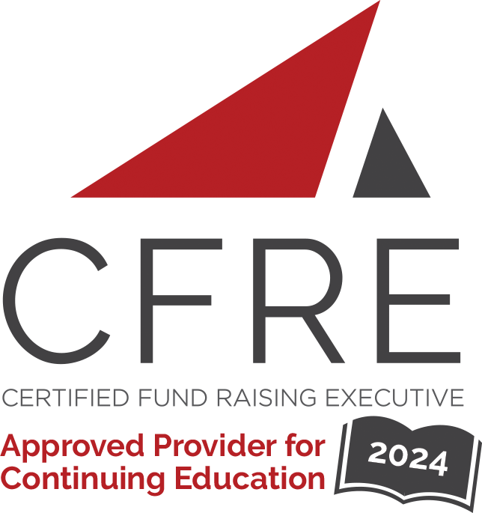  CFRE International has developed this form as a way for you to quickly track (and keep in your files!) the continuing education sessions you have attended. Simply check the boxes next to the sessions you attended. At the end of the conference, add up the total number of hours. Keep this sheet and you will be ready to complete your application form. All of the session slots listed are eligible for continuing education points on your CFRE application for initial certification and/or recertification. Sessions not listed here are not eligible for points. |  | CONTINUING EDUCATION POINTS TRACKER

Activity Organizer: - Direct Marketing Association of Washington
Title of Activity: - Multi-Channel Mini-Con
Names of Presenter(s): - Various
Dates and Location: - 23-24 October, 2024 – Washington D.C., USA

Date: 23 October, 2024
Session 1: 9:15am – 10:00am (1 pt)
- The Importance of Collaboration Among Fundraisers

Date: 23 October, 2024
Session 2: 10:15am – 11:00am (1 pt)
- How Operation Smile Used Omnichannel Marketing to Maximize Donor Engagement
- Email Optimization

Date: 23 October, 2024
Session 3: 2:50pm – 3:35pm (1 pt)
- BoysTown and Fundraise Up Case Study: Harnessing New Technologies and Platforms for Digital Fundraising
- BEATS Model for Attribution

Date: 24 October, 2024
Session 4: 9:05am – 9:50am (1 pt)
- Giving Tuesday & RKD Group Giving Pulse Field Guide

Date: 24 October, 2024
Session 6: 10:05am – 10:50am (1 pt)
- Creative Rule Breaking for Direct Mail Nerds with Q&A

Date: 24 October, 2024
Session 7: 11:05am – 11:50am (1 pt)
- Tables Have Four Legs: Ensuring Your Program Isn’t Dependent or One Channel

Date: 24 October, 2024
Session 8: 1:05pm – 1:55pm (1 pt)
- All-Star Panel: Innovation in Action

Total number of points attained: __________

