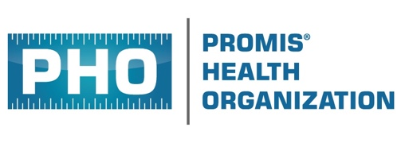 | PO Box 6092  River Forest, Illinois USA  www.promishealth.org  info@promishealth.org
Request for Letter of Invitation
The 12th Annual PROMIS® International Conference
22-23 October 2026 – Prague, Czechia

First Name * Last Name * Middle Initial *

* as it appears on your passport

Degree (i.e., MD, PhD)

Street Address

City State / Province / Territory

Zip / Postal Code Country

Email Address

Submit this request form
to Karen Stenmark, PHO Meetings and Events
karen-stenmark@promishealth.org

Once this form is received, a letter of invitation shall be sent by e-mail to the individual named above
(invited presenter and/or registered attendee).

A letter of invitation is not a commitment on the part of the PHO to provide any financial support for conference attendance or participation.

