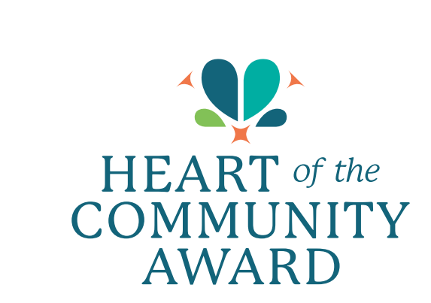
Heart of the Community Award Nomination Form
Presented by the Shawnee Chamber of Commerce

Nomination Deadline: December 9th
Thank you for participating in the Heart of the Community Award nominations! Please fill out the form below to nominate a deserving Shawnee citizen, business leader, group, project, or place that has made a positive impact on the Shawnee community. The Eligibility period is focused on 2024 but projects or initiatives that have spanned several years will also be considered.

Nominee Information
- Nominee Name (Individual, Group, Project, or Place):

- Primary Contact for Nominee (if applicable):

- Nominee's Phone Number:

- Nominee's Email Address:

- Nominee's Address or Location:

Nominator Information
- Your Name:

- Your Phone Number:

- Your Email Address:

- Your Relationship to Nominee:

Award Category (select one):
- ☐ Individual
- ☐ Group or Organization
- ☐ Project or Initiative
- ☐ Place

Narrative: Why Does the Nominee Deserve the Heart of the Community Award?
(Please provide specific examples of how the nominee has made a positive impact on Shawnee. Consider how they have contributed to building a connected, compassionate, and thriving community. Feel free to include any collaborative efforts, long-term initiatives, or stories of the nominee’s work.)
Response:

(Continue on additional pages if needed)

Supporting Materials (Optional):
Please attach any additional documents or materials that support your nomination, such as photos, articles, or letters of recommendation.

Submission:
Please submit your completed nomination form by December 9th via:
- Email: asmithtate@shawneekschamber.com
- Mail: Shawnee Chamber of Commerce, 15100 W 67th Street, Suite 202 | Shawnee, KS 66209
- Online: www.shawneekschamber.com

Thank you for helping us recognize and celebrate those who create a heart-filled, positive impact in Shawnee!

