# A white background with blue and red stars and text Description automatically generatedLocal Finalist Eligibility Verification Form

Sponsor

The sponsor of the contest is The Opelika Chamber, 200 S. 6th St Opelika, AL 36801 ("Sponsor"). The term “Foundation” shall refer to the U.S. Chamber of Commerce Foundation, which organizes and helps facilitate the National Civics Bee®.

Eligibility For Participation

To be eligible to participate in the National Civics Bee competition in Opelika hosted by The Opelika Chamber, an applicant ("Participant") must:

1. Be a student in grades six to eight at the time of entry;
2. Enter only one local competition in their state of residence;
3. Have submitted entries in the English language;
4. Be the sole author of their Entry – no group entries or entries written by parents will be accepted;
5. Have submitted a new, unique Entry, if they’ve participated in any National Civics Bee contests held in 2024 or before;
6. Have not previously won first place at the National Civics Bee National Championship;
7. Not be an immediate family member (parents, spouses, children, siblings) or residing in the household of a judge participating in any round of the 2025 National Civics Bee competition (a “Judge”).
8. Agree to all National Civics Bee Rules, including potentially attending the local, state, and national competitions.

The following persons are not eligible to participate: (1) employees, officers, and directors of the Sponsor (“Sponsor Persons”); (2) employees, officers, and directors of the U.S. Chamber of Commerce Foundation (“Foundation Persons”); (3) employees, officers and directors of the Chamber of Commerce of the United States of America (“Chamber Persons”); and (4) members of the immediate families (parents, spouses, children, siblings) or individuals residing in their household (whether or not related) of Sponsor Persons, Foundation Persons and/or Chamber Persons.

# A white background with blue and red stars and text Description automatically generatedLocal Finalist Eligibility Verification Form (Cont.)

Eligibility For Participation (Continued)

The following persons are also not eligible to participate: (1) immediate family members (parents, spouses, children, siblings) of Judges; and (2) any individuals residing in the household of a Judge (whether or not related to the judge) of any round of the National Civics Bee.

**Certification**

I, , Parent/Guardian of

, hereby certify that my child

is in grade. I further certify that my child is eligible to participate in the National Civics Bee and meets the eligibility criteria listed above (i.e., my child is not, in any way, associated with or residing with employees, officers, and directors of the Sponsor, Judges, Foundation and/or Chamber).

Erroneous or false information provided in the Entry will result in the immediate disqualification of the applicants. Sponsor otherwise retains the right to disqualify any applicant in their sole discretion.

Parent/Guardian Name:

Parent/Guardian Signature:

Date:

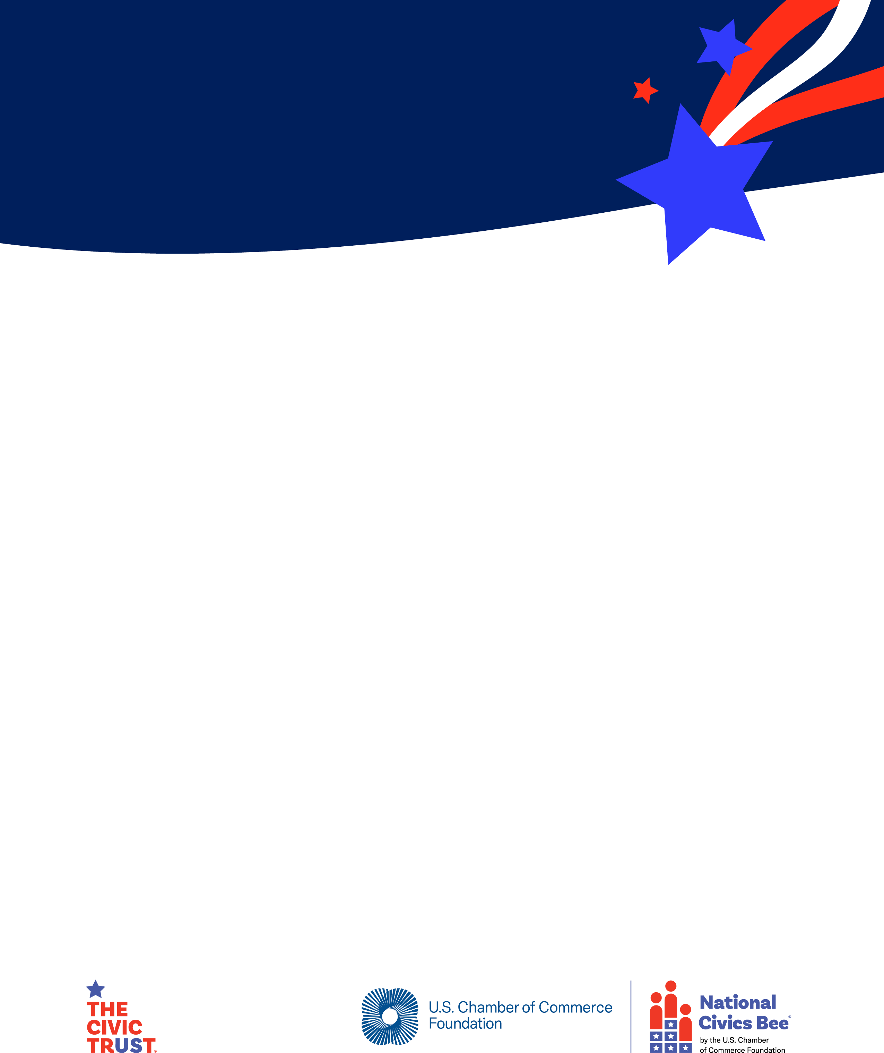**2025 National Civics Bee® Local Finalist**

**Publicity Release Form**

The sponsor of the Local Competition of the National Civics Bee to be held at 200 S. 6th St. Opelika, AL 36801 on Monday, April 28th 2025 (the “Local Competition”) is The Opelika Chamber (“Sponsor”). The term “Foundation” shall refer to the U.S. Chamber of Commerce Foundation, which organizes and helps facilitate the National Civics Bee.

On behalf of the participant, you as the parent/guardian hereby enter into this Publicity Release (this “Release”) in exchange for the intangible value gained by participating in the Local Competition and agree that both the minor participant and you shall be bound by all of the terms and conditions of this Release.

You hereby grant permission for the Sponsor, the Foundation and their respective agents to photograph, film, and record the participant at the Local Competition (the “Footage”), and authorize the Sponsor, the Foundation and their respective designees to use the Footage and participant’s name, city, and state, likeness, biographical information, and/or any statements made by him/her at, regarding, or in any way related to, the Local Competition (collectively, the “Background Information”) for purposes of advertising, promotion, and other purposes without additional financial or other compensation. You understand that you do not have the right to review or approve the advertisements, social media posts, or other materials incorporating the Footage or Background Information before they are used by Sponsor, the Foundation, or their designees.

You hereby grant the Sponsor, the Foundation, and their designees a non-exclusive, perpetual, worldwide license to edit, telecast, exhibit, rerun, reproduce, use, syndicate, license, print, distribute, and otherwise exploit the Footage or any portion thereof, in any manner, and in any and all formats and media now known or hereafter devised, without payment to you or any third party.

You represent and warrant that you are the parent or legal guardian of the minor participant, you have entered into this Release voluntarily, and you have the full legal right, power, and authority to enter into this Release and are not restricted by commitments to third parties. Notwithstanding the foregoing provisions of this Release, this Release does not provide any rights or licenses with respect to the essay or related written material provided by the participant during the National Civics Bee Essay Round.

BY SIGNING, YOU ACKNOWLEDGE THAT YOU HAVE READ AND UNDERSTAND ALL OF THE TERMS OF THIS RELEASE AND THAT YOU ARE GIVING UP SUBSTANTIAL LEGAL RIGHTS.

Finalist Name:

Parent/Guardian Name:

Parent/Guardian Signature:

Date:

**Local Finalist Parental Consent Form**

Sponsor

The sponsor of the National Civics Bee® Local Competition in Opelika, AL, described in more detail below, is The Opelika Chamber, 200 S. 6th St. Opelika, AL 326801 (“Event Sponsor”).

Consent to Participate

I, , Parent/Guardian of

, hereby consent to my child participating in the National Civics Bee Local Competition, being held on 4/28/25 at 11AM at 200 S. 6th St. Opelika, AL 36801 (“Live Event”).

I understand that participating in the National Civics Bee, including but not limited to the Local Competition, does not create a joint venture, partnership, employment, or agency relationship between me and the Sponsor or between me and the U.S. Chamber of Commerce Foundation (the “Foundation”).

I understand that the decisions of the judges at the Live Event are final, and I specifically agree that the decisions of these judges and any decision of Sponsor or the Foundation are not subject to review or appeal in any forum whatsoever, including courts of law.

Parent/Guardian Name:

Parent/Guardian Signature:

Parent/Guardian Email:

Parent/Guardian Phone Number:

Date: