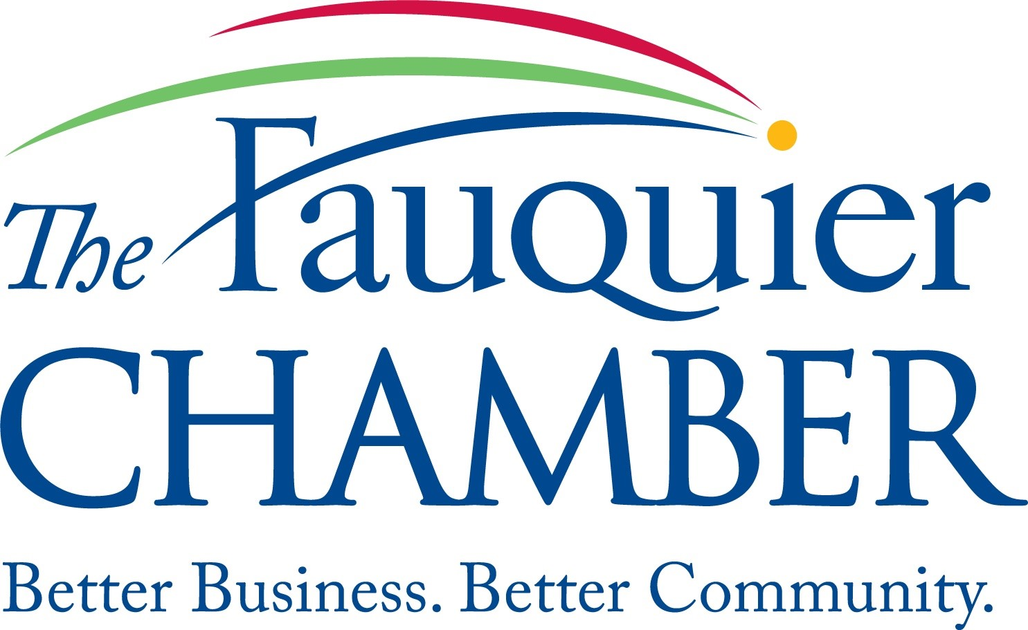

**Economic Development & Legislative Affairs Committee**

***Meeting held in person at***

***Chamber Offices / 321 Walker Drive / Warrenton***

**April 8th, 2024**

*Mission: The Fauquier Chamber helps the community do business so that we all can thrive through Relationships, Resources and Revitalization.*

**4:00 Call to order – Angie Thomas**

**4:05 Old Business**

* Newsletter – Alec update
* Partner with SBDC & MEC on specific offerings
* Committee Members Recruitment
* Panel Discussion – What is Economic Development? – Doug Update
* Workforce – Alec update
  + Food Service Partnership with the Sheriff’s office
* April Event - Coffee & Commerce

**4:15 Programming**

* Economic Summit
* Proposed Partnership Event – Trades Building Visit/Laurel Ridge
* September Expo/Event for National Preparedness Month
* Advocacy Issues

**5:00 Adjourn**