](https://www.candgnews.com/)

**Leader Dogs for the Blind seeks host homes for breeding dogs, puppies**

By: [Mary Beth Almond](https://www.candgnews.com/reporterbio/Mary-Beth-Almond) **|** [**Rochester Post**](https://www.candgnews.com/newspaper/rochesterpost)**|** **Published August 23, 2023**

[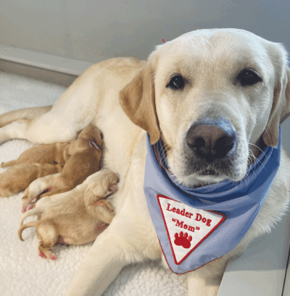](https://www.candgnews.com/admin/articles/temp-image/7114a30fd2e2d40d355d245dc5460923.gif)

**A proud yellow Labrador retriever Leader Dogs for the Blind mom shows off her new litter of Labrador/golden retriever crosses.**

**Photo provided by Leader Dogs for the Blind**

[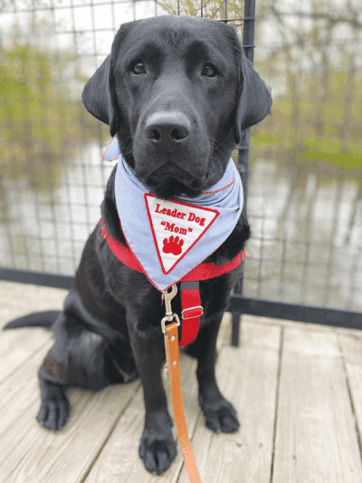](https://www.candgnews.com/admin/articles/temp-image/5c6a4abc88be11272b983b89fc34b95f.gif)

**A Black Labrador retriever mom takes time out from a walk for a photo. When not in season or pregnant, Leader Dogs moms enjoy their walks as much as most family pets.**

**Photo provided by Leader Dogs for the Blind**

ROCHESTER HILLS — Leader Dogs for the Blind is looking to the community to host a breeding dog in their home, a volunteer opportunity that the nonprofit says is now more accessible for a variety of lifestyles.

Leader Dogs’ breeding program was established in the 1980s, according to Dana Hunter, Leader Dogs breeding manager.

“One of the reasons that we first started a breeding program was so that we could better ensure the quality of the dogs that we were providing to our clients. We know, through science and practice, that the best way to care for dogs and raise litters of puppies is to do it in a home environment, because that’s eventually where these dogs are going to live in the future,” she said. “It’s the sole source of how we acquire guide dogs for our clients.”

Previously, Leader Dogs hosts could choose to welcome either a breeding mom or a dad into their home, a program that has recently expanded to include five options to make hosting more flexible.

“Our strategic plan included goals for us to create more dynamic volunteer opportunities, so that more people could get involved with Leader Dog,” Hunter said. “Everybody wants to give back in some way, so we were challenged with creating some new dynamic volunteer roles.”

New this year is the “breeding mom (non-whelp) host,” who must live within six hours of Leader Dogs’ campus and agree to care for an adult female dog in their home — except when she is giving birth (whelping) in another host’s home and until her puppies are 7 weeks old.

The new “whelp and litter host” must live within two hours of Leader Dogs’ campus and agree to invite a Leader Dogs mom to birth in their home and care for the litter until they are 7 weeks old.

The traditional “breeding mom (whelp) host” must live within six hours of Leader Dogs’ campus and agree to care for an adult female dog in their home — including having her give birth at home and care for her puppies until they are 7 weeks old.

Those who live within four hours of Leader Dogs’ campus continue to have the option of becoming a “breeding dad host,” who cares for an adult male dog in their home and transfers the dog to Leader Dogs as requested for breeding duties.

Leader Dogs’ new “temporary host” option, which must live within two hours of Leader Dogs’ campus, agrees to house a Leader Dogs mom or dad in their home for a year or less.

All volunteer hosts, except for temporary hosts, can adopt the dog in their care upon retirement or a puppy from a litter born in their home.

“We’re excited to see if we can capture some new audiences of people that may have been interested and wanted to participate in our breeding program, but were limited, for whatever reason — maybe the number of dogs in their home, or they didn’t want to add another pet to their family, or they wanted another dog but didn’t want to go through the whelp and litter care,” Hunter said.

All veterinary care, until the breeding dog retires, is provided by Leader Dogs, along with heartworm and flea/tick medications.

Pam Smaby, of Dexter, became a breeding mom host five years ago and has enjoyed it so much she is currently hosting her third momma dog. She adopted the first two dogs she hosted upon their retirement.

“For me, it was really a life-changing experience,” she said.

Smaby, a full-time middle school teacher, now also serves as a mentor for the breeding program.

“I love being able to help and support all the new homes. … I will be involved with Leader Dog for the rest of my life,” she said.

Those interested in learning more are invited to a “Meet the Moms” event 6-8 p.m. Aug. 24 on Leader Dogs’ campus, 1039 S. Rochester Road in Rochester Hills. The event will allow potential volunteers to meet current Leader Dogs moms, volunteer breeding hosts and learn more about the options for hosting a dog in their home.

Anyone unable to attend the event can sign up for an online information session, held monthly, about becoming a host at LeaderDog.org/Volunteer.

“We’re hopeful that we will be able to expand our volunteer base in a way which will also supplement our program and ensure that these puppies are being raised in a home environment by qualified volunteers that are dedicated to do what’s best for the litters and moms,” Hunter said.

For more information, to donate or to become a volunteer host, email leaderdog@leaderdog.org, visit leaderdogs.org or call Leader Dogs for the Blind at (248) 651-9011.