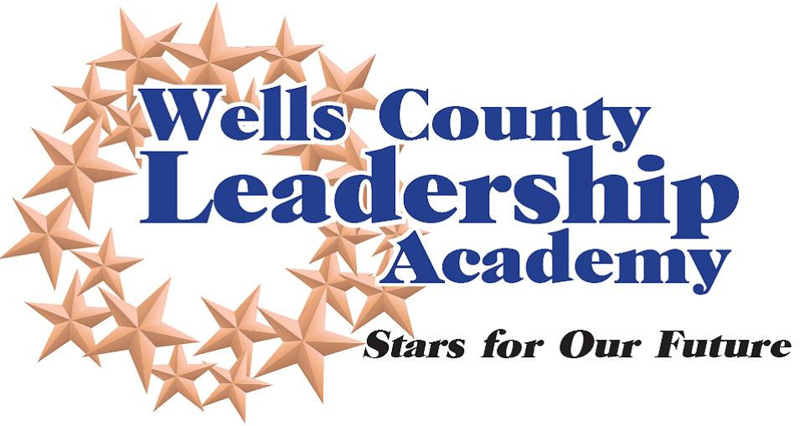

Commitment to Participate
WCLA Level 2
2024-2025 Year

Cost: $800
Instructions:
- Please complete each section in full
- Print in black ink or type
- Limit answers to space provided
- Send completed applications by June 7, 2024 to:
Wells County Leadership Academy, c/o Wells County Chamber of Commerce
211 W. Water St., Bluffton, IN 46714
eprible@wellscoc.com. Call 824-0510 with questions.

Acceptance notification letters will be mailed the week of July 22, 2024.

Personal Data
Name Mr. Ms _________________________________________________________________
Address _________________________________________________________________________
Phone (h) E-mail Address (h) __________________________________________
Cell Number: ___________________________________________________________________________
Years of work or residency in Current County _____________________________________________

Employment
Employer Occupation ________________________________________
Address ________________________________________________________________________________
Phone (w) E-mail Address (w) ___________________________________
Name of immediate supervisor ____________________________________________________________
Supervisor Email Address __________________________________________________________________
Commitment
Attendance at each session is imperative to the successful completion of the WCLA. Participants who accrue more than two absences must meet with the Facilitator, who will make a determination regarding the participant’s ability to successfully complete the program. The WCLA (session one) will commence on September 20, 2023. No tuition refunds will be granted following the September start date. If selected as a participant, I agree to attend the program sessions, complete assignments as required and participate in any project. WCLA Level 2 will meet the third Wednesday of each month (September – May) from 8 a.m. – 12 p.m.

Participant Signature _____ Date ________________
Over Please…
Business or Organization Commitment (if applicable)
This candidate has my full support to participate in WCLA. I am aware of the time commitment involved, as well as the financial obligation. The WCLA (session one) will commence on September 13, 2023. No tuition refunds will be granted following that date.

Signature ____________ Date ______________________
Name ____________ Title ______________________
Company/Organization __________________________________________________________________
Supervisor Email Address _________________________________________________________________

