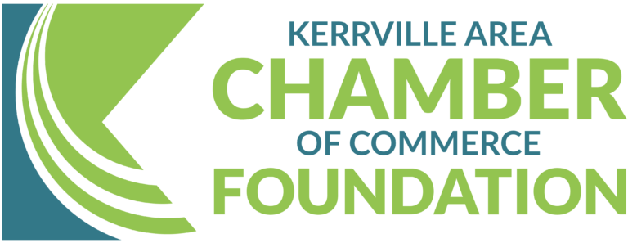

Kerrville Area Rebuilding & Recovery Fund

Phase Two Grant Guidelines

The Kerrville Area Chamber of Commerce has launched Phase Two of the Kerrville Area Rebuilding & Recovery Fund to provide larger-scale recovery support for local businesses affected by the devastating July 4th, 2025, floods. While Phase One focused on immediate relief, Phase Two offers strategic recovery grants to support long-term resilience and business continuity.

Who Can Apply?
- Businesses located in the Kerrville area
- Direct or indirect impact from the July 4, 2025, flood

Available Grant Amounts
Businesses may apply for the following grant amounts based on demonstrated need and impact severity: Up to $25,000 - Direct or Indirect Impact

Impact Categories - Applicants must indicate whether their business has experienced:
- Direct Impact: Physical damage to facilities, equipment, or inventory, structural repairs
- Indirect Impact: Revenue loss, employee displacement, or operational disruption due to direct flood-related effects

Eligible Use of Funds
- Structural repairs or reconstruction
- Replacement of business-critical equipment or inventory
- Working capital (e.g., payroll, rent)
- Infrastructure improvements or utility upgrades
- Other long-term recovery costs

How to Apply
1. Complete the Phase Two Grant Application form (see next page).
2. Include supporting documentation such as damage photos, financials, or estimates.
3. Submit In-person: 1700 Sidney Baker St, Suite 100, Kerrville, TX 78028
***(No online applications for phase 2 will be accepted) ***

Kerrville Area Rebuilding & Recovery Fund

Phase Two Grant Application

Business Information
Business Name: _________________________________________________________________________
Business Address: _______________________________________________________________________
Primary Contact Name: ___________________________________________________________________
Phone: ________________________________ Email: _______________________________________
Chamber Member?
☐ Yes ☐ No ☐ I would like to join
Who referred you? __________________________________________________________ ☐ N/A
Have you applied with us before?
☐ Yes ☐ No
If yes, how much did you receive? ___________________________________________________________
Have you received funding from any other sources? (Lift Fund, SBA, FEMA, etc...)
☐ Yes ☐ No
If yes, how much did you receive? ___________________________________________________________

Flood Impact Type
Check one:
☐ Direct Impact (e.g., physical damage)
☐ Indirect Impact (e.g., revenue loss)

Impact Description
Briefly describe how your business was impacted
Estimated cost damages ____________________________________________________________
What are your plans for recovery ______________________________________________________
________________________________________________________________________________

Planned Use of Funds (check all that apply)
☐ Structural repairs
☐ Equipment/inventory replacement
☐ Utility/infrastructure upgrades
☐ Working capital (e.g., payroll)
☐ Other: _______________________________________________________________________________

Required Supporting Documents
☐ Photo ID
☐ Photos of damages – no more than 5 (if applicable)
☐ Financial loss or revenue statement
☐ SS4 Form - EIN
☐ Contractor estimates or invoices
☐ Insurance documentation (if available)
☐ Recovery plan or continuity summary
☐ Business Bank Statement starting June 2025 through December 2025
☐ 2024 Tax Return
*Additional information may be required – We will contact you if needed

Attestation
I hereby certify that the information provided in this application and all accompanying documents is true, complete, and accurate to the best of my knowledge. I understand that false or misleading information may result in disqualification and repayment of any received funds. Submission does not guarantee an award.
I certify that I will use these funds for damage recovery of my business.
This is a grant program- funds do not need to be repaid. All applications awarded disbursements are subject to Kerrville Area Chamber of Commerce Foundation Board approval.

*By signing this application, I certify that all awarded funds will be used in accordance with the grant guidelines and approved purposes.
Signature: _______________________________________________________________________
Printed Name: ____________________________________________________________________
Title: ___________________________________________________________________________
Date: ___________________________

Edited 1.22.26

