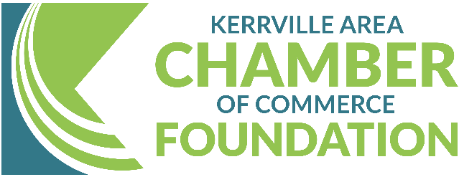
Kerrville Area Rebuilding & Recovery Fund
Guidelines & Application Overview
Phase I

Help Us Rebuild the Hill Country
Now Accepting Applications from Affected Local Businesses
The Kerrville Area Chamber of Commerce has established the Kerrville Area Rebuilding & Recovery Fund to assist our small businesses impacted by the devastating July 4, 2025, floods. This initiative provides direct financial support to help local businesses recover, rebuild, and reopen.
Who Can Apply?
Eligible applicants must: - Operate a business in Kerr County - Have experienced flood-related damage – You must Submit basic documentation and damage information.
What Can the Fund Be Used For?
- Physical repairs to interiors/exteriors
- Façade improvements and new signage
- Utility bill assistance
- Equipment or inventory replacement
- Gap funding due to insurance delays or denials
- Other flood-related business recovery needs
Note: This is a grant program — funds do not need to be repaid.
How to Apply
- Fill out the grant application form (see page 3)
- Provide a description of damages and supporting documents
- Submit by email or in-person to:
- info@kerrvillechamber.biz
- 1700 Sidney Baker St STE 100, Kerrville, TX 78028
Application Timeline
- Phase One Applications Open: Now!
- Rolling approvals and disbursements, as funds are available.
Questions?
Contact us at info@kerrvillechamber.biz or contact the Chamber offices @ 830-896-1155.
Donate or Spread the Word!
If you're not in need of assistance but want to support this effort, we welcome your donations. Every dollar helps a local business take one step closer to recovery.
Donate here: Online at Kerrville Area Rebuilding & Recovery Fund- Kerrville Area Chamber of Commerce. https://www.kerrvillechamber.biz/foundation-kerrville-area-rebuilding-recovery-fund/
Checks may be made payable to: Kerrville Area Chamber of Commerce Foundation- Kerrville Rebuilding and Recovery Fund.
Mail or drop by 1700 Sidney Baker Street, STE 100, Kerrville, Texas 78028
*All donations are tax-deductible and will be managed with full transparency and accountability, in partnership with the Kerrville Area Chamber of Commerce and its Board of Directors. *

Let’s rebuild the heart of our community together.

Edited 7-21-25

Kerrville Area Rebuilding & Recovery Fund Grant Application Form:

Business Information

Business Name: ___________________________________________________________________________
Business Address: _________________________________________________________________________
Owner:_______________________ _____________________________________________________________
Phone: _______________________________ Email: ______________________________________________
Chamber Member? Yes/ No/ Interested in information on how to join
Who referred you to us? ____________________________________________________________________
Flood Impact Information
Describe how your business was impacted by the July 4th flood:
____________________________________________________________________________________________
____________________________________________________________________________________________
____________________________________________________________________________________________
____________________________________________________________________________________________
Estimated financial loss or damage cost: ___________________________________________________
Do you have insurance? Yes No
Are you a non-profit? Yes No
Have you applied for other grants? Yes No - If yes, which ones? ________________________

Please list the types of support you are requesting (check all that apply):
Repairs to building/facilities, Façade or signage improvements, Utility bill support
Equipment/inventory replacement, Insurance gap coverage
Other: _____________________________________________________________________________________

Supporting Documents Checklist (Please attach):
Copy of Driver’s License
Photos of damage (if available)
Proof of Business Ownership Documents
Any other supporting documents

All personal and organizational information provided in this application will be kept confidential and used solely to evaluate eligibility and administer funds. Information will not be shared with third parties without prior consent, except as required by law.
By signing this application, I hereby certify that the information provided in this application and all accompanying documents is true, complete, and accurate to the best of my knowledge. I understand that submission of false or misleading information may result in disqualification from the Kerrville Area Rebuilding & Recovery Fund and may require repayment of any funds received. I also understand that submission of this application does not guarantee funding and that all awards are subject to funding availability and review by the Kerrville Area Chamber of Commerce.

Signature: _________________________________________________________________________________
Date: __________________________________

