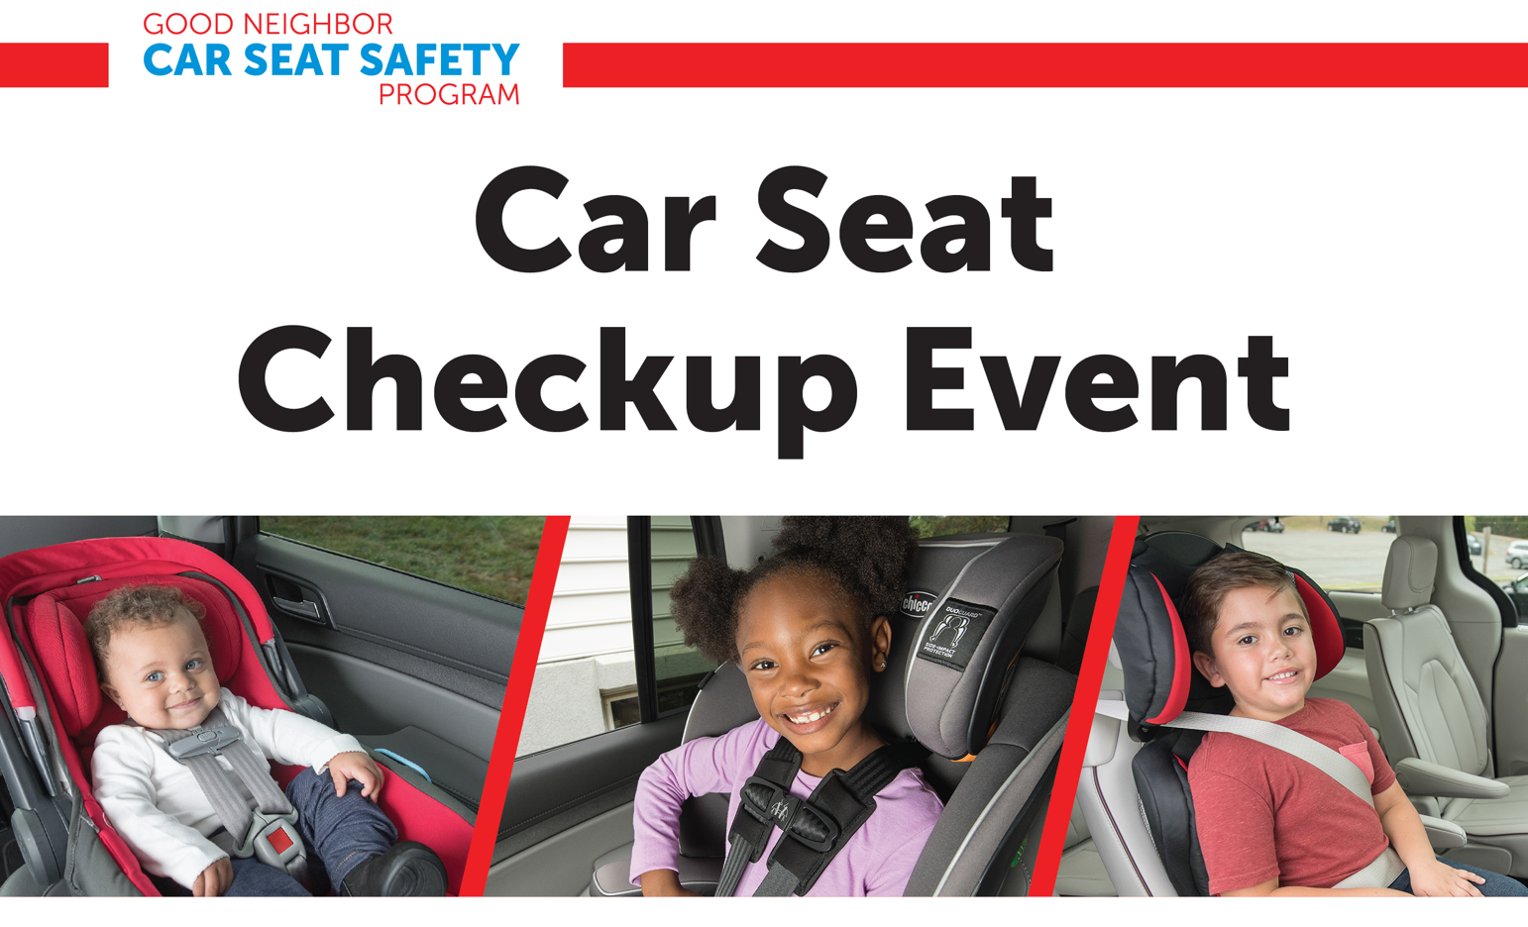
Is your child in the right car seat? Is it installed correctly? Other questions?
Our certified Child Passenger Safety Technicians are here to help for Free.

Tuesday, September 22, 2026 from 4-7 pm
Parking Lot at Geisinger Clinic
Bloomsburg Reichart Road
2407 Reichart Road, Bloomsburg, PA 17815

Bring your unwanted, expired, or unsafe car seat in for a reward!

