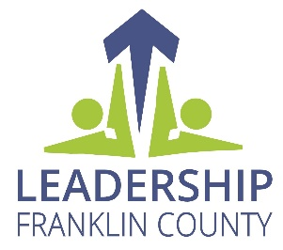
Leadership Franklin County
Community Service Project
Request for Proposal (RFP)

History:
Leadership Franklin County (LFC), founded in 1985, is the flagship leadership program of the Greater Chambersburg Chamber Foundation. The mission of LFC is to develop “. . . an inclusive continuum of civic leaders engaged in the advancement of the quality of life in Franklin County.” To further this mission, the LFC program provides participants with opportunities to explore leadership roles while gaining knowledge about the community and experience in public service.

One LFC component requires students to work in teams to complete community service projects. The goal is to provide students with opportunities to learn group dynamics, relationship building, and project planning. This Request for Proposal (RFP) is seeking qualified community organizations with a project that could be accomplished by one of the LFC teams.

Project Guidelines

- This RFP is open to any non-profit, educational, or governmental organization with a project in Franklin County. An IRS Determination Letter is required as proof of nonprofit status. All entities submitting a proposal must be in good standing with the IRS. Documentation that the organization’s steering body approves of the project must be submitted with the proposal. For example, meeting minutes showing board of director approval or a resolution from the governing board could be offered.

- Project organization must:

  - Have a representative attend the virtual RFP introductory meeting
  - Have a representative attend the class retreat to present information regarding the organization and the scope of the project
  - Designate one person to communicate between the project organization and the LFC team
  - Provide ample support, both financial and administrative

- Project scope is as follows:

  - Project impacts the community
  - Project provides an opportunity for LFC team members to experience personal leadership growth
  - Project has specific deliverables during the course of the LFC class cycle (October – April)
- Project aligns with one or more of the LFC course components (Agriculture, Arts, Criminal Justice, Economic Development, Education, Health, History/Tourism, Local Government, Nonprofit Impact)

- Project scope does not allow for the following:

- LFC students to provide or solicit financial support, monetary or other donations, sponsorships, prizes, etc. or any type of contribution beyond volunteer time
- Strategic planning, recruitment of board members, or organizational development
Leadership Franklin County
Community Service Project
Request for Proposal (RFP)

2025 Proposals will be reviewed by the LFC Steering Committee and LFC Project Mentors to ensure proper scope and alignment with LFC objectives.

Proposals should be sent or emailed to:
Greater Chambersburg Chamber Foundation
Ginny Harriger, Executive Director
100 Lincoln Way East, Suite A
Chambersburg, PA 17201
gharriger@chambersburg.org

Important Dates:
April 23 or May 27 Mandatory Virtual Proposal Introductory Meetings (Pick one)
Register on the CVBA Event page - Zoom link and instructions will be sent when registered

June 20, 2025 Proposal Deadline – Submitted by 4:30 p.m.

August 8, 2025 Proposal Status Announcements

September 6, 2025 Mandatory Class Retreat Project Session – morning time TBA

Leadership Franklin County
Community Service Project
Request for Proposal (RFP)

Organization Profile:
Organization: Click here to enter text. Primary Contact: Click here to enter text.
Address: Click here to enter text.
Phone: Click here to enter text. E-mail: Click here to enter text.
EIN #:Click here to enter text.

Organization Overview:

Descriptive Summary (250 words or less): Click here to enter text.
Mission/Vision statement (if applicable): Click here to enter text.
Key programs and services provided (250 words or less): Click here to enter text.

Project Overview:

Project Title: Click here to enter text.
Project summary with desired deliverable(s) (250 words or less): Click here to enter text.
Target population(s): Click here to enter text.
Benefit(s) to the organization: Click here to enter text.
Benefit(s) to the community: Click here to enter text.
Deadline for project completion: Click here to enter a date.
Amount of funding available to complete the project: Click here to enter text.
Barriers to completing the project: Click here to enter text.

Leadership Franklin County
Community Service Project
Request for Proposal (RFP)

Check each box to accept the requirements of the project:
☐IRS Determination Letter
☐Documentation of steering body project approval
☐A designated primary contact person from the organization
☐An organizational representative attending the class retreat project session
☐Money provided by the organization to complete the project
☐ Acknowledgment that LFC students cannot provide or solicit financial support, monetary or other donations, sponsorships, prizes, etc.
☐Acknowledgment the project must be completed during the LFC class cycle (October – April)
☐Acknowledgement the project aligns with one or more of the LFC course components

Please indicate one or more course components related to your project:
☐Agriculture
☐Arts
☐Criminal Justice
☐Economic Development
☐Education
☐Health
☐History/Tourism
☐Local Government
☐Nonprofit Impact

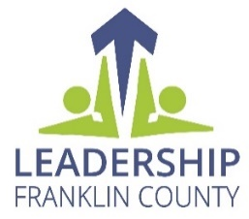
LFC Community Service Project Proposal – Rubric

Organization: _____________________________________

Reviewer: Date:

Documentation | Yes | No
IRS Determination Letter
Documentation of organization steering body project approval
A designated primary contact person from the organization
An organizational representative attending the class retreat project session
Funds provided by the organization to complete the project
Acknowledge that LFC students cannot provide or solicit financial support,
monetary or other donations, sponsorship, prizes, etc.
Acknowledge the project must be completed during the LFC class cycle (Oct.-April)
Acknowledge the project aligns with one or more of the LFC course components
*All answers above must be “Yes” to continue.

Use the following scale to grade this section:
0-does meet criteria 1-minimally meets criteria, 2-meets criteria, 3-exceeds criteria

Project Scope | Score | Comments
Project impacts the community
Project provides an opportunity for LFC team members to experience personal leadership growth
Project has specific deliverables that are outlined in this section
Project Scope Total

Use the following scale to grade this section: 1-Poor, 2-Fair, 3-Very Good, 4-Excellent

Organization Overview | Score | Comments
Descriptive Summary
Mission/Vision Statement
Key Programs and Services Provided
Organization Overview Total

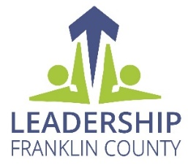
LFC Community Service Project Proposal – Rubric

Organization: _____________________________________

Reviewer: Date:

Use the following scale to grade this section: 0-Poor, 1-Fair, 2-Moderate, 3-Very Good, 4-Excellent

Project Overview | Score | Comments
Project Summary
Target Population
Benefit(s) to Organization
Benefit(s) to Community
Deadline
Available Funding
Barriers to Completing the Project
Project Overview Total

Scoring:
Section | Section Total
Project Scope
Organization Overview
Project Overview
Grand Total

Recommend: Yes No
General Comments (if any):

