The Marietta Area Chamber of Commerce agrees to:
- Print and sell Marietta Bucks to individuals and employers as a community gift certificate – Marietta Bucks will be sold year-around.
- Print Marietta Bucks on safety paper that limits the possibility of being photocopied or altered. A serial number will also be stamped on the certificate and are tracked
- Process redeemed Marietta Bucks and mail checks to participants each week they are submitted for the face value less a 2.5% service charge
- Distribute with a current list of members who have elected to redeem Marietta Bucks
- Advertise and promote the Marietta Bucks program
The Chamber Member agrees to:
- Inform your employees of the Marietta Bucks Program
- Be responsible for checking the authenticity of Marietta Bucks by treating them in the same manner as a check
- Ask the customer to sign the certificate in the space provided
- Ask for customer identification
- Use a check deposit stamp or company stamp on the back of each buck before sending them for redemption
- Display a provided window decal stating that your business redeems Marietta Bucks
- Allow the Chamber to publicize your participation in the Marietta Bucks program
- To remain a member in good standing of the Marietta Area Chamber of Commerce. Sponsorship right will expire upon expiration of Chamber membership
- Submit Marietta Bucks for redemption by filling out a redemption form provided by the Chamber and submitting the physical bucks your business accepted
- Refrain from accepting expired bucks. Marietta Bucks are valid for two years after the date of issuance, bucks that have been expired for more than three months will not be redeemed by the Chamber back to your business.
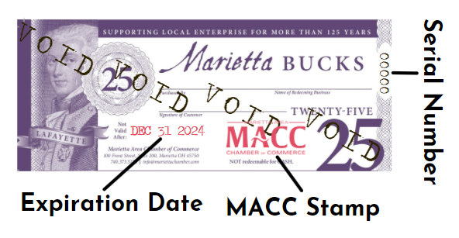
- Give customers store credit (such as a gift card) or the difference in cash if they make a purchase for less than the stated buck’s amount
- Avoid redeeming bucks that look questionable (i.e. they are missing an expiration stamp, miss a MACC stamp, missing a serial number or they appear to be forged or photocopied etc.) If you have questions about the authenticity, please call the Chamber at 740-373-5176.
THE ABOVE IS AGREED AND ACCEPTED BY:
Name of Member Business: _________________________________ ___

Authorized Signature/Title: Date:
Print Name:

