|  |  |
| --- | --- |
| Logo OL w-1 tag  **FOR IMMEDIATE RELEASE:**  May 22, 2025 | **Contact:**  Carla N. Carnevale  Community Relations Manager  Monson Savings Bank 413-893-0120  [ccarnevale@monsonsavings.com](mailto:ccarnevale@monsonsavings.com) |

**Monson Savings Bank Supports Ware/Monson Area Salvation Army Housing Assistance Program with $5,000 Donation**

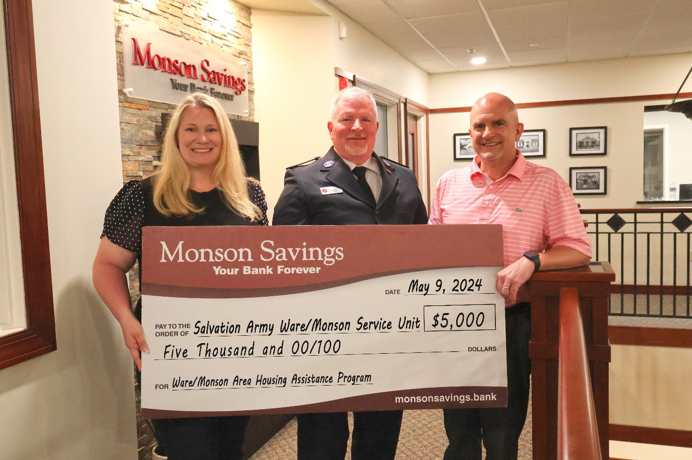

*Monson Savings Bank’s Vice President BSA/Fraud Officer & Compliance Manager and Salvation Army volunteer Heather Arbour and President & CEO Dan Moriarty (right) proudly present the Bank’s contribution to Wilfred Leslie, Service Extension Director, The Salvation Army Massachusetts Division.*

**Monson, MA** – Monson Savings Bank is proud to continue giving back to the communities it serves by donating $5,000 to The Salvation Army’s Ware/Monson Area Housing Assistance Program. This generous contribution will directly assist local individuals and families experiencing housing instability, helping them stay in their homes and avoid homelessness.

The donation was presented by Dan Moriarty, Monson Savings Bank President and CEO, and Heather Arbour, Vice President BSA/Fraud Officer & Compliance Manager and longtime Salvation Army volunteer, to Wilfred Leslie, Service Extension Director for The Salvation Army’s Massachusetts Division. The funds will be used to support residents in the Bank’s communities by providing assistance with rent, utilities, and emergency housing needs.

“At Monson Savings Bank, we are deeply committed to helping our neighbors in need,” said Dan Moriarty, President and CEO of Monson Savings Bank. “We understand how important it is to feel safe and secure in your home. Through this donation, we’re proud to help ease the burden for individuals and families who are facing financial hardships. The Salvation Army is a critical partner in these efforts, and we are honored to support the meaningful work they do.”

Wilfred Leslie expressed sincere appreciation for the support from Monson Savings Bank.

“This support from Monson Savings Bank allows us to do more for the people who need it most,” said Leslie. “This donation will go a long way in helping families stay in their homes during times of crisis. We are grateful for the Bank’s dedication to community well-being and for being an ally in our mission.”

Monson Savings Bank’s support of the Housing Assistance Program reflects its broader commitment to strengthening local communities in which it operates through philanthropy, volunteerism, and strategic partnerships. The Bank has a strong history of supporting initiatives that align with its mission to improve the lives of those who live and work in the communities it serves.

To learn more about The Salvation Army, please visit: www.salvationarmyma.org

To learn more about Monson Savings Bank’s community commitment, please visit: <https://www.monsonsavings.bank/connect/our-community/our-community-commitment.html>

**About The Salvation Army**

The Salvation Army helps more than 27 million people in nearly every ZIP code in America overcome poverty, addiction, and economic hardships through a range of social services. By providing food for the hungry, emergency relief for disaster survivors, rehabilitation for those suffering from substance abuse, and clothing and shelter for people in need, The Salvation Army is doing the most good at our more than 6,400 centers of operation around the country. In 2024, Forbes ranked The Salvation Army 6*th* in its list of America’s Top 100 Charities. And in 2021, The Chronicle of Philanthropy ranked The Salvation Army 2*nd* on its list of “America’s Favorite Charities.”. For more information about supporting The Salvation Army or your local service centers, visit [salvationarmyma.org](https://url.us.m.mimecastprotect.com/s/sFIDCG6Qz6S1EGqqH7hRfBZ0KM?domain=salvationarmyma.org/). Follow us on X @SalvationArmyMA and #DoingTheMostGood.

**About Monson Savings Bank**

Incorporated as a mutually chartered community bank in 1872, Monson Savings Bank has one of the longest tenures of service and stability in its market. Civic leaders chartered the bank with the intent to give working men and women the opportunity to save, which – incredibly, they could not do prior to the bank’s inception. Today, Monson Savings Bank retains its legacy of empowerment through savings, but has expanded to serve its customers with a variety of innovative financial services, including digital banking, online mortgage applications and business banking, and commercial lending. The bank has expanded on its promise of “where people save, businesses prosper, and communities benefit” by opening offices in Hampden, Wilbraham, Ware, and most recently East Longmeadow, Massachusetts. The bank also opened a retail and business loan operations center in Wilbraham in 2020. Member FDIC, Member DIF, Equal Housing Lender.

###