  FOR IMMEDIATE RELEASE:  May 12, 2025 | Contact:  Carla N. Carnevale  Community Relations Manager  Monson Savings Bank  413-893-0120  ccarnevale@monsonsavings.com
Monson Savings Bank is Hosting a FREE Shred Day on Saturday, June 14th at Monson Branch
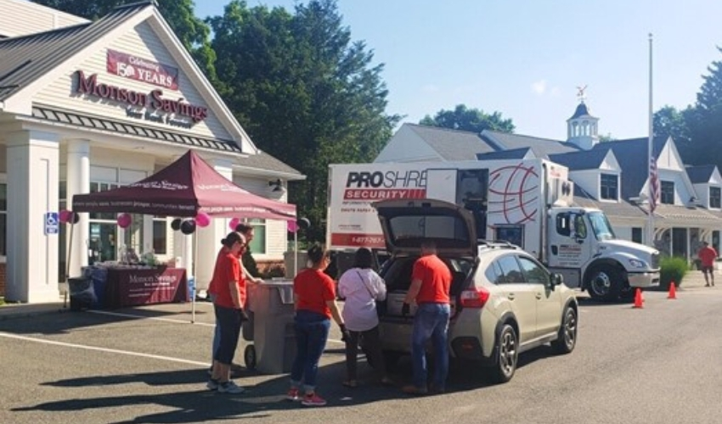
Monson Savings Bank will be hosting their annual FREE Community Shred Day on Saturday, June 14th from 9 AM to 12 PM at their Monson Branch. All are welcome.

Monson, MA – Monson Savings Bank is excited to announce they will be hosting their annual FREE Community Shred Day on Saturday, June 14th, from 9am – 12pm at the Bank’s Monson Branch, 146 Main Street, Monson. As in past years, Monson Savings Bank is partnering with PROSHRED of Wilbraham for this event. The Bank will be welcoming the public to dispose of their private documents onsite. All are welcome.

Storing documents that contain personal information in your home can pose a major security risk. Monson Savings Bank is encouraging residents to shred any documents they no longer need, especially those that contain private information. Monson Savings Bank’s FREE Community Shred Day is a perfect opportunity to properly discard unwanted documents, such as tax returns, bank or credit card statements, bills, medical records, and more.
“At Monson Savings Bank, safeguarding our customers’ and community members’ personal information is a top priority,” said Dan Moriarty, President & CEO of Monson Savings Bank. “Our team is committed to maintaining the highest standards of information security. We’re proud to offer a free Shred Day, providing our customers with a safe and secure way to dispose of sensitive documents.”

Monson Savings Bank’s FREE Shred Day, when and where:

Saturday, June 14th, 9AM – 12PM
Monson Savings Bank’s Monson Branch
146 Main Street, Monson, MA 01057

Prepackaged refreshments and giveaways will be available, while supplies last.

Monson Savings Bank understands the importance of protecting personal information. They hope to educate and protect the public with events, like Community Shred Days, and through the Bank’s frequently updated Safety and Security blog. These learning opportunities and reminders help everyone stay vigilant when it comes to protecting private information. Visit Monson Savings Bank’s Safety and Security blog to learn more.

If you have any questions about Monson Savings Bank’s FREE Community Shred Day, please contact Monson Branch Manager Amber Messer via email at amesser@monsonsavings.com.

About Monson Savings Bank
Incorporated as a mutually chartered community bank in 1872, Monson Savings Bank has one of the longest tenures of service and stability in its market. Civic leaders chartered the bank with the intent to give working men and women the opportunity to save, which – incredibly, they could not do prior to the bank’s inception. Today, Monson Savings Bank retains its legacy of empowerment through savings, but has expanded to serve its customers with a variety of innovative financial services, including digital banking, online mortgage applications and business banking, and commercial lending. The bank has expanded on its promise of “where people save, businesses prosper, and communities benefit” by opening offices in Hampden, Wilbraham, Ware, and most recently East Longmeadow, Massachusetts. The bank also opened a retail and business loan operations center in Wilbraham in 2020. Member FDIC, Member DIF, Equal Housing Lender

###

