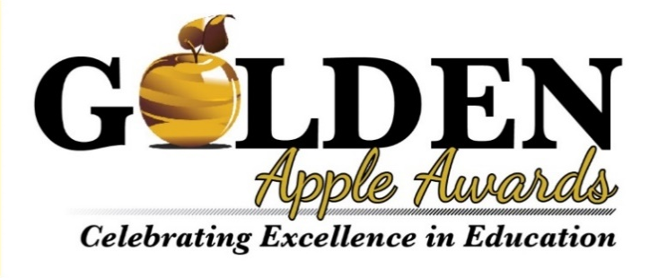
The Portage County Business Council’s Partners in Education Committee seeks to recognize K-12 teachers who have made significant contributions to education and work with future leaders.

The Golden Apple Award is given annually to a teacher who exemplifies creativity, enthusiasm, commitment and development of a positive learning environment. The selected recipient and all nominees will be recognized at PCBC’s Creative Excellence Awards Breakfast on Wednesday, April 2, 2025.
Nominations are due by Monday, March 2, 2026.

Who is eligible? Nominees must be a Pre-K to 12th grade teacher from a public or private district in Portage County (WI) with at least one year of teaching in their current district. Nominees for this award should exhibit innovative teaching strategies, demonstrate enthusiasm and vitality in teaching, and inspire students to learn. Nominees should go above and beyond in their role, supporting students and fellow educators.

Who can submit a nomination? Anyone can nominate a teacher for the award; a student, a parent, fellow teacher or community member. An individual may nominate only one person for the award. Nominations may include optional letters of support from other parents, colleagues, students, former students, etc. These letters should describe the attributes that the nominee possesses that make him/her an outstanding teacher.

Nomination Instructions: Complete this nomination form with necessary detail to allow the Partners in Education Committee to make an award decision. Please answer at least two of the four detail questions based on your knowledge of the nominee. Nominees will be judged on their creativity, enthusiasm, and commitment to education and their ability to provide a positive learning environment. Optional letters of support will help to provide the committee with greater insight into the nominees work.

Once complete, return the nomination form to the Portage County Business Council. Please send to Holly Fox, Director of Professional Development, hollyf@portagecountybiz.com. Call the Business Council at 715-344-1940 with any questions.
NOMINATOR INFORMATION (You!)
Full name:
Email Address:
Phone Number:
Relationship to Nominee:
(i.e.: current or former student; student’s parent; fellow teacher; administrator; community member)

NOMINEE INFORMATION
Full Name:
Email Address:
Nominee’s School District: (Select One)
Stevens Point Area Public School District
Rosholt School District
Tomorrow River (Amherst) School District
Almond-Bancroft School District St. Paul Lutheran
Pacelli Catholic Schools
Stevens Point Christian Academy
Tri-County-Plainfield

Nominee’s School & Role (grade or subject taught)
What word best describes this nominee?
Teacher
Administrator
Support Staff
Counselor
Volunteer
Other

NOMINATION NARRATIVE
Be as descriptive as possible in answering the following questions to help the committee best capture a snapshot of the nominees’ teaching. When possible, please use specific examples.

Why should this teacher receive the Golden Apple Award?

*Please answer at least two of the following four questions.

In what ways does this teacher use innovation and creativity in their classroom and teaching strategy?

How does this teacher demonstrate enthusiasm for their subject matter?

How does this teacher inspire their students to learn and achieve?

What does this teacher do to go “above and beyond” outside of their classroom – in their school or in their community?

