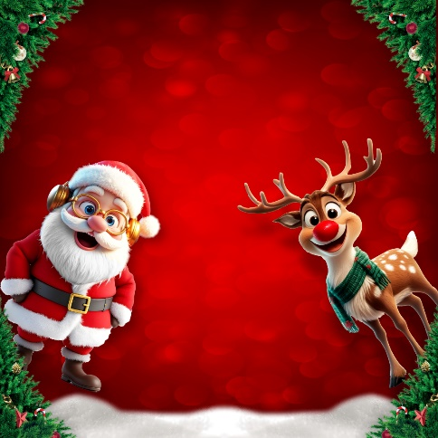

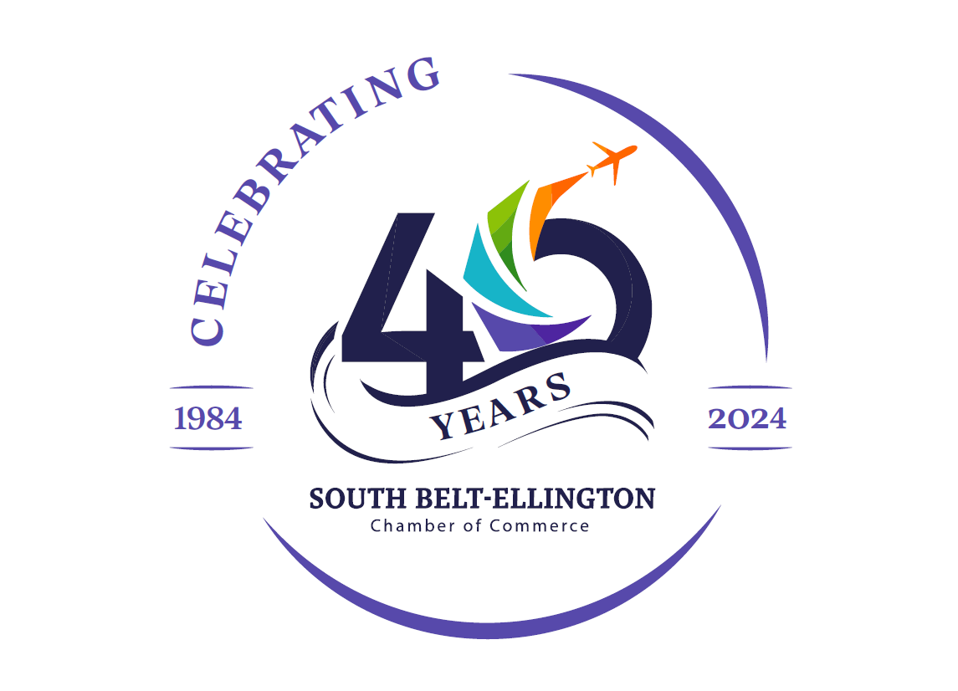
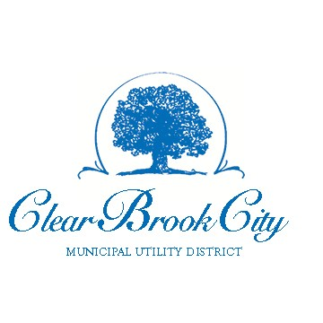
2025 Winter Wonderland

December 7, 2025 | 4-7 PM 11911 Blackhawk Boulevard

Houston, 77089

Showcase your restaurant this year at the 4th annual Winter Wonderland, produced by the CBC MUD and SBE Chamber of Commerce!

Please reserve space for my restaurant or catering business:

PARTICIPANT:
(PRINT YOUR COMPANY NAME AS IT IS TO APPEAR ON YOUR BOOTH) CONTACT:
PH:
CELL PH:

EMAIL:

WEBSITE:

ZIP:

☐I require access to electricity.
☐I require a 10x10 tent space. **Participant provides tent.**
☐I understand I will supply a table and chairs for volunteers.
☐I plan to offer a savory or sweet item. Please select the choice if known.
☐Savory
☐Sweet
☐A participants meeting will be held at the South Belt-Ellington Chamber of Commerce on Thursday, November 20, 2025, 3:00 p.m. I/we agree to attend or send at least one representative.

Liability Release: Neither the South Belt-Ellington Chamber of Commerce nor Clear Brook City MUD will be responsible for any damage to or loss of exhibit materials or related items brought to the Winter Wonderland by exhibitors, or for any personal injury resulting from your or your employees’, agents’, and representatives’ participation therein. South Belt-Ellington Chamber of Commerce reserves the right to approve exhibit materials or exhibitors and may cancel the reservation or remove the exhibit of any participant without cause.

Signature
Date

