

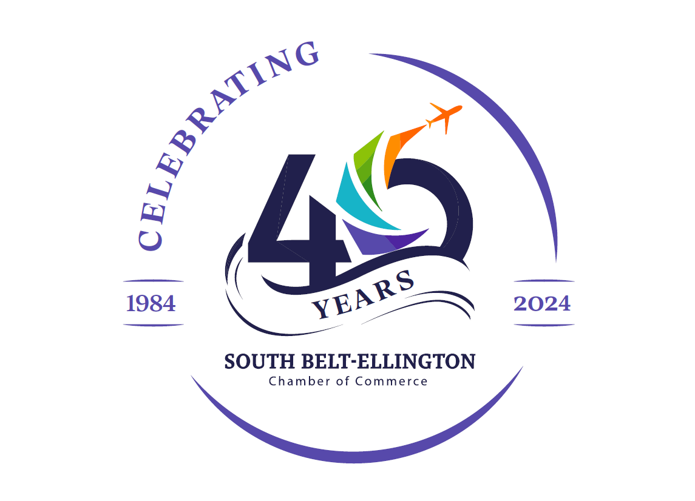
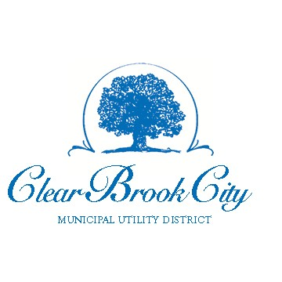
2025 Winter Wonderland

December 7, 2025 | 4-7 PM

11911 Blackhawk Boulevard

Houston, 77089
Showcase your business at the 4th annual Winter Wonderland, produced by the CBC MUD and SBE Chamber of Commerce!

Please reserve space for my business:

PARTICIPANT:
(PRINT YOUR COMPANY NAME AS IT IS TO APPEAR ON YOUR BOOTH) CONTACT:

PH:
CELL PH:

EMAIL:

WEBSITE:

Credit Card #
EXP: CVC:
ZIP:

Make checks payable to: South Belt-Ellington Chamber of Commerce.
Payment must be received by November 21, 2025.

I require access to electricity.
I require a 10x10 tent space. **Participant provides tent.**
I understand I will supply a table and chairs for volunteers.
A participants meeting will be held at the South Belt-Ellington Chamber of Commerce on Thursday, November 20, 2025, 3:00 p.m. I/we agree to attend or send at least one representative.

Liability Release: Neither the South Belt-Ellington Chamber of Commerce nor Clear Brook City MUD will be responsible for any damage to, or loss of exhibit materials or related items brought to Winter Wonderland by exhibitors; or for any personal injury resulting from you or your employees’, agents’, and representatives’ participation therein. South Belt-Ellington Chamber of Commerce reserves the right to approve exhibit materials or exhibitors and may cancel the reservation or remove the exhibit of any participant without cause.

Signature
Date

