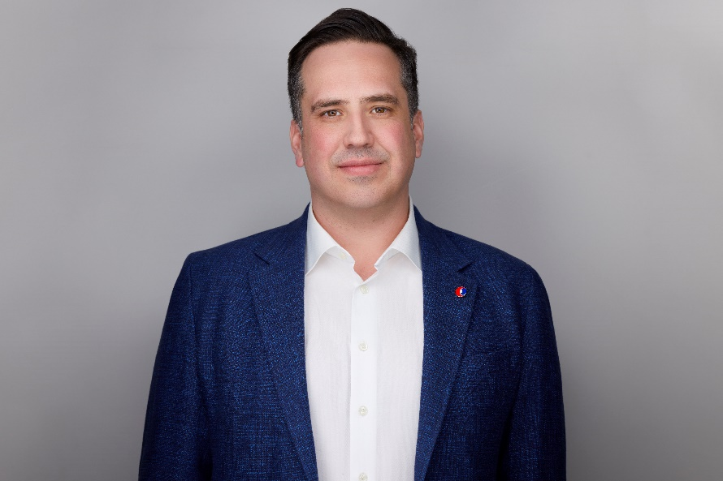
Todd is the Operations Manager for Chandos’ Edmonton District, overseeing preconstruction, operations, and field teams across a workforce of over 180 staff. He thrives on collaboration and is interested in working to improve outcomes between owners, consultants, and contractors in the construction industry. Todd is passionate about ensuring all industry partners continue to engage in project delivery with fair and equitable delivery models.
Todd began his construction career in 2008 after earning a Bachelor of Science in Engineering from the University of Saskatchewan. Over the past 17 years, he has worked across multiple sectors, including commercial, institutional, transportation, and civil infrastructure. Most recently, he served as Project Director of Chandos’ municipal infrastructure group, leading water and wastewater projects with a portfolio exceeding $1 billion. His experience spans a range of delivery models, including P3, IPD, CM, and lump sum, for both public and private sector clients. Todd has successfully managed projects from small-scale builds to those valued at over $300 million.
Beyond his professional role, Todd chaired Chandos’ national charitable initiative from 2019 to 2024, helping raise more than $1 million for local and national causes and coordinating thousands of volunteer hours across Chandos’ operating regions. He remains actively involved in his community as a youth soccer coach and local league supporter. As a parent of three, Todd stays closely connected to family and youth programs in his community.

