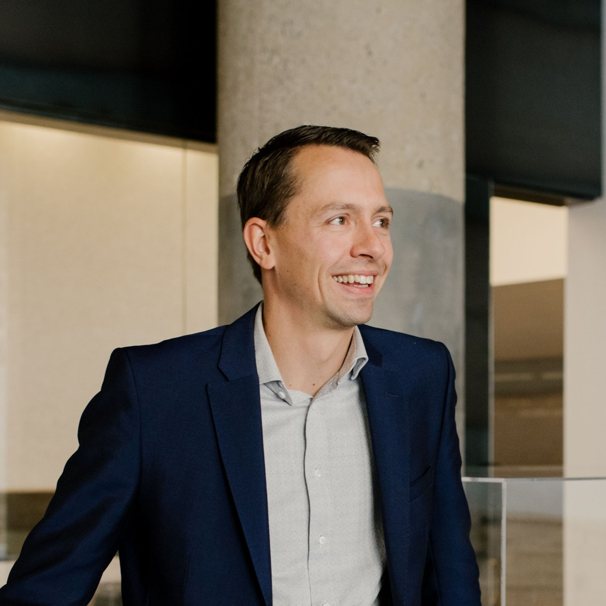
Professional Biography
Steven Oosterhof is a Partner at DIALOG, where he brings extensive experience and leadership in the design and construction industry. With a strong commitment to excellence and innovation, Steven has played a leadership role in delivering impactful projects across various sectors in Edmonton and across Canada. His professional journey is marked by a deep understanding of collaborative design and a passion for creating sustainable and community-focused environments.
Steven has demonstrated a strong dedication to governance and industry service. He served a 3-year term as a Director on the Board of the Edmonton Construction Association (ECA), where he contributed to strategic initiatives and industry advocacy. Additionally, he completed a 5-year term on DIALOG's governing council, providing leadership and guidance on firm-wide policies and direction. Steven also held the position of Chair for the Consulting Engineers of Alberta (CEA) Edmonton Buildings Committee, where he championed collaboration and best practices within the local building industry.
Through his professional and volunteer roles, Steven continues to foster meaningful connections within the industry and remains committed to advancing the built environment through thoughtful leadership and community engagement.

