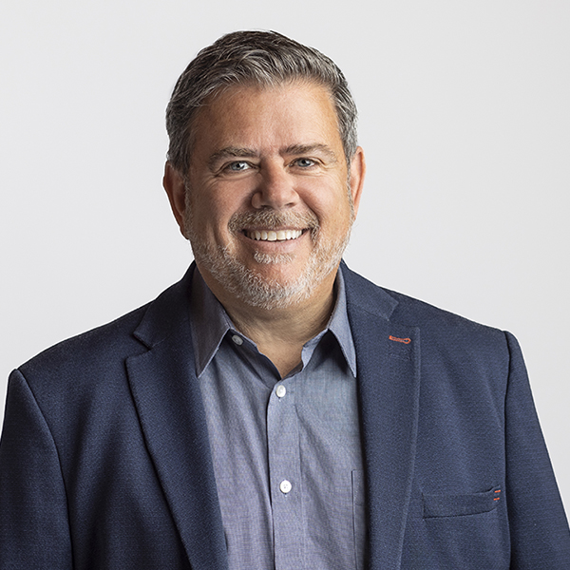
Eddo is a Partner and Principal at ACI, bringing nearly four decades of expertise in architectural design, project leadership, and collaborative delivery to the firm since joining in 2017. Over the course of his career, Eddo has worked across diverse sectors, including sports and recreation facilities, K-12 educational institutions, libraries, cultural centers, protective services, and award-winning community developments. His comprehensive skill set spans the full project lifecycle, from early-stage planning and concept development to design execution, contract documentation, and administration. Known for his hands-on leadership style, Eddo fosters client and stakeholder engagement to ensure collaborative, mission-driven outcomes. He is a recognized industry leader in alternative project delivery methods, advising municipalities, public entities, and government ministries on strategies that optimize collaboration and efficiency.
Eddo’s commitment to mentorship and professional growth extends to nurturing the next generation of architectural leaders. Through his guidance, he shares valuable insights that leave a lasting impact on both his projects and the broader architectural community.

Education
MBA, Queens University
Bachelor of Architecture, University of Arizona
Architectural Technology Diploma, NAIT
Bachelor of Science, University of Alberta

Affiliations
Board Member Edmonton Construction Association
Board Member, ARPA Alberta Recreation and Parks Association
Board Member, Recreation for Life
Board Member & President, Italian Cultural Society
Past Board Member, Consulting Architects of Alberta

