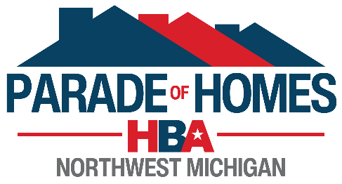

**2025 HBA of Northwest Michigan Parade of Homes**

*formerly the HBA of the Grand Traverse Area*

**Non-Profit Organization**

**Application to Participate**

**Parade Dates: June 12-15, 2025**

**NON-PROFIT ORGANIZATION INFORMATION:  
*PLEASE PRINT***

Organization Name: ____________________________________________________________________

*Mailing Address: __________________________________________________________

City: __________________________________________ State: _____________ Zip: ______________

Organization Phone #: __________________________________________________________________

**\*NOTE: All correspondence will be directed to the address above.**

**NON-PROFIT ORGANIZATION CONTACTS:**

**NOTE**:**We request at least two (2) contact names to assure communication with your organization.**

***PLEASE PRINT***

|  |  |  |  |
| --- | --- | --- | --- |
|  | **CONTACT PERSON #1** |  | **CONTACT PERSON #2** |
| Contact Name: |  |  |  |
| Cell Phone Number: |  |  |  |
| E-Mail Address: |  |  |  |

**NOTE: Although an area cannot be guaranteed, please let us know whicharea (county or city, etc.) you would prefer to host a home and we will do our best to accommodate your organization.**

_______________________________________________________________________________________________________________________________________________________________________________________________________________________________________________________________

**COMPLETED APPLICATION SHOULD BE RETURNED TO:**

The Home Builders Association of Northwest Michigan

3040 Sunset Lane

Traverse City, MI 49684

Phone: (231) 946-2305 Fax: (231) 946-1051 Email: debbie@hbagta.com

**NOTE: Groups will be notified in late April or early May, after all builder contracts are received. Homes will be assigned based on a lottery & home location.**