SPONSORED BY:
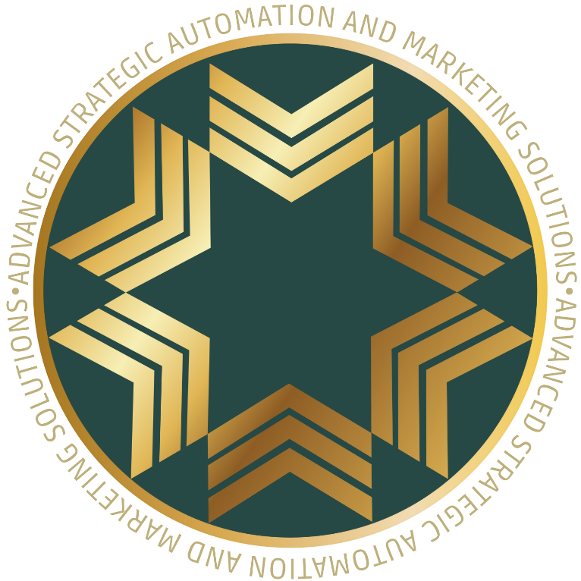
We help high-performing service professionals scale without burnout by capturing every lead, automating every step to conversion, and cutting wasted spend all through our proprietary S.A.V.E. Method.

The S.A.V.E.™ Method
Our signature AI-powered system captures more leads, closes more sales, and gives you back your time. Each component is a pillar of your new growth engine.
Contact Stephanie Kim 1-844-432-0011


