BOOT SCOOTIN’ SNACKS SPONSORED BY:



Other contributors:

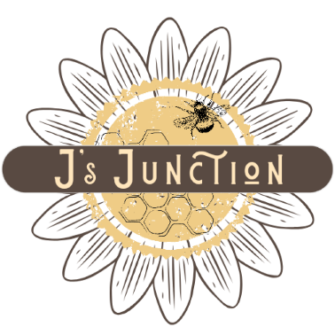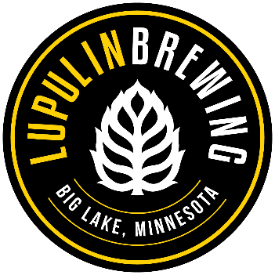

THANK YOU ALL FOR COMING TONIGHT !!!!
HAVE FUN!

