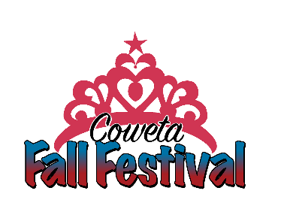
PAGEANT AFFADIVT

I understand and agree as the parent of _______________________________in the Coweta Fall Festival Pageants that I understand and will adhere to all the rules signed in the applications and contracts. There will be not exception to the rules of the pageant.
I also agree to and will follow all rules regarding rehearsals, dressing room procedures and stage etiquette. Any items left or not picked up from the Coweta Chamber of Commerce by September 20, 2024 will be disposed of. People’s Boxes must be picked immediately following the contestant’s pageant. Any boxes not picked up will disposed of following the Miss Fall Festival Pageant.
I understand the People’s Choice is voluntary and not a judged or scored category. Judges are not aware of who has or does not have a People Choice Box, or the amount of money raised.
These guidelines and rules are put to place to make a fair and flawless pageant for all. As Pageant Directors, Chairs, Volunteers and more our one and only goal is for the contestants to have an enjoyable and fun experience.
Please remember that the Miss Fall Festival Pageants are solely ran by volunteers and respectfully request that before you post any negative comments about the outcomes or opinions of the pageants on Social Media you keep the hearts of the volunteers in mind.

If you have any questions, concerns or suggestions on the pageant following it you may reach out to Nicole Gordon, Pageant Director or Christy Wheeland, Chamber Director following the Fall Festival.

_____________________________________________________
Parent Signature Date

