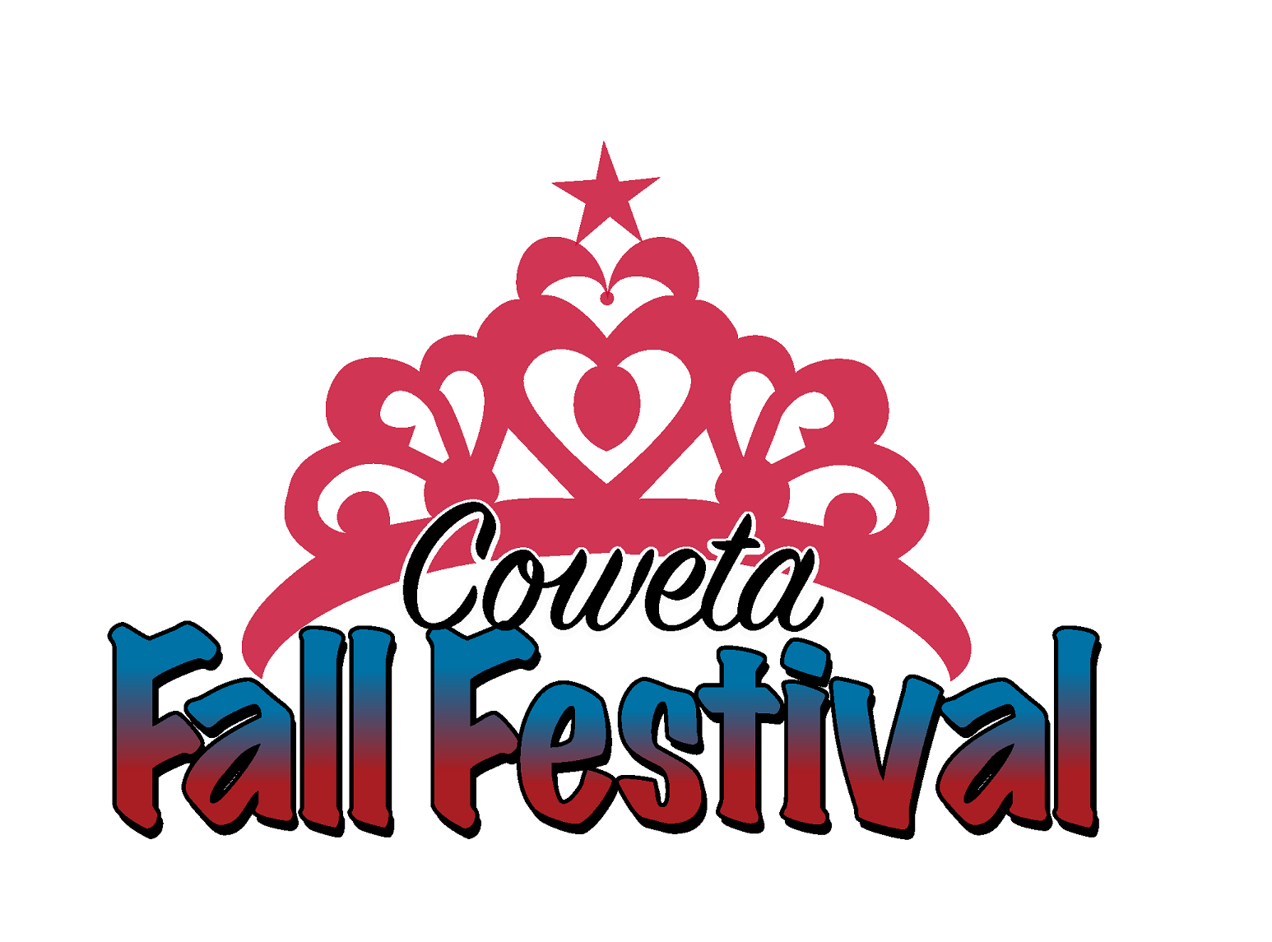
2025 Little Miss Fall Festival Pageant
Applicant Packet
Director: Nicole Gordon
Cell: (918) 638-9228
E-mail: fallfestivalpageants@gmail.com

A meeting will be held on Wednesday, August 27 at 6:00 p.m. at Coweta City Hall.
This is a mandatory meeting, and photos for Social Media will be taken.

This year’s pageant will be held on Thursday, September 11, 2025.
We look forward to working with you as you participate in the
2025 Little Miss Fall Festival pageant!

Application Rules and Deadlines:
- Pageant is limited to the first 12 applicants.
- Completed applications must be turned in to the Coweta Chamber of Commerce by
5 p.m. Tuesday, August 26, 2025.
- Emailed applications will NOT be accepted.
- Applications will not be considered complete until $10.00 entry fee is paid.
- Each contestant must submit a color headshot photo no larger than 4x6 in size. This must be received along with the application. Please put the contestant’s name on the back of the photograph. (This does not have to be a professional picture)
If photo is not received with the application, a one point deduction will be received in the photogenic category for each day it is late.
- No changes can be made to their talent (types, song changes, etc.) after applications are received. A point deduction in the talent will be received each time they are changed, and judges will be notified.
- Any changes to talent must be emailed to: fallfestivalpageants@gmail.com

RULES AND REGULATIONS
LITTLE MISS FALL FESTIVAL PAGEANT

EACH CONTESTANT MUST:
- Be a female resident of Coweta or enrolled in Coweta Public Schools ages 5-8
- Be at least five years of age on/or before September 1st. 2025, but not over eight years of age on pageant day.
- Not be a previous winner of the Little Miss Fall Festival Pageant.
- Provide her own transportation to and from activities.
- Be able to attend all activities preceding the Pageant.
- Make every effort to attend all activities sponsored by the Chamber of Commerce. A minimum participation of 50% is required. Attendance will be checked quarterly and if attendance is below the required 50%, she will be asked to give up her title and any unused prizes. The first runner-up will be asked to assume the title for the remaining activities and must also conform to the attendance requirements.
- Must not have engaged in any activity, which, by community standards, could be characterized as dishonest, immoral, immodest, indecent, or in bad taste.
- Any monies won will be paid out after pageant reign.

I have read and understand the rules and regulations cited above. Should I agree to submit my resignation as Little Miss Fall Festival or become unwilling or unable to comply with the above rules and regulations, I will return any unused prizes and will hold the pageant and committee and its members harmless from any liability, which may arise, from failure to comply with these rules and regulations.

Contestant’s Name Parent’s Telephone Number

Date Parent or Guardian Signature

2025 LITTLE MISS FALL FESTIVAL PAGEANT
THURSDAY, SEPTEMBER 11, 2025
REGISTRATION FORM

Requirements:
- All participants must be five by September 1st, 2025, to eight years of age on date of pageant.
- All participants must be a resident of Coweta or be enrolled in Coweta Public Schools.
- No participant can be a previous Little Miss Fall Festival Pageant winner.
- A headshot or close-up photograph must be provided with the completed application, if it is not turned in with the application a point deduction in the Photogenic Category will be received. 1 point per day it is late will be received. PARENT INTIALS____________.
- Talent including the type and name of the song must be completed on the completed application. Any changes to the talent after the applications are turned will results in a point deduction in the talent category. PARENT INTIALS____________.
- Talent Music must on a Flash Drive in MP3 format and turned in by Wednesday, September 4at 5pm. Any music not turned by the deadline will be omitted from the talent competition and the contestant will perform talent without music. PARENT INTIALS__________.
- Judges will be notified of any point deductions due to missed deadlines.
- Talent can be no longer than 90 seconds.
- The entry forms must be turned in to the Coweta Chamber.
- No late entries will be allowed.
- No entries will be taken via the telephone.
- No live animals, fire hazards, or any other props deemed hazardous may be used for talent (i.e. bow and arrow).
- The winner of the 2024 Little Miss Fall Festival Pageant must attend all Coweta Chamber of Commerce sponsored activities, per the Chamber Director. Agree to wear dressy casual attire (no shorts or off the shoulder tops) when representing the Coweta Chamber of Commerce. A minimum of 50% participation is required or the winner must give up her title and the first runner-up will assume the Little Miss Fall Festival duties.

Parent/Guardian Signature:_______________________________________________________________

Date:___________________

Name of Participant: _________________________ Phone Number: ______________________

Name of Parent(s)/Guardian(s): ____________________________________________________

Siblings: ______________________________________________________________________

Email address: _________________________________________________________________

Mailing Address: _______________________________________________________________

Date of Birth: __________________________ Grade in School: _________________________

School They Attend:____________________________________________________________

Talent (Please include type and title of song also): ___________________________________

Hobbies: _____________________________________________________________________

Special Interests: ______________________________________________________________

Clubs and Activities: ___________________________________________________________

Have you child describe their personality in their own words:__________________________

___________________________________________________________________________
___________________________________________________________________________

What is their favorite thing to do with mom/dad:____________________________________

___________________________________________________________________________
Favorite Food: ____________________________Favorite Color: ________________________

Favorite Book:____________________________Favorite Movie:________________________

PARTICIPANT BIOGRAPHY
Please fill in the following lines with what you would like to be said as your daughter is introduced during the pageant. Include parent’s names, school, hobbies, interests, activities, or even a funny story, etc.

Date: ___________________

