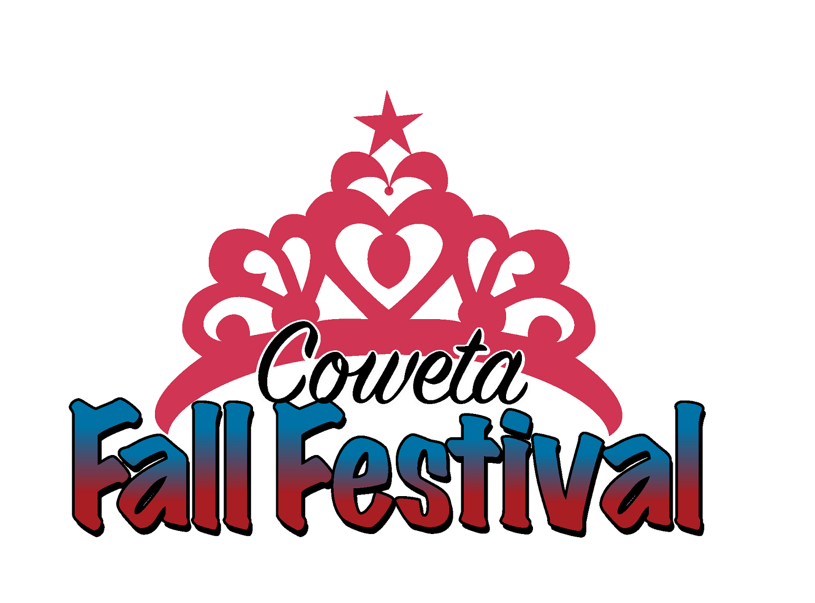
2025 Junior Miss Fall Festival Pageant
Applicant Packet
Director: Nicole Gordon
Cell: (918) 638-9228
E-mail: fallfestivalpageants@gmail.com

A meeting will be held on Wednesday August 27 at 6:00 p.m. at Coweta City Hall
This is a mandatory meeting and photos for Social Media will be taken

This year’s pageant will be held on Thursday, September 11, 2025.
We look forward to working with you as you participate in the
2025 Junior Miss Fall Festival pageant!

Application Rules and Deadlines:
- The Pageant is limited to the first 12 applicants.
- Completed applications must be turned in to the Coweta Chamber of Commerce by 5 p.m. Tuesday, August 26, 2025.
- Emailed applications will NOT be accepted.
- Applications will not be considered complete until a $10.00 entry fee is paid.
- Each contestant must turn in a color no larger than 4x6 headshot. This must be turned in with the application. Please put the contestants’ names on the back of the photograph. (This does not have to be a professional picture)
- If photo is not received with the application, a one point deduction will be received in the photogenic category for each day it is late..
- No changes can be made to their talent (types, song changes, etc.) after applications are submitted.
- If changes are made to Talent after applications are submitted, a one point deduction per change will be deducted from the talent score.
- Any changes to talent must be emailed to: fallfestivalpageants@gmail.com

RULES & REGULATIONS
Junior Miss FALL FESTIVAL SCHOLARSHIP PAGEANT

EACH CONTESTANT MUST:
- Be a female resident of Coweta or enrolled in Coweta Public Schools between the ages of 9 - 12.

- Be at least 9 years of age and/or before the date of the pageant and not older than 12.

- Be single & never have been married. If a contestant gets married after entering the pageant or during her reign, she must withdraw as a contestant or voluntarily forfeit her title, crown, sash, and all unused awards & scholarships. The First Runner-up will be asked to assume the title for the remaining reign & must also conform to these rules.

- A current headshot or close-up photograph must be submitted with the completed application. If it is not received, a point deduction of one point per day the overall is not received will be deducted from the photogenic score. Parent Initials_______ Contestant Initials_______

- No changes to the Talent type and/or song are allowed once applications have been submitted. Each change made will result in a point deduction for each change made after the application deadline. Parent Initials_________ Contestant Initials________

- Talent Music must on a Flash Drive in MP3 format and turned in by Wednesday, September 3 at 5pm. Any music not turned by the deadline will be omitted from the talent competition and the contestant will perform talent without music. PARENT INTIALS__________.

- All talent flash drives must have contestants name, contestant number and pageant entered in labeled on it. Flash drives not labeled correctly will not be accepted.

- Judges will be notified of any missed deadlines of how many points to lower each score by.

- No live animals, fire hazards, or any other props deemed hazardous may be used for talent (i.e. bow and arrow).

- She must have no children & must not be pregnant. If a contestant becomes pregnant after entering the pageant or during her reign, she must withdraw as a contestant or voluntarily forfeit her title, crown, sash, and all unused awards & scholarships. The First Runner-up will be asked to assume the title for the remaining reign & must also conform to these rules.

- Not be a previous winner of the title of Miss Teen or Junior Miss Fall Festival.

- Provide her own transportation to and from all activities and events.

- Be able to attend all activities & events during her reign as Miss Teen Fall Festival.

- Have at least a 2.75 overall grade point average. Applications will not be accepted without signature of verifying attached documentation (i.e. PowerSchool print off)

- Have no criminal convictions against her.

- Not having engaged in any activity which, by community standards, could be characterized dishonest, immoral, immodest, indecent, or in bad taste. This does in include social media postings on main or “spam” accounts. You are an example to your peers from the day you take your crown to the day you take it off, please act accordingly.

- Any monies won will be paid out after pageant reign.

- Make every effort to attend all activities sponsored by the Coweta Chamber of Commerce. A minimum participation of 50% is required. Attendance will be checked quarterly and if attendance is below 50%, she will be asked to voluntarily forfeit her title, crown, sash, and all unused awards & scholarships. The First Runner-up will be asked to assume the title for the remaining reign & must also conform to the attendance requirements.

- Agree to wear dressy casual attire while representing the Coweta Chamber of Commerce. Jeans with holes or rips are not allowed, spaghetti straps or crop tops are prohibited, and skirts/dresses must be of an appropriate length.

I HAVE READ AND I UNDERSTAND THE RULES AND REGULATIONS CITED ABOVE. SHOULD I AGREE TO SUBMIT MY RESIGNATION AS MISS TEEN FALL FESTIVAL OR BECOME UNWILLING TO OR UNABLE TO COMPLY WITH THE ABOVE RULES AND REGULATIONS, I WILL RETURN THE CROWN, SASH, AND ANY UNUSED SCHOLARSHIPS AND PRIZES AND WILL HOLD THE PAGEANT, COMMITTEE, AND COWETA CHAMBER OF COMMERCE MEMBERS AND EXECUTIVES HARMLESS FROM ANY LIABILITY WHICH MAY ARISE FROM MY FAILURE TO COMPLY WITH THESE RULES AND REGULATIONS.

_________________________ _________________________________________________
Date Signature of Contestant
_________________________________________________
Parent or Guardian Signature

Junior Miss FALL FESTIVAL PAGEANT APPLICATION
Interview and Evening Gown Biography

Date________________________________

Name_______________________________ Age______ Phone Number____________________

Mailing Address____________________________________________________________________________

Email Address_____________________________________________________________________________

Parent(s) or Guardian(s) Name(s) _______________________________________________________________

Parent or Guardian Phone Numbers______________________________________________________________

School Attending__________________________________________ Grade in School__________________

Overall Grade Point Average____________________

Signature of school official verifying GPA___________________________________________________ or attached verifying documentation.

Talent (singing, dancing, reading, dramatic interpretation, etc. – PLEASE PROVIDE NAME OF SONG ALSO) May not be changed after submission -any changes will result in point deduction from talent competition.

__________________________________________________________________________________________________________________________________________________________________________________

Favorite school subjects
__________________________________________________________________________________________________________________________________________________________________________________

Career plans & goals
_________________________________________________________________________________________
__________________________________________________________________________________________________________________________________________________________________________________

Organizations you belong to
____________________________________________________________________________________________________________________________________________________________________________________________________________________________________________________________________________________________________________________________________________________________________

Elective offices you hold or have held.
_____________________________________________________________________________________________________________________________________________________________________________________________________________________________________________________________________________________________

Past achievements
____________________________________________________________________________________________________________________________________________________________________________________________________________________________________________________________________________________________________________________________________________________________________________________________

Hobbies, Special Interest or Causes You Support: __________________________________________________________

_______________________________________________________________________________________________

What are your core values? _________________________________________________________________________

And why? ______________________________________________________________________________________

Do you have social media? If so how and where do we find you? _______________________________________________

What would you like to accomplish in the next 5 years? ______________________________________________________

One Word That Best Describes You: __________ What Brings You the Most Happiness: ____________________________

What is your most Prized Possession? ____________ What makes you a good friend: _____________________________

Favorite Book:_________________ Favorite Movie:________________________

Signature of Parent or Guardian ________________________________________________________________

Signature of Contestant______________________________________________________________________

