**For Immediate Release**

**Windsor Chamber of Commerce and Visitors Center**

**(707) 838-7285**

**Susanne@ WindsorChamber.com**

**Release Date: February 20, 2025**

**Windsor Chamber of Commerce Opens Applications for Leadership Windsor Class 3**  
**Applications Accepted Through April 25, 2024**

**Windsor, CA [February 20, 2025]** – The Windsor Chamber of Commerce is pleased to announce the continuation of its Leadership Windsor program. Since its launch in August 2023, this initiative has provided participants with an in-depth understanding of Windsor’s community dynamics and leadership opportunities.

With two successful sessions behind us, Class 2 recently completed its seventh full day of activities, featuring an insightful exploration of youth and education, including challenges and possibilities.

Participants have explored topics such as leadership principles, local government operations, business and industry dynamics, planning and development, cultural awareness, and public safety.

QUOTE

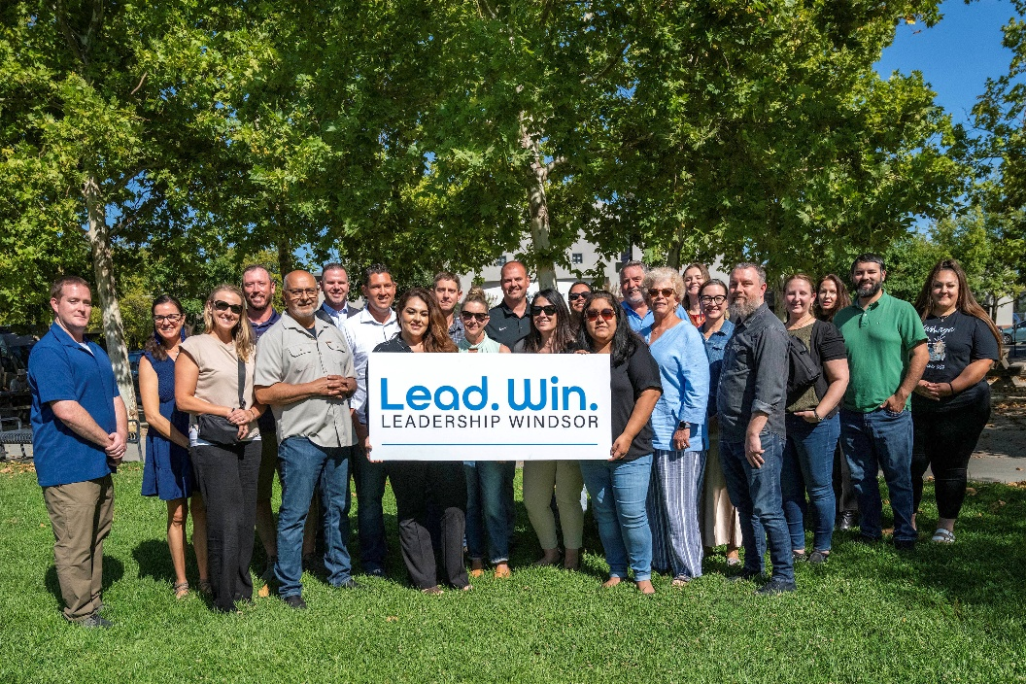

Now, the Windsor Chamber of Commerce is actively recruiting for Class Three, which will run from August 2025 to May 2026. Applications are open until April 25, 2025. The program consists of ten full-day comprehensive sessions, with a tuition fee of $1,000 covering meals, transportation, and administrative costs.

Scholarships based on financial need are available, with an interview process ensuring a diverse and dedicated cohort. Community sponsors are also invited to support the program through contributions toward participant fees, administrative expenses, and other essential costs.

Two introductory sessions have been scheduled for Thursday, February 27 and Monday, March 10, 2025 from 5:30pm – 7:00pm. The sessions will be held at the Windsor Chamber of Commerce located at 9001 Windsor Road, Windsor in The Windsor Depot. Interested parties are encouraged to register for one of the two events on the [Chamber Website](https://www.windsorchamber.com/events-2/leadership-windsor/).

For more information or to apply, contact Maureen Merrill, Steering Team Chair, at (707) 484-0320 or maureen@maureenmerrill.com.

Details can also be found on the Windsor Chamber’s website: [www.windsorchamber.com](https://www.windsorchamber.com/).

**About Leadership Windsor:**  
Leadership Windsor is an initiative of the Windsor Chamber of Commerce designed to cultivate informed and engaged community leaders. Through hands-on experiences and expert-led sessions, participants gain a comprehensive understanding of Windsor’s civic, business, and social landscape.

**Media Contact:**  
**Susanne Lake**  
Windsor Chamber of Commerce  
Susanne@WindsorChamber.com  
(707) 838-7285  
[www.windsorchamber.com](https://www.windsorchamber.com/)