For Immediate Release
Windsor Chamber of Commerce Continues Inaugural Leadership Program
Windsor, CA [April 18, 2024] - The Windsor Chamber of Commerce proudly announces the successful continuation of its first-ever Leadership Windsor program, following the model of Leadership Santa Rosa. Launched in August 2023, this engaging initiative has seen Class One complete its ninth full day of activities, culminating in a visit to the Town of Windsor’s Transportation and Public Works facilities yesterday.
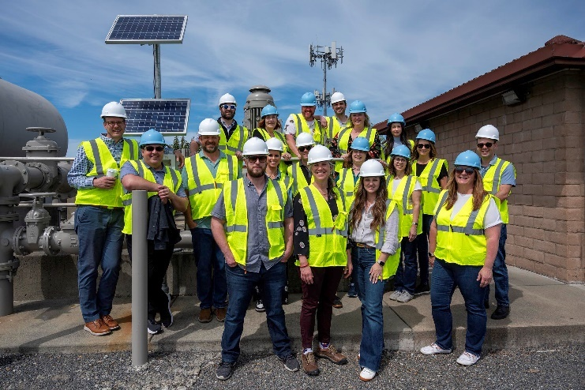
"Participating in Leadership Windsor has been an eye-opening experience. It has truly broadened my perspective on our community and how various factors shape its development. The program has empowered me to take on leadership roles with confidence and make a positive impact in Windsor and beyond,” said Alissa Johnson with Sonoma County Resource & Recovery, a participant in the ten-month program.
During its ten-month program, participants of Leadership Windsor delved into a diverse range of topics crucial to community development, including leadership principles, local government operations, health and human services, business and industry dynamics, community building strategies, planning and development initiatives, youth and education programs, cultural aspects, as well as communication and media influences.
"We are excited to witness the successful journey of our inaugural Leadership Windsor class and look forward to welcoming new participants into this enriching program," said Jim Curry, Chair of the Windsor Chamber of Commerce Board of Directors. "Leadership Windsor is not just about learning; it's about forging lasting connections, deepening community knowledge, and empowering individuals to make a difference in Windsor and beyond."
In a bid to foster continued leadership development and community engagement, the Windsor Chamber of Commerce is now actively recruiting for Class Two of Leadership Windsor, slated to run from August to May 2025. Applications are open until May 3, 2024, with a tuition fee of $1,000 for ten comprehensive sessions. This fee covers expenses such as meals, transportation to various program locations and administrative costs.
Scholarships based on financial need are available for eligible applicants, who will undergo an interview process to ensure a diverse and dedicated cohort for Class Two. Additionally, the program invites community sponsors to join in supporting this initiative, contributing towards participant fees, administrative costs, refreshments, transportation, and more.
To learn more about Leadership Windsor and how to apply, interested individuals are encouraged to reach out to Maureen Merrill, the program's Steering Team Chair, at (707) 484-0320 or via email at maureen@maureenmerrill.com.
More information may also be found on the Windsor Chamber’s website: https://www.windsorchamber.com/
About Leadership Windsor: Leadership Windsor is a comprehensive leadership development program offered by the Windsor Chamber of Commerce. Designed to empower individuals with a deep understanding of Windsor's community dynamics, businesses, social services, and public sectors, the program aims to cultivate a network of dedicated leaders committed to driving positive change.
Contact Information:
Susanne Lake
Windsor Chamber of Commerce
Office@WindsorChamber.com
(707) 838-7285
https://www.windsorchamber.com/

