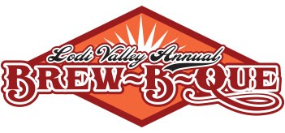

Application for 2025 Chili Contestant

Thank you for your interest in the chili competition at our Brew-B-Que! This year’s event will be held on Saturday September 20, 2025 on Main Street in downtown Lodi Wisconsin. The event will officially begin at 10 am, however your entry for the chili competition should arrive between 8 & 9 am. The Chili Station will be located on Main Street, just in front of the Police Department. You are welcome to park behind City Hall and use the alley to bring your chili up. You must provide 3 gallons of Chili in a Nesco container for VIP Ticket Holder judging. We will provide the crackers and supplies to go with it. Winners will be announced around 4 pm on the Main Stage at the event.

Please fill out this entry form to reserve your spot.

Name:______________________________________________________________________________

Chili Entry Name:__________________________________________________________________

Mild Chili Hot Chili With Meat Meatless

Contact Phone:_____________________________________________________________________

Contact Address____________________________________________________________________

Contact Email:_____________________________________________________________________

