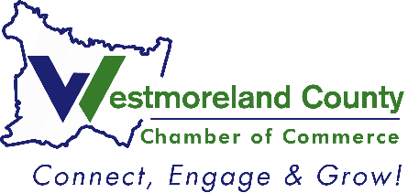
2024
Not-For-Profit of the Year
Nomination

Please complete and return to Lindsay Neary, Events and Communications Manager
Deadline: July 25, 2024

Criteria: Awarded to an outstanding not-for-profit organization in Westmoreland County that is dedicated to providing outstanding service to residents county-wide, and continually demonstrates community involvement and is an active member of the Westmoreland County Chamber of Commerce.

Non-Profit Name: ____________________________
Address: ____________________________
City, State, Zip: ____________________________
In Westmoreland County: ____________________________
Member since: ____________________________
Nominated by: ____________________________
__Feel free to share with the nominee that I nominated him/her
__Please keep my identity anonymous (will only be known by Chamber Staff)

Provide a brief description of the organization’s mission and goals.

How many years has this organization been serving the community?

What differentiates this not-for-profit from others?

How does this not-for-profit encourage volunteerism and promote it within the community?

Please site 2 to 3 specific examples of how this not-for-profit is making a significant contribution to the Westmoreland County community.

Describe how this organization is an active and supportive member of the Chamber.

