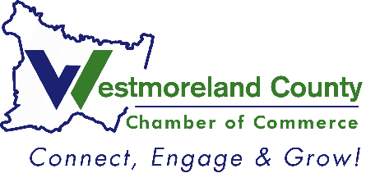
2024
Chamber Member
of the Year Nomination

Please complete and return to Lindsay Neary, Events and Communications Manager
Deadline: July 25, 2024

Criteria: Awarded to an active member of the Westmoreland County Chamber who consistently fosters membership and development for the Chamber; he/she is active in committees and events and is creative in promoting and supporting the Chamber's vision.

Nominee Name: ____________________________
Company: ____________________________
Nominated by: ____________________________
__Feel free to share with the nominee that I nominated him/her
__Please keep my identity anonymous (will only be known by Chamber Staff)

For how many years has this nominee been a member of the Westmoreland County Chamber of Commerce?

Describe the ways in which he/she supports and promotes the Chamber.

List the Chamber committee(s) in which the nominee is/was a member and any positions held.

Please provide additional comments and/or examples of why he/she should be chosen as Chamber Member of the Year.

