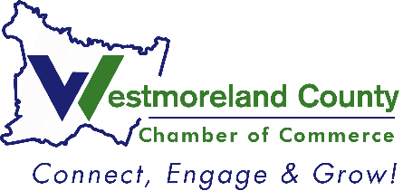
2024
Business of the Year
Nomination

Please complete and return to Lindsay Neary, Events and Communications Manager
Deadline: July 25, 2024

Criteria: Awarded to an outstanding business member of this chamber that is dedicated to community involvement, promotes job growth and employee retention, and
is committed to the growth and promotion of Westmoreland County.

Business Nominee: ____________________________
Address: ____________________________
City, State, Zip: ____________________________
Westmoreland County Business: ____________________________
Member since: ____________________________

Nominated by: ____________________________
__Feel free to share with the nominee that I nominated him/her
__Please keep my identity anonymous (will only be known by Chamber Staff)

Provide a brief description of the business.

How many years has this company been in business?

Please site 1 to 2 examples of how this company gives back to the community.

Describe the ways in which this business promotes job growth and retention.

Explain the ways in which this company has made a conscious effort to work with local suppliers, vendors, etc. in order to promote business growth and commerce locally.

Describe how the company is an active and supportive member of the Chamber.

