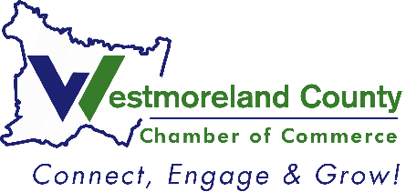
2024
ATHENA Award
Nomination

Please complete and return to Lindsay Neary, Events and Communications Manager
Deadline: July 25, 2024

Criteria: Awarded to an active chamber member who has achieved the highest level of professional excellence, contributes time and energy to improve the quality of life for others in Westmoreland County, and actively assists others, particularly women, in realizing their full leadership potential.

Nominee: ____________________________

Nominated by: ____________________________
__Feel free to share with the nominee that I nominated him/her
__Please keep my identity anonymous (will only be known by Chamber Staff)

List the company that the nominee is currently associated with, along with his/her job title.

Describe specific ways in which the nominee mentors women to reach their full potential.

How do you feel the nominee has contributed to improving the quality of life for others through his/her profession or volunteer efforts?

Describe one or two initiatives or creative strategies that the nominee has implemented in his/her business or profession.

