﻿==== ACSA E-News ==== October 9, 2026

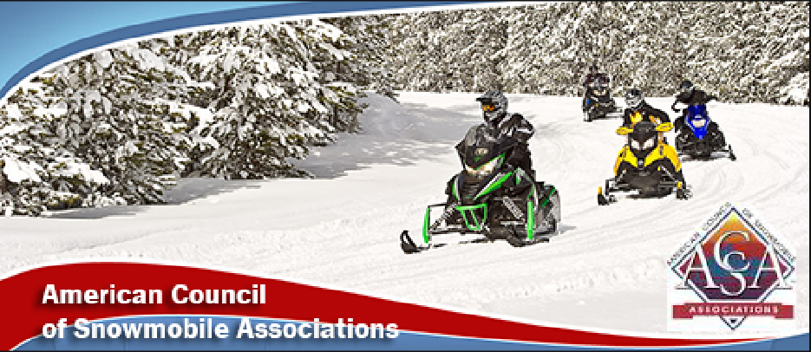

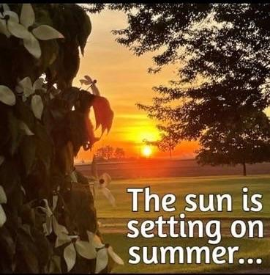

After this weekend temps are falling -
﻿along with the leaves!
BLM Seeking RAC Nominations
The BLM is now accepting nominations to fill the positions on 20 of the regional Resource Advisory Councils that currently have vacancies or have terms ending for current representatives.
These RACs provide advice and recommendations to the BLM on land use planning and management of the National System of Public Lands within the geographic areas for which the RACs are organized.
All nominations must be received no later than October 26, 2026.
Click here for additional information and details on submitting nominations.
It is very important that "recreationists" fill these positions that make recommendations on future use!
BLM Selling Timber
The Bureau of Land Management generated $29.8 million in revenue from timber sales during the third quarter of 2026, supporting American jobs and increasing domestic timber supply.
During July, August, and September, the BLM sold about 121 million board feet of timber across 5,300 acres in Oregon, Washington, Wyoming, and Idaho. That amount of lumber is enough to build about 7,600 homes. The sales support local economies with well-paying jobs in logging, milling, and construction.
“I’ve met the people whose livelihoods depend on this work, from foresters in the woods to employees at local mills,” said BLM Director Steve Pearce. “These timber sales have a real impact in rural communities, and that’s something that goes well beyond the numbers in a quarterly report.”
In Case You Missed This....
This week Yamaha and John Deere announced a new partnership to develop future side-by-side vehicles. According to the Press Release, this is a joint agreement for development and mutual supply of recreational off-highway vehicles.
Yamaha will contribute its powertrain and vehicle design expertise while John Deer will bring the vehicle development capability, US manufacturing expertise and customer insights.

ACSA SnowBusiness
The October SnowBusiness Zoom call has been scheduled and is open to all. This is a 30 minute presentation, along with Q&A.
Topic: Are You Beeping?
The new owner of the Are You Beeping, Erik Olson, will be the speaker for this month's educational presentation. Many people spend money on avalanche equipment - but sometimes do not recall the fundamentals. Learn all about Are You Beeping before you head for the mountains to ride!
When: Wednesday, October 28th
Time: 8:00 pm Eastern/7:00 pm Central/6:00 pm Mountain
and 5:00 pm Pacific
Zoom Registration: Click here
Paste: https://us06web.zoom.us/j/2329225743?pwd=qwwFTXQuo3LZpurjEGM9HbxqWcraX0.1&omn=82087354543

THANKS FOR PARTICIPATING!
As you know, within the last couple of weeks there were at least 2 big issues that were open to comments - issues that could impact snowmobiling.
Many people encouraged organizations and individuals to submit comment letters—and they listened!
The Travel Management Rule received 135,000 comment letters.
The Roadless Rule received 370,000 comment letters.
That's a lot of letters -- hopefully from people that actually visit the forests and enjoy our public lands!

UPCOMING EVENTS
October 9: Washington Board Meeting 6 pm- Enumclaw
October 23 - 25: Minnesota Fall Workshop - Alexandria
Wisconsin Fall Workshop - Manitowoc
October 24: MISORVA Annual Meeting - Gaylord
November 6 -8: Illinois Convention - Galena
Novi Snow Show
November 20 - 22: Iowa Convention - Clear Lake
Nebraska Convention - Kearney
December 3 -5: South Dakota Convention - Aberdeen
January 22-23: Idaho Convention - Burley
February 3 - 7 ACSA Trails Meet/Ride - Siren, WI
February 15-21: ACSA Mountain Summit - W. Yellowstone
Avalanche Seminars
October 13: Summit Motorsports, Bozeman, MT
October 14: Elevated Powersports, Billings, MT
October 15: Beaverhead Motors, Dillon, MT
October 16: Gull Boats, Missoula, MT
October 22: Mies Outland, St. Cloud, MN
October 23: Minneapolis Motorsports, Minneapolis, MN
October 27: Big Pine, Fairview, UT
October 28: Young Powersports, Logan, UT
October 29: Weller Recreation, Kamas, UT
November 3: Frank May Rev Motorsports, Honeyville, UT
November 4: Ultimate Powersports, Preston, ID
November 5: Rexburg Motorsports, Rexburg, ID
November 6: REV Motorsports, Idaho Falls
November 11: Dennis Dillon, Boise, ID
November 12: Mile High Powersports, McCall, ID
December 1: Mankato Motorsports, Mankato, MN
All Avalanche Seminars begin at 6:00 pm

GET SOCIAL WITH US!

Follow us on Facebook
Click Here
P.O. Box 1670, Brighton, MI 48116
(517) 351-4362 | Email



