ACSA E-NEWS  September 18, 2026 | American Council of Snowmobile  Associations | 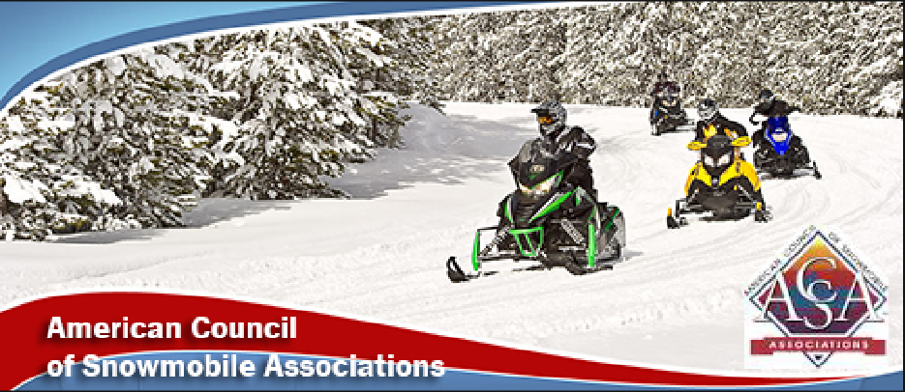
ACSA NEXT GEN
Next Gen Riders at Hay Days
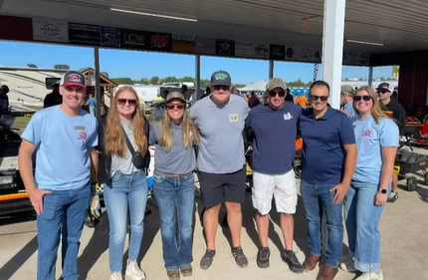
ACSA Next Gen National Riders were at Hay Days and met up with other next gen leaders!
Our future is bright with the Next Gen Riders!
ACSA E-NEWS
September 18, 2026 | American Council of Snowmobile
Associations
SKI-DOO SNOWPASS GRANTS
Ski-Doo SnowPASS Grants Awarded
Many thanks to Ski-Doo and the Ski-Doo Dealers for the generous SnowPASS Grants awarded to snowmobile clubs across the US and Canada!
The 2026 recipients of the SnowPASS grants, awarding more than 50 clubs up to $5,000 each to help maintain and protect winter access, were announced this week. The program supports the grassroots organizations and volunteers who work year-round to preserve access, improve trails and strengthen snowmobiling across North America.
Funding was awarded to projects focused on trail infrastructure, access preservation, bridge repairs, signage improvements, volunteer recruitment and introducing new riders to the sport. These investments reflect Ski-Doo’s ongoing commitment to supporting the people and places that make snowmobiling possible.
Click here to see the clubs that were awarded project grants.
Thank you Ski-Doo!!
FOREST SERVICE
Forest Service Travel Management Rule
It's very important for snowmobile clubs and individuals to submit comment letters on the proposed Revision of the Travel Management that has been in place since 2005.
Suggested areas for comments:
- Proposal of an "Open Unless Closed" policy. Existing roads and trails will be presumed open unless a closure or restriction is required by law or otherwise justified. For forests that do not already have winter travel plans, the status quo designation for OSVs will be “open.”
- Minimization criteria historically directed land managers to consider minimizing damage to soils, watersheds and wildlife harassment, and have recently been used to establish an adequate minimum snow depth of 8-12 inches before grooming can occur.
- Annual review of closed or restricted routes, including annual review to add new roads and/or trails.
Submit comments via this link: click here
ACSA E-NEWS
September 18, 2026 | American Council of Snowmobile
Associations
PUBLIC LANDS
Rescinding the Forest Service Roadless Rule
The USDA is moving forward to rescind the Road Rule which encompasses inventoried roadless areas on approximately 44.7 million acres of National Forest System lands, including in Alaska.
The proposed rule would rescind the 2001 Roadless Area Conservation Rule which prohibits road construction, road reconstruction, and timber harvesting in inventoried roadless areas, with limited exceptions.
State-specific roadless rules for Idaho and Colorado will be retained.
Rescinding the 2001 Roadless Rule is intended to return decision-making for road construction, road reconstruction, and timber harvest in inventoried roadless areas to local officials, in conjunction with Forest-level land management planning.
Maps of Roadless Areas can be found here.
The Comment Period has been extended to October 6. Submit comments via this portal:
Roadless Rule FS-2025-0001
The Comment Period has been extended to October 6.
FARM BILL
Farm Bill
This week the U.S. Senate Agriculture Committee passed the Agricultural Act of 2026, the Senate version of the 2026 Farm Bill. The bill now moves to the full Senate floor when the Senate returns in November.
ACSA E-NEWS
September 18, 2026 | American Council of Snowmobile
Associations
WILDLIFE
Wolves - Endangered Species Recovery?!?
President Trump signed an Executive Order in early September giving the Secretary of Interior 90 days to decide whether to remove Endangered Species Act protections for gray wolves and Mexican wolves in the United States.
The Supporting America’s Ranchers Executive Order calls for Secretary of Interior Doug Burgum to decide within 90 days whether gray wolves and Mexican wolves have met their recovery criteria and to begin the process of delisting or downlisting them.
The Executive Order also calls for Burgum to prepare a legislative recommendation for Trump to fully delist or downlist wolves and, upon determination that recovery criteria have been met, encourage states to delist wolves and revise state standards for the killing of wolves in order to help ranchers.
ACSA E-NEWS
September 18, 2026 | American Council of Snowmobile
Associations
UPCOMING EVENTS
Mark Your Calendar
DATE | EVENT | LOCATION / NOTE
September 18 - 20 | International Snowmobile Hall of Fame | Eagle River, WI
September 19 | Wyoming Board Meeting | Dubois
September 23 | Travel Management Rule Comments due! | Click here for the Rule & Comments info
September 23 | Michigan Board Meeting | Zoom
October 2 - 3 | Big East Power Show and New York Board Meeting | Syracuse
October 3 | Montana Board Meeting | Helena
October 5 | ISMA Grant Applications | Deadline
October 6 | Roadless Rule Comments Due! click here | Press Release and Maps can be found here.
October 23 - 25 | Minnesota Fall Workshop | Alexandria
October 23 - 25 | Wisconsin Fall Workshop | Manitowoc
November 6 - 8 | Illinois Convention | Galena
November 6 - 8 | Novi Snow Show
November 20 - 22 | Iowa Convention | Clear Lake
November 20 - 22 | Nebraska Convention | Kearney
December 3 - 5 | South Dakota Convention | Aberdeen
GET SOCIAL WITH US!
American Council of Snowmobile Associations | P.O. Box 1670, Brighton, MI 48116 | (517) 351-4362

